**INDIRA GANDHI NATIONAL OPEN UNIVERSITY**

­

**Online Maintenance Management System**

By

SORABH

Under Guidance of

**­**

**Counsellor’s Name :**

Submitted to the School of Computer and Information Sciences in partial fulfilment of the requirements

for the degree of

**Masters**

**Of**

**Computer Applications**

# ABSTRACT

Online Maintenance Management System is a web-based project which is made for booking/requesting remote-services through internet. As the technology is being advanced the way of life is changing accordance. Due to rise of internet in our life, we can place order for any services by setting at home, there is no need to go to many shopkeepers for asking for repairing your devices. Here you just have to register on website, by filling up a simple form and login, after login to your account you can add details of your devices, and subscribe to available services as well as request a quick fault repairs.

This documents describes the first phase in the development of a Online Maintenance Management System which will be used to assure that the maintenance necessary to ensure the qualification of environmentally qualified, safety-related equipment is performed.

Regulatory requirements, risk factors and liabilities, and a requirement for better assets, employees, customers management are generating intense interest in Online Maintenance Management System. Online Maintenance Management System programs provide corrective and preventive maintenance scheduling and record keeping. A common database can share information for repair trending, equipment histories, device tracking and contract warranty information.

Competitiveness has forced companies to improve the overall performance of the business. In the area of maintenance, much has been written about strategies, such as total productive maintenance or reliability centred maintenance, in order to increase the reliability and therefore capacity of the industrial plants in their quest for world‐class maintenance. However, if a strategy is to be effective, it must be supported with an invaluable resource, information. In the present work, the role of Online Maintenance Management System is discussed as a powerful tool necessary for obtaining information from raw data and support the decision‐making process. Assign engineer to a task, keep track records of work in progress.

# ACKNOWLEDGEMENT

This work was carried out during September 2018 to October 2018 at Universal Institute of Computer & Technology (UICT), Noida sector-62, as one of course of MCA 4th semester, MCSP-044-Mini Project for Web Development, It covers an Online Maintenance Management System given by Indira Gandhi Open University (IGNOU).

I would like to thank the teachers of Universal Institute of Computer & Technology, and there faculty members, teachers for their guidance. I would not forget to thank Mr. Abhimanyu Sir and Mr. Ramasankar Sir, whom for without his patience, guidance and understanding, I wouldn’t have made it this far. I also remain grateful and thankful to all of those whom have managed and guided me throughout my time of study here. You all are special to me.

I am also thankful to Mr. Ravi Sir for their guidance, help and suggestion for complete the project near to perfection.

# TABLE OF CONTENTS

Contents

ABSTRACT 2

ACKNOWLEDGEMENT 3

TABLE OF CONTENTS 4

TABLE OF FIGURES 6

1. INTRODUCTION 7

1.1. Background 7

1.2. Objectives 7

1.3. Purpose, Scope, and Applicability 8

1.3.1. Purpose 8

1.3.2. Scope 8

1.3.3. Applicability 9

1.4. Achievements 10

1.5. Organisation of Report 11

2. SURVEY OF TECHNOLOGIES 12

2.1. Technology Explanation 14

2.2. Technologies & Languages 15

3. REQUIREMENTS AND ANALYSIS 16

3.1. Problem Definition 16

3.2. Requirements Specification 17

3.3. Planning and Scheduling 18

3.3.2 GANTT CHART 18

3.3.3. PERT CHART 18

3.3.2 Feacibility Studies 19

3.4. Software and Hardware Requirements 20

3.4.1. HARDWARE 20

3.4.2. SOFTWARE 20

3.5. Preliminary Product Description 21

3.5.1 Modules 21

3.6. Conceptual Modals 22

3.6.1. DATA FLOW DIAGRAMS 22

3.6.2. ER DIAGRAM 33

4. SYSTEM DESIGN 34

4.1. Basic Modules 34

4.2. Data Design 35

4.2.1. Schema Design 35

4.4. User interface design 40

4.6. Test Cases Design 42

5. IMPLEMENTATION AND TESTING 43

5.1. Implementation Approaches 43

5.2. Coding Details and Code Efficiency 45

5.2.1. Coding Details 45

5.3. Testing Approach 180

5.3.1. Unit Testing 180

5.3.2. Integrated Testing 181

6. RESULTS AND DISCUSSION 182

6.1. Test Reports 182

6.2. User Documentation 183

7. CONSLUSIONS 188

7.1. Conclusion 188

7.2. Limitations of the System 188

7.3. Future Scope of the Project 189

REFERENCES 190

# TABLE OF FIGURES

Figure 1- Gantt Charts 18

Figure 2- Pert chart 18

Figure 3 – DFD Level 0 22

Figure 4 – DFD LEVEL-1 23

Figure 5 – DFD Level-2 Registration 1.0 24

Figure 6 – DFD Level-2 Login2.0 25

Figure 7 – DFD Level-2 Fautl Repair Service 3.0 26

Figure 8 – DFD Level-2 Maintanence Service Subscription 4.0 27

Figure 9 – DFD Level-2 Hire/Discharge Engineer 5.0 28

Figure 10 – DFD Level-2 Product 6.0 29

Figure 11 – DFD Level-2 Product Category 7.0 30

Figure 12 – DFD Level-2 Customer Info 8.0 31

Figure 13 – DFD Level-2 Maintenance Service 9.0 32

Figure 14 - ER Diagram 33

Figure 15 - MVC Diagram 40

Figure 16 MVC class-diagram 41

Figure 17 - Water Fall Model 43

Figure 18 - Integration Testing 181

# 1. INTRODUCTION

## 1.1. Background

The “Online Maintenance Management System” has been developed to override the problems prevailing in the practicing manual system. The currently service request done manually or through phone calls, in which the customers are given choice of dates when they visit to the Service Centre and it should be approved by the member of staff. If customer book their service request then they have to wait for automate machine to answer and then choose available dates. This Software can help to eliminate and in some cases reduce the hardships faced by existing system that needed to used paper work as well as human resources for entering each activity as well as executing them. The application can reduced as much as possible to avoid errors while entering the data. It also provide error message while entering invalid data. Thus by this all it proves it is user-friendly , error free, secure, reliable and fast management system. It can assist the user to concentrate on their other activities rather to concentrate on the record keeping. Thus it will help hospital in better utilization of resources.

## 1.2. Objectives

Every Service Centre, whether big or small, has challenges to overcome and managing the information’s of customers, service orders, records for progress of their employees, etc. Every Electronic product have need different type of expert engineer’s, therefore we are going to design a Online Maintenance Management System that are adapted to your managerial requirements. This is designed to assist in strategic planning, and will help you ensure that your organization is equipped with the right level of information and details for future goals. The project is built at administrative end and client end, customers can register and login to access information, like list of devices, work in progress, booking of fault repair, purchase of maintenance services, etc. Administrator are responsible for entering information’s and keep track of availabilities that customer can access for requesting services for repairing their devices. It is the user friendly application for Service Centre which reduces the burden and helps to manage all sections, like employees, customers, devices and Billing etc., which improve the processing efficiency.

## 1.3. Purpose, Scope, and Applicability

### 1.3.1. Purpose

The purpose is to provide a way to our customer to go online, by sitting at home request a fault repair service for their electrical or electronic devices or subscribe to a maintenance service for their home or business devices. We have to automate our existing manual system by the help of computerized equipment’s and full-fledged computer software, fulfilling their requirements, so that their valuable data/information can be stored for a longer period with easy accessing and manipulation of the same. Basically describes how to manage for good performance and better services for the clients.

### 1.3.2. Scope

The Customer of this system can register their information like name, address, phone number, etc. After registration customer can add their products/device details, like name, brand name, choose a category, date of purchase, serial number of device (if any), purchased price, fault description, etc. and request for services. Once order for fault repairs is submitted, he will be get contacted by selected engineer, and he will visit to given address for collecting the faulty device. Once fault resolved, repaired device will be sent back to customer with bill.

The System Admin can manage customers, engineers, products and their categories from their own area. This will help to reduce extra staff needed for keeping records. Admin can get notification after login and can easily select required engineer, who can do such task. He is in control of managing this Online Maintenance System. After getting a request of required service onto a device he can easily contact the customer with their given phone number and assign a engineer to take over to fix the possible problem.

### 1.3.3. Applicability

1. **Details:** The new proposed system stores and maintains all the details of the customers, customer devices, engineers, services, etc..
2. **Registers:** There is no need of keeping and maintaining database manually. It remembers each and every record and we can get any report related to products and customer at any time.
3. **Speed:** The new proposed system is very fast with 100% accuracy and saves time.
4. **Manpower:** The new proposed system needs less manpower. Less people can do the large work.
5. **Efficiency:** The new proposed systems complete the work of many persons in less time.
6. **Past details:** the new proposed system contains the details of every past user for future assistance.
7. **Reduces redundancy:** The most important benefit of this system is that it reduces the redundancy of data within the data.
8. **Work load:** Reduces the work load of the data store by helping in easy updates of the records and providing them with the necessary details together with database management system.

## 1.4. Achievements

We are going to achieve following goals:

1. Our current manual system has a lot of paper work and all records will be maintain in different registers, maintenance of those records are itself a big work. We are going to provide a easy to Manageable System that provides administrator to search records as quickly and in more efficient way. As we know if we are using traditional workflow for our business then it required us to facilitate much bigger storage space, but here we achieved a unlimited storage that didn’t required us to rent bigger buildings.
2. Customer are getting a System that is helping them to manage their product & devices records together, he is able to raise a request on faulty device anytime without filling those records each time.
3. We are maintaining our employees and keep track of their expertise, this will helpful information to management department to find rightful candidate for work.
4. Engineer are also living in a much tension free environment, only because of our system we can keep track every one of them working on fixing a problem and those are resting. So it will help management department to decide appraisal to rightful engineer.
5. Searching records or retrieval of records of previously years or month is a tedious job, but our system is going to provide a fully functional database searching environment, where we can search records based on name, date, serial no, etc.
6. Providing security to the records are a pain, anyone disarrange the records of your system in traditional system by visiting to storage facility, but we achieved a authenticate based system that secure our data to going into wrong hands.
7. It provides better user experience to both customers and administrator.

## 1.5. Organisation of Report

After visiting to some of the Service Centre, we have found that there are mainly following services provided:

1. **Preventative maintenance schedules**

This consists of a timetable stating when (and how frequently) maintenance should be done, and a list of maintenance activities for each item. These schedules should provide simple guidelines for all types of equipment, covering the tasks to be undertaken in the following areas:

* + Care and cleaning
  + Safety checks
  + Functional and performance checks
  + Maintenance tasks (changing parts, lubricating moving parts, etc.)

1. **Repair**

Repair means responding to the breakdown of equipment and undertaking work to correct the problem in order to return the equipment to a working condition.

* **Simple repairs** can be done by the in-house or external **maintenance and repair team**. If the equipment is repaired where it is used, it is important that the team is trained to work safely and that they don't create hazards for customers or staff.
* **More complex repairs** will be carried out by **specialised maintenance personnel**; they might come to the eye care unit or you may have to send the equipment to them for repairs.

Some items of equipment will be found to be damaged beyond repair. For others, spare parts may no longer be available as the equipment has become outdated. These will have reached the end of their lives and must be taken out of service (decommissioned or retired) and be replaced if the service they provide is to continue.

# 2. SURVEY OF TECHNOLOGIES

We are creating a ONLINE MAINTENANCE MANAGEMENT SYSTEM for Service Centre, who is providing two kinds of services for electrical and electronics product such as TV, Washing Machine, Refrigerator, Air Conditioners, Air Coolers, Microwave Ovens, etc. Our System will be shared across internet to access anywhere at any point of time.

For our management system, basically three technology required:

1. **Client :** Technology for client side, frameworks those can send request or receive information from http protocol or https protocol, i.e. web browser can request to any server via different protocols like http, https, ftp, etc.

For Client side we commonly used HTML, CSS and JavaScript, those are commonly used languages and fully documented, learning those are much more easy because of all online documentation and tutorials on internet.

1. **Database :** Technology for saving data, as it is important to save records for information at some place, we can call it a database.

We have large numbers of database management system to choose from, some of are SQLite, MySQL, Oracle Express, MongoDB, etc.

1. **Server :** Technology for server side, this is a module that exist at any server that communicate on web, based on request from client side response are given.

There is also a wide range of servers available for our development process some of are IIS – Window servers, Glassfish, Tomcat, Apache, Node.js Express Server, and many more.

We are selecting Apache Server on Linux platform (Apache, MySQL, PHP) stack, reason are discus below:

* 1. Linux Server are more secured and cheap as compare to any other servers.
  2. There are full community support and updates.
  3. There are many distribution available as per your needs and budgets.
  4. Those are Cross Platform Compatible, means you can easily run them by setting up apache server on windows, macOS, or any other Linux distribution.
  5. It is totally open source, and completely free, we can get there full source code for further scope.
  6. This is a fully secured environment due to have large community support, updates are maintained by apache federation in continuous intervals.
  7. Documentation are well maintained.
  8. Finding helps are much easy on different community forms like https://stackoverflow.com .

## 2.1. Technology Explanation

There are three types of webservers, each of them have their own scope of functionality, those are as mention below:

1. **Web Server :** Server on which your website is hosted. This server will have installed web servers such as IIS, apache, etc. The Web server deals with HTTP(S) requests, and passes these requests on to "handlers". They have built-in handlers for file requests - HTML pages, images, CSS, JavaScript etc. You can add additional handlers for requests that they cannot manage - e.g. dynamic pages delivered by the application server. Web servers implement the HTTP specification, and know how to manage request and response headers.
2. **Application Server :** Server on which your created applications which are utilizing your database, web service, etc. This application server will host business layer (wrapped with web services), scheduled jobs, windows services, etc. The application server handles requests which create dynamic pages. So instead of serving an HTML page that is stored on the hard drive, they dynamically generate the HTML sent to the end user. Common languages/frameworks for this are Java/JSP, .Net (aspx), PHP, Ruby (on Rails or not), Python etc. Most of the time, this application server software is running on the same physical server machine as the web server.
3. **Database Server :** Database server will have your one or more database hosted such as Oracle, SQL Server, MySQL, etc. The database server software is where the application stores its structured information. Typically, this means custom software which allows the application server to ask questions like "how many items does user x have in their basket?", using a programming language. Examples are MySQL, SQL Server, Oracle (all "relational databases"), and MongoDB, Redis and CouchDB ("NoSQL" solutions).

## 2.2. Technologies & Languages

1. **HTML :** We can say it as, Hypertext Mark-up Language. It is the set of mark-up symbols or codes inserted in a file intended for display on world wide web browser page. Each individual mark-up code is referred to as an element, many peoples also refer to as tag. Some elements comes with pairs, to define display starting position to display ending position, but there are few of them, that doesn’t follow this scenario.
2. **CSS :** It stands for Cascading Style sheets. CSS basically work is to provide look and feel to existed HTML elements. It was developed to distribute work among website designers and website developer. CSS saves a lot of work. It can control the layout of multiple pages all at once. There are external stylesheet as well as internal stylesheet.
3. **JavaScript :** It is a programming language commonly used in web development, also known as ECMA script. JavaScript ("JS" for short) is a full-fledged dynamic programming language that, when applied to an HTML document, can provide dynamic interactivity on websites. It was invented by Brendan Eich, co-founder of the Mozilla project, the Mozilla Foundation, and the Mozilla Corporation.
4. **PHP :** PHP originally stood for Personal Home Page, but it now stands for the recursive acronym PHP : Hypertext Preprocessor. PHP code may be embedded into HTML code, or it can be used in combination with various web template systems, web content management systems, and web frameworks.
5. **SQL :** SQL is an abbreviation for structured query language. It is a standardized query language for requesting information from a database, is a standard computer language for relational database management and data manipulation. SQL is used to query, insert, update and modify data. Most relational databases support SQL, which is an added benefit for database administrators (DBAs), as they are often required to support databases across several different platforms.

# 3. REQUIREMENTS AND ANALYSIS

## 3.1. Problem Definition

The old manual system are not much maintainable, it kinds of suffering from a series of drawbacks. Maintaining and retrieving the information was very tedious and lengthy. The records were never used to be in a systematic order, it will be lots of difficulties in associating any particular transaction with a particular context. Finding information from a room filled with entry-registers are kind of feels like a nightmare. If any information was to be fount it was required to go through the different registers, documents there would never exist anything like report generation. There would always be unnecessary consumption of time while entering records and retrieving records. One more problem was that it was very difficult to find errors while entering the records. Once the records were entered it was very difficult to update these records.

1. **Problem of Scalability:** Ourcurrent system is not scalable, it will go down as more customers waiting in queue for request a repair service, you didn’t have any mechanism to schedule them on further.
2. **Problem in Customer Satisfaction:** Our current system will loose to a greater extend than usual, those are standing in queue for requesting technical personal, because all of other staff are busy handling others.
3. **Problem of Reliability:** The current system is not reliable. It seems to vary in from one month to the, next. Some times it gives quality good output, but some times the output is worst.
4. **Problem of Accuracy:** There are too many mistakes in reports, because everything is written on hardcopy, there is chances that on Service Centre records and customer slip have difference due to human error.
5. **Problem of Timeliness:** Our current system based worked only if staff members are available to received requests from customers. The reports and output produced is mostly late by searching all relative files and registers by calculating each of them and adding subtracting, etc. and in most of the cases it is useless because it is not on time.
6. **Problem of Validity:** The output and reports mostly contains misleading information. The customer’s information is sometimes not valid or there information have been changed.
7. **Problem of Economy:** The current system is very costly. We have  to spend lots of money to keep the system up and going, but still not get the desired results with speed.
8. **Problem of Capacity:** The current system is suffering from problem of capacity also. The staff for organization is very less and the workload is too much. Few peoples cannot handle all the work.

## 3.2. Requirements Specification

The proposed system has the following requirements :-

* System needs to store information about new entry of Customer & their Products/Devices.
* System needs to provide a way to customer so they can easily access to services provided by Service Centre for repairing & maintenance for Electrical or Electronic devices like TV, Washing Machine, Refrigerator, Air Conditioners, Air Coolers, Microwave Ovens, etc.
* System need to also provide various maintenance contract to their customers to subscribe or purchase.
* System need to manage engineers for organization maintenance & repair team.

## 3.3. Planning and Scheduling

### 3.3.2 GANTT CHART

Gantt charts mainly used to allocate resources to activities. The resources allocated to activities include staff, hardware, and software. Gantt charts (named after its developer Henry Gantt) are useful for resource planning. A Gantt chart is special type of bar chart where each bar represents an activity. The length of each bar is proportional to the duration of the time planned for the corresponding activity.

Gantt chart is a project scheduling technique. Progress can be represented easily in a Gantt chart, by coloring each milestone when completed.

|  |  |  |  |  |  |  |
| --- | --- | --- | --- | --- | --- | --- |
| Requirement Analysis |  |  |  |  |  |  |
| System Design |  |  |  |  |  |  |
| Implementation & Code |  |  |  |  |  |  |
| Testing |  |  |  |  |  |  |
| Deployment |  |  |  |  |  |  |
| Maintenance |  |  |  |  |  |  |
|  | Jul | Aug | Sep | Oct | Nov | Dec |

Figure - Gantt Charts

### 3.3.3. PERT CHART

A PERT chart is a project management tool used to schedule, organize, and coordinate tasks within a project.

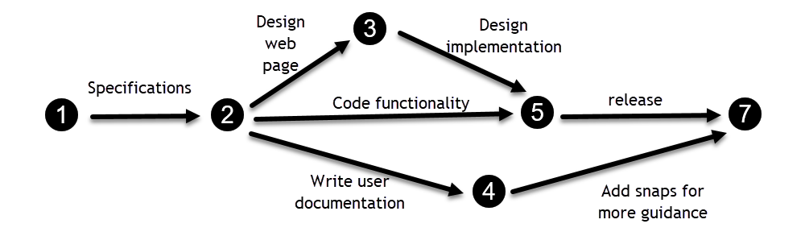

Figure - Pert chart

### 3.3.2 Feasibility Studies

After doing the project, study and analysing all the existing or required functionalities of the system, the next task is to do the feasibility study for the project.

The proposed solution should satisfy all the user requirements and should be flexible enough so that future changes can be easily done based on the future upcoming requirements.

#### 3.3.2.1. Economical Feasibility

* All hardware and software cost has to be minimum based on organization budget.
* We have to estimated that it will benefits the organization overall. The initial costs and the later on running cost for system will be minimum.

#### 3.3.2.2. Technical Feasibility

We have to study of function, performance and constraints that may affect the ability to achieve an acceptable system. For this feasibility study, we studied complete functionality to be provided in the system, and checked if everything was possible using different type of frontend and backend platform.

#### 3.3.2.3. Operational Feasibility

The proposed system is fully Web Based that is going to run inside of any browser, like firefox, safari, internet explorer, google chrome, etc. We will have an admin section for maintaining records so a proper training has been conducted to let know the essence of the system to the users so that they feel comfortable with new system.

asfd

## 3.4. Software and Hardware Requirements

### 3.4.1. HARDWARE

|  |  |
| --- | --- |
| Processor | Inter core 2 Duo or above |
| Memory | 2 GB RAM or above |
| Cache Memory | 128 KB or above |
| Hard Disk | 30 GB or above [at least 3 MB free space required] |
| Printer | Inkjet or laser printer |

### 3.4.2. SOFTWARE

|  |  |
| --- | --- |
| Operating System | Any of Windows, MAC, Linux Distribution (Recommended Windows 10) |
| Font End Languages & Technologies | HTML, CSS, JavaScript |
| Back End Languages & Technologies | PHP, SQL |
| Server | Any stack of (Linux, Apache, MySQL, PHP), i.e. XAMPP, WAMP, LAMP. (based on OS) |
| Code Editor | Sublime Text 3 |

## 3.5. Preliminary Product Description

### 3.5.1 Modules

* **Customer Module**

In this module, customer activities included. Customer can do such activities

* + Customer Login
  + Customer Registration
  + Customer Profile
  + Edit Profile
  + Logout
  + Add Product details
  + Request Fault Repair Service
  + Subscribe Maintenance Service
* **Website Module**

This module contains some static web pages for demonstrate information about organization.

* + Home
  + About
  + Contact
* **Admin Module**
  + Admin Login
  + Dashboard
  + View Customer List
  + Add / Edit / Delete Customer
  + View Product List
  + Add / Edit / Delete Product
  + View Employee List
  + Add / Edit / Delete Employee
  + View Product Category List
  + Add / Edit / Delete Product Category
  + View Maintenance Services List
  + Add / Edit / Delete Maintenance Service
  + View Fault Repair Service Request List
  + Add / Edit / Delete Fault Repair Service
  + Admin Logout

## 3.6. Conceptual Modals

### 3.6.1. DATA FLOW DIAGRAMS

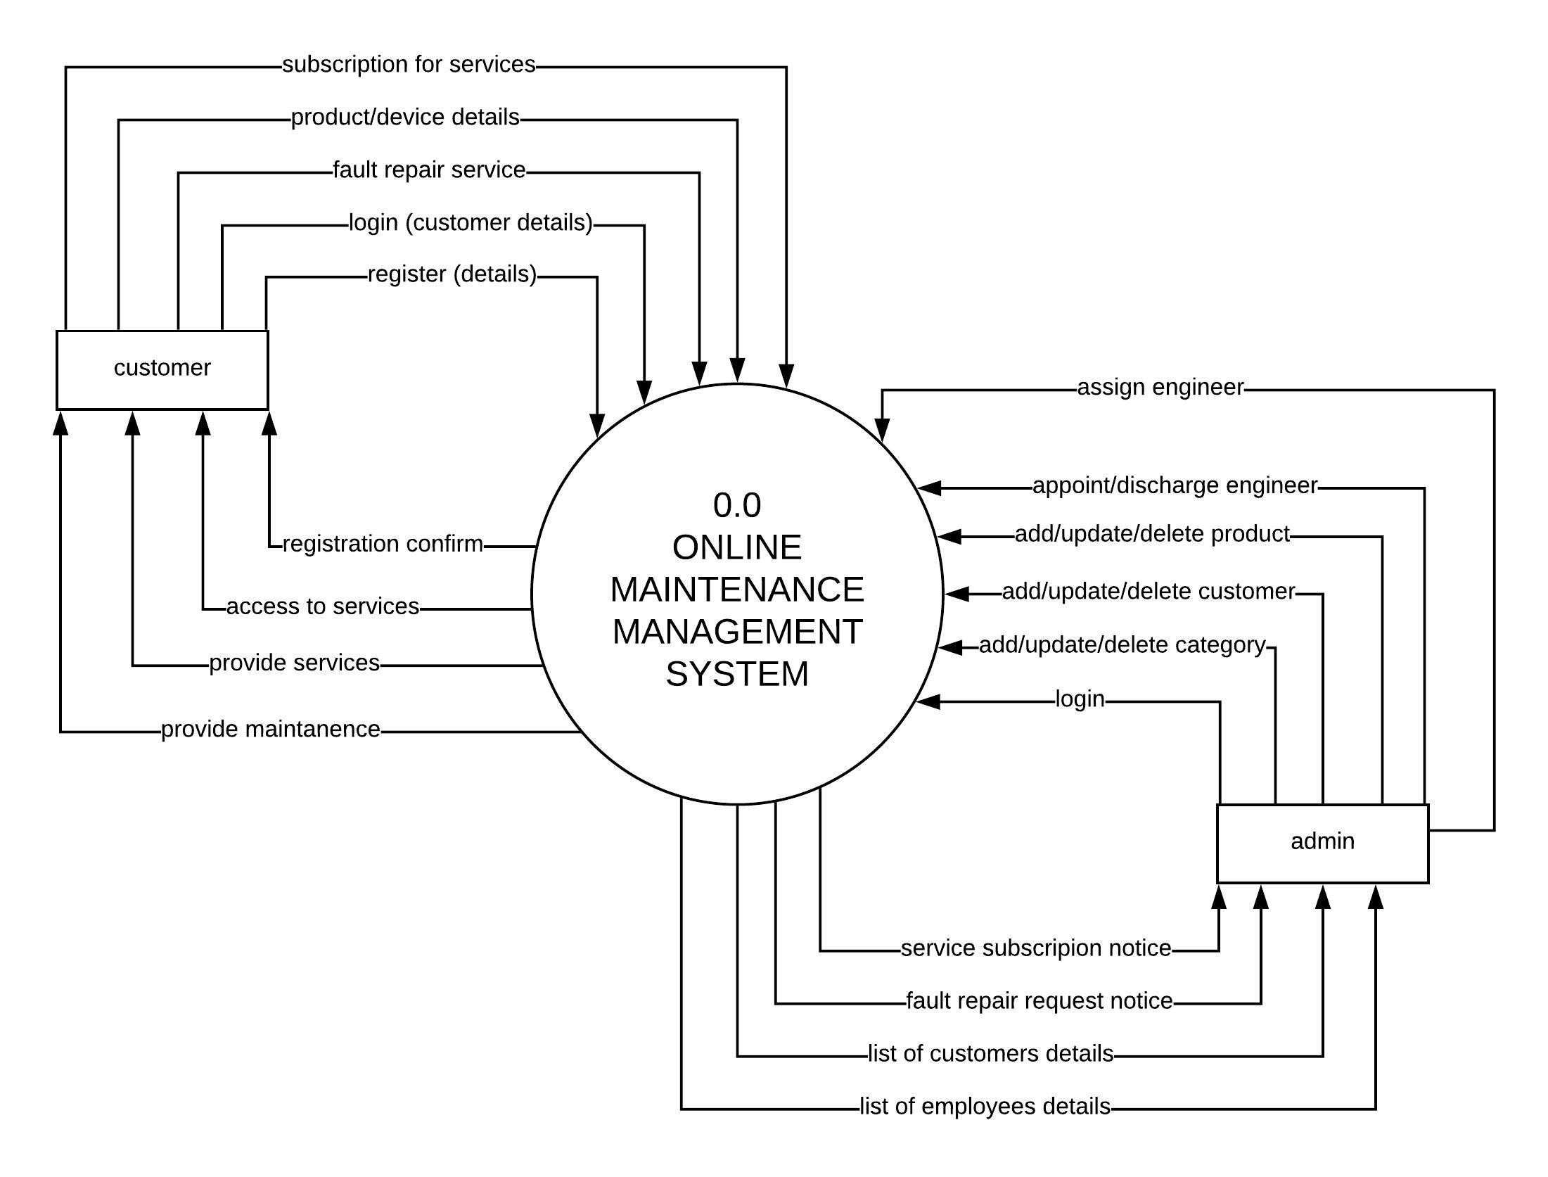

Figure – DFD Level 0

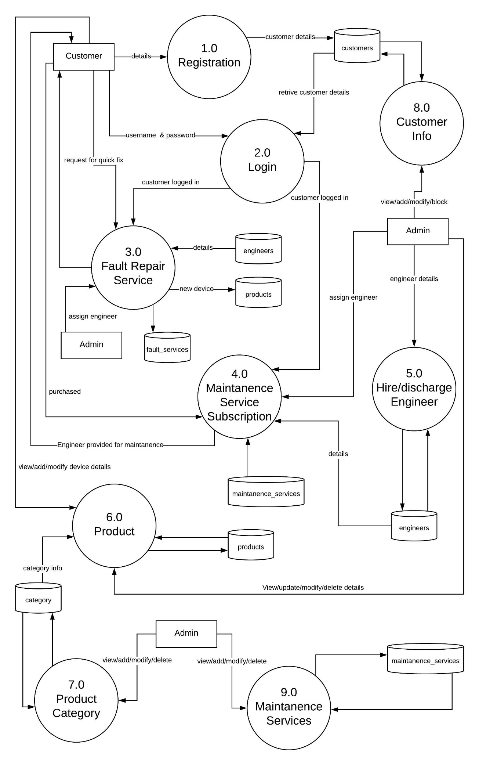

Figure – DFD LEVEL-1

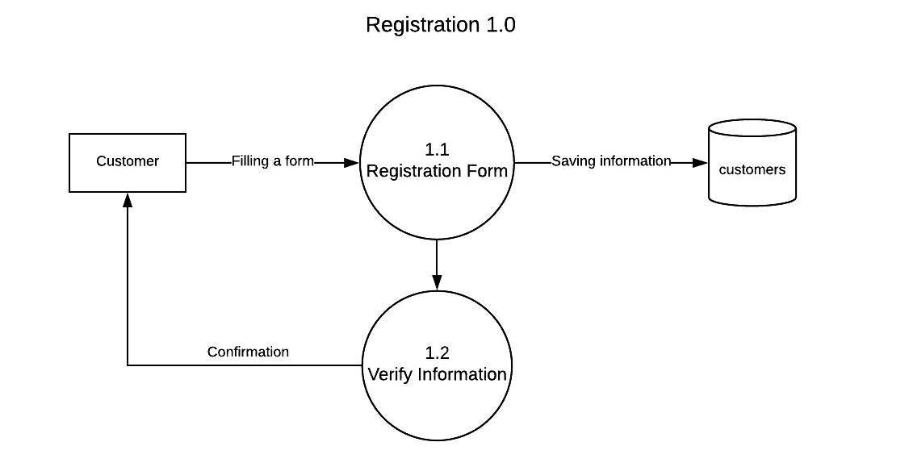

Figure – DFD Level-2 Registration 1.0

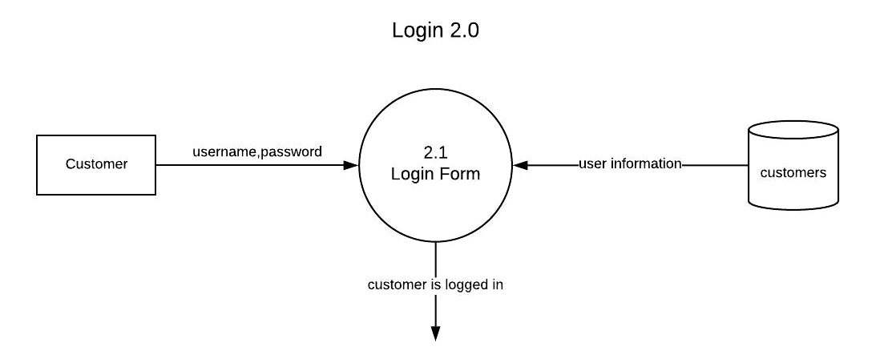

Figure – DFD Level-2 Login2.0

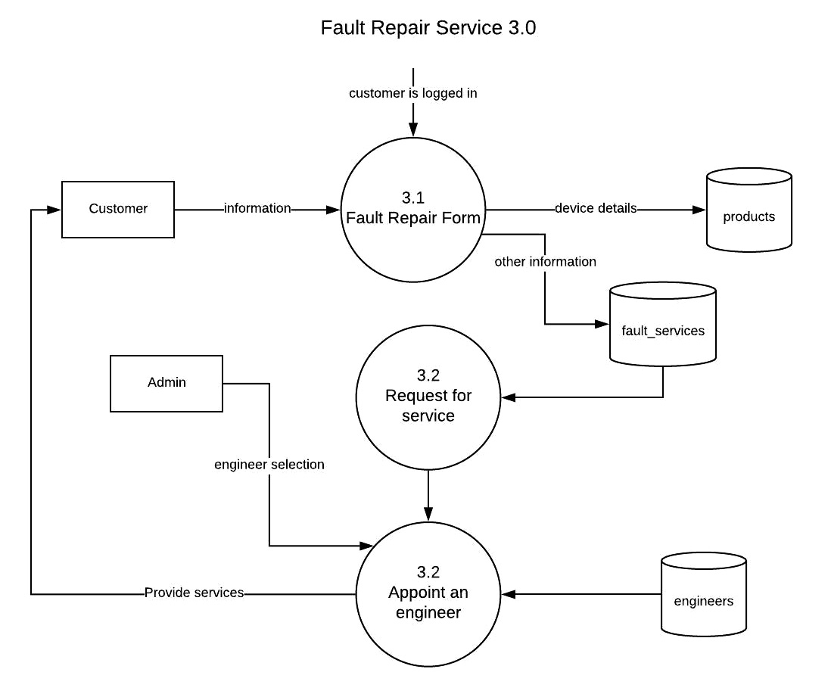

Figure – DFD Level-2 Fautl Repair Service 3.0

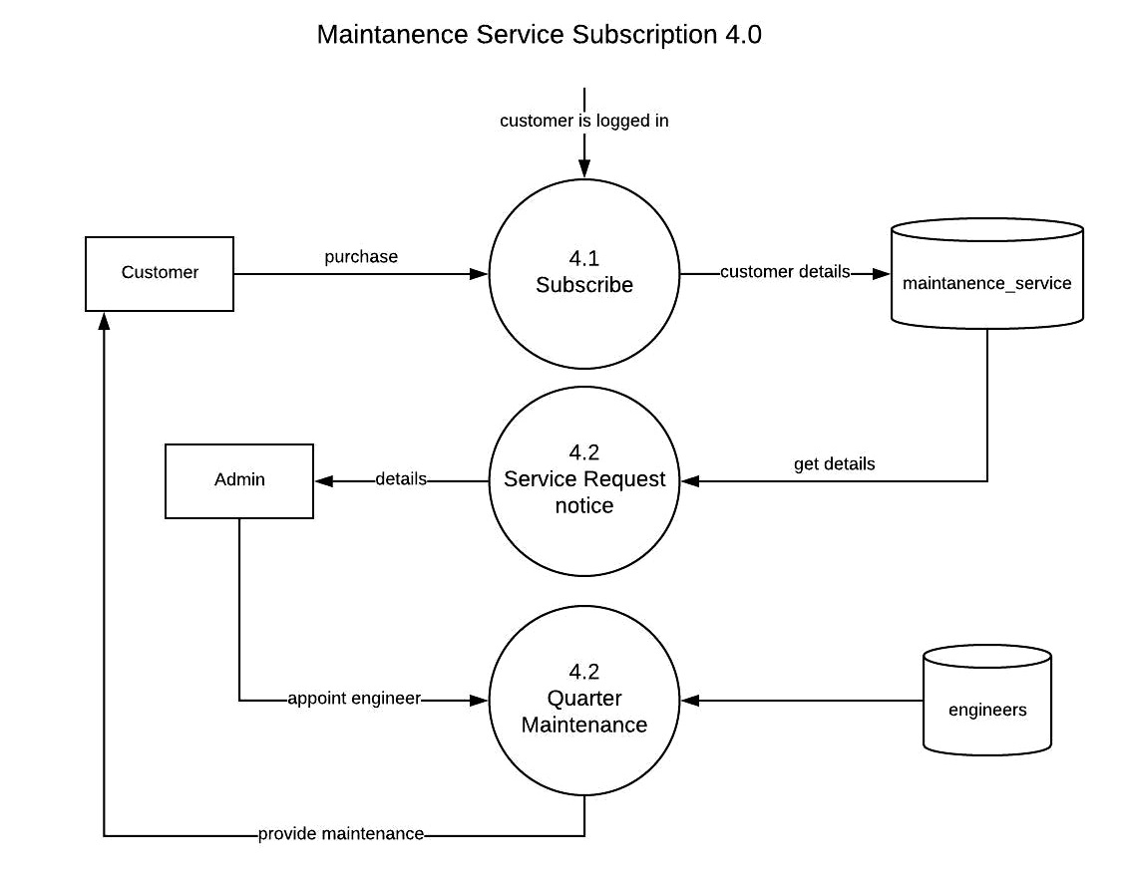

Figure – DFD Level-2 Maintanence Service Subscription 4.0

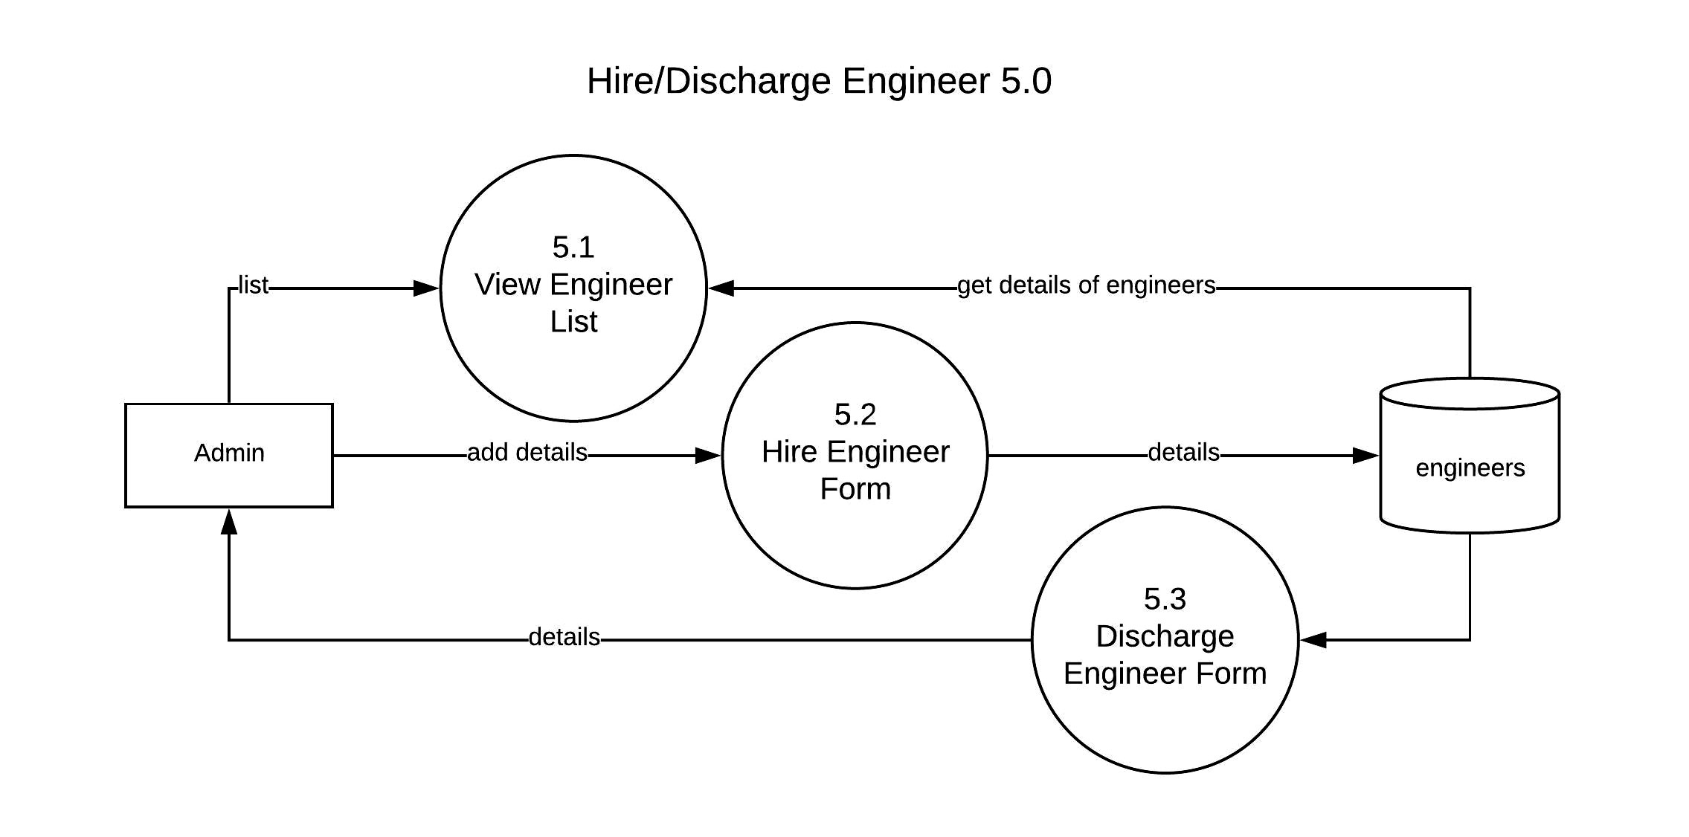

Figure – DFD Level-2 Hire/Discharge Engineer 5.0

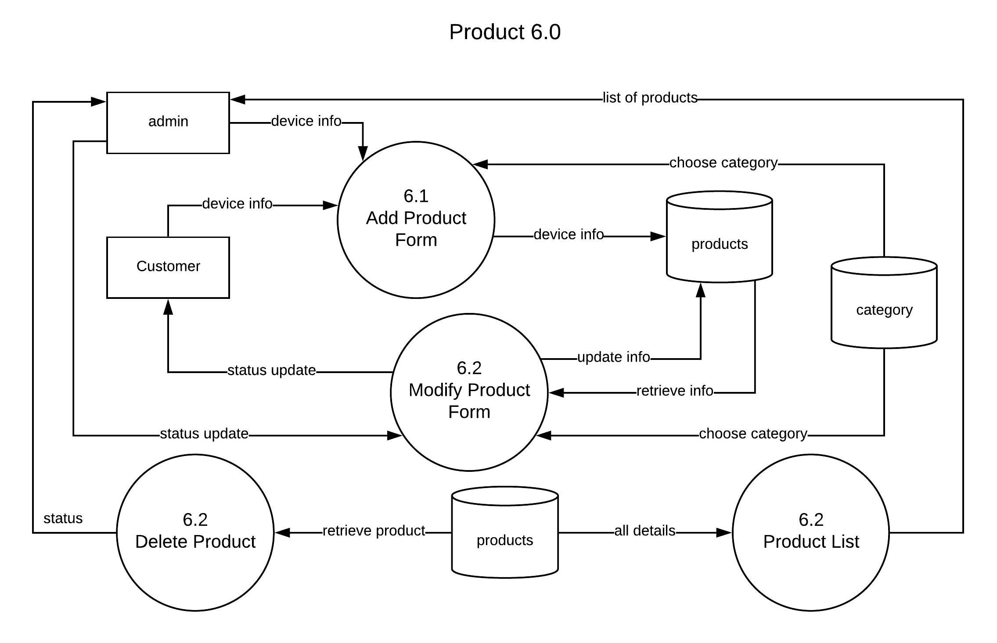

Figure – DFD Level-2 Product 6.0

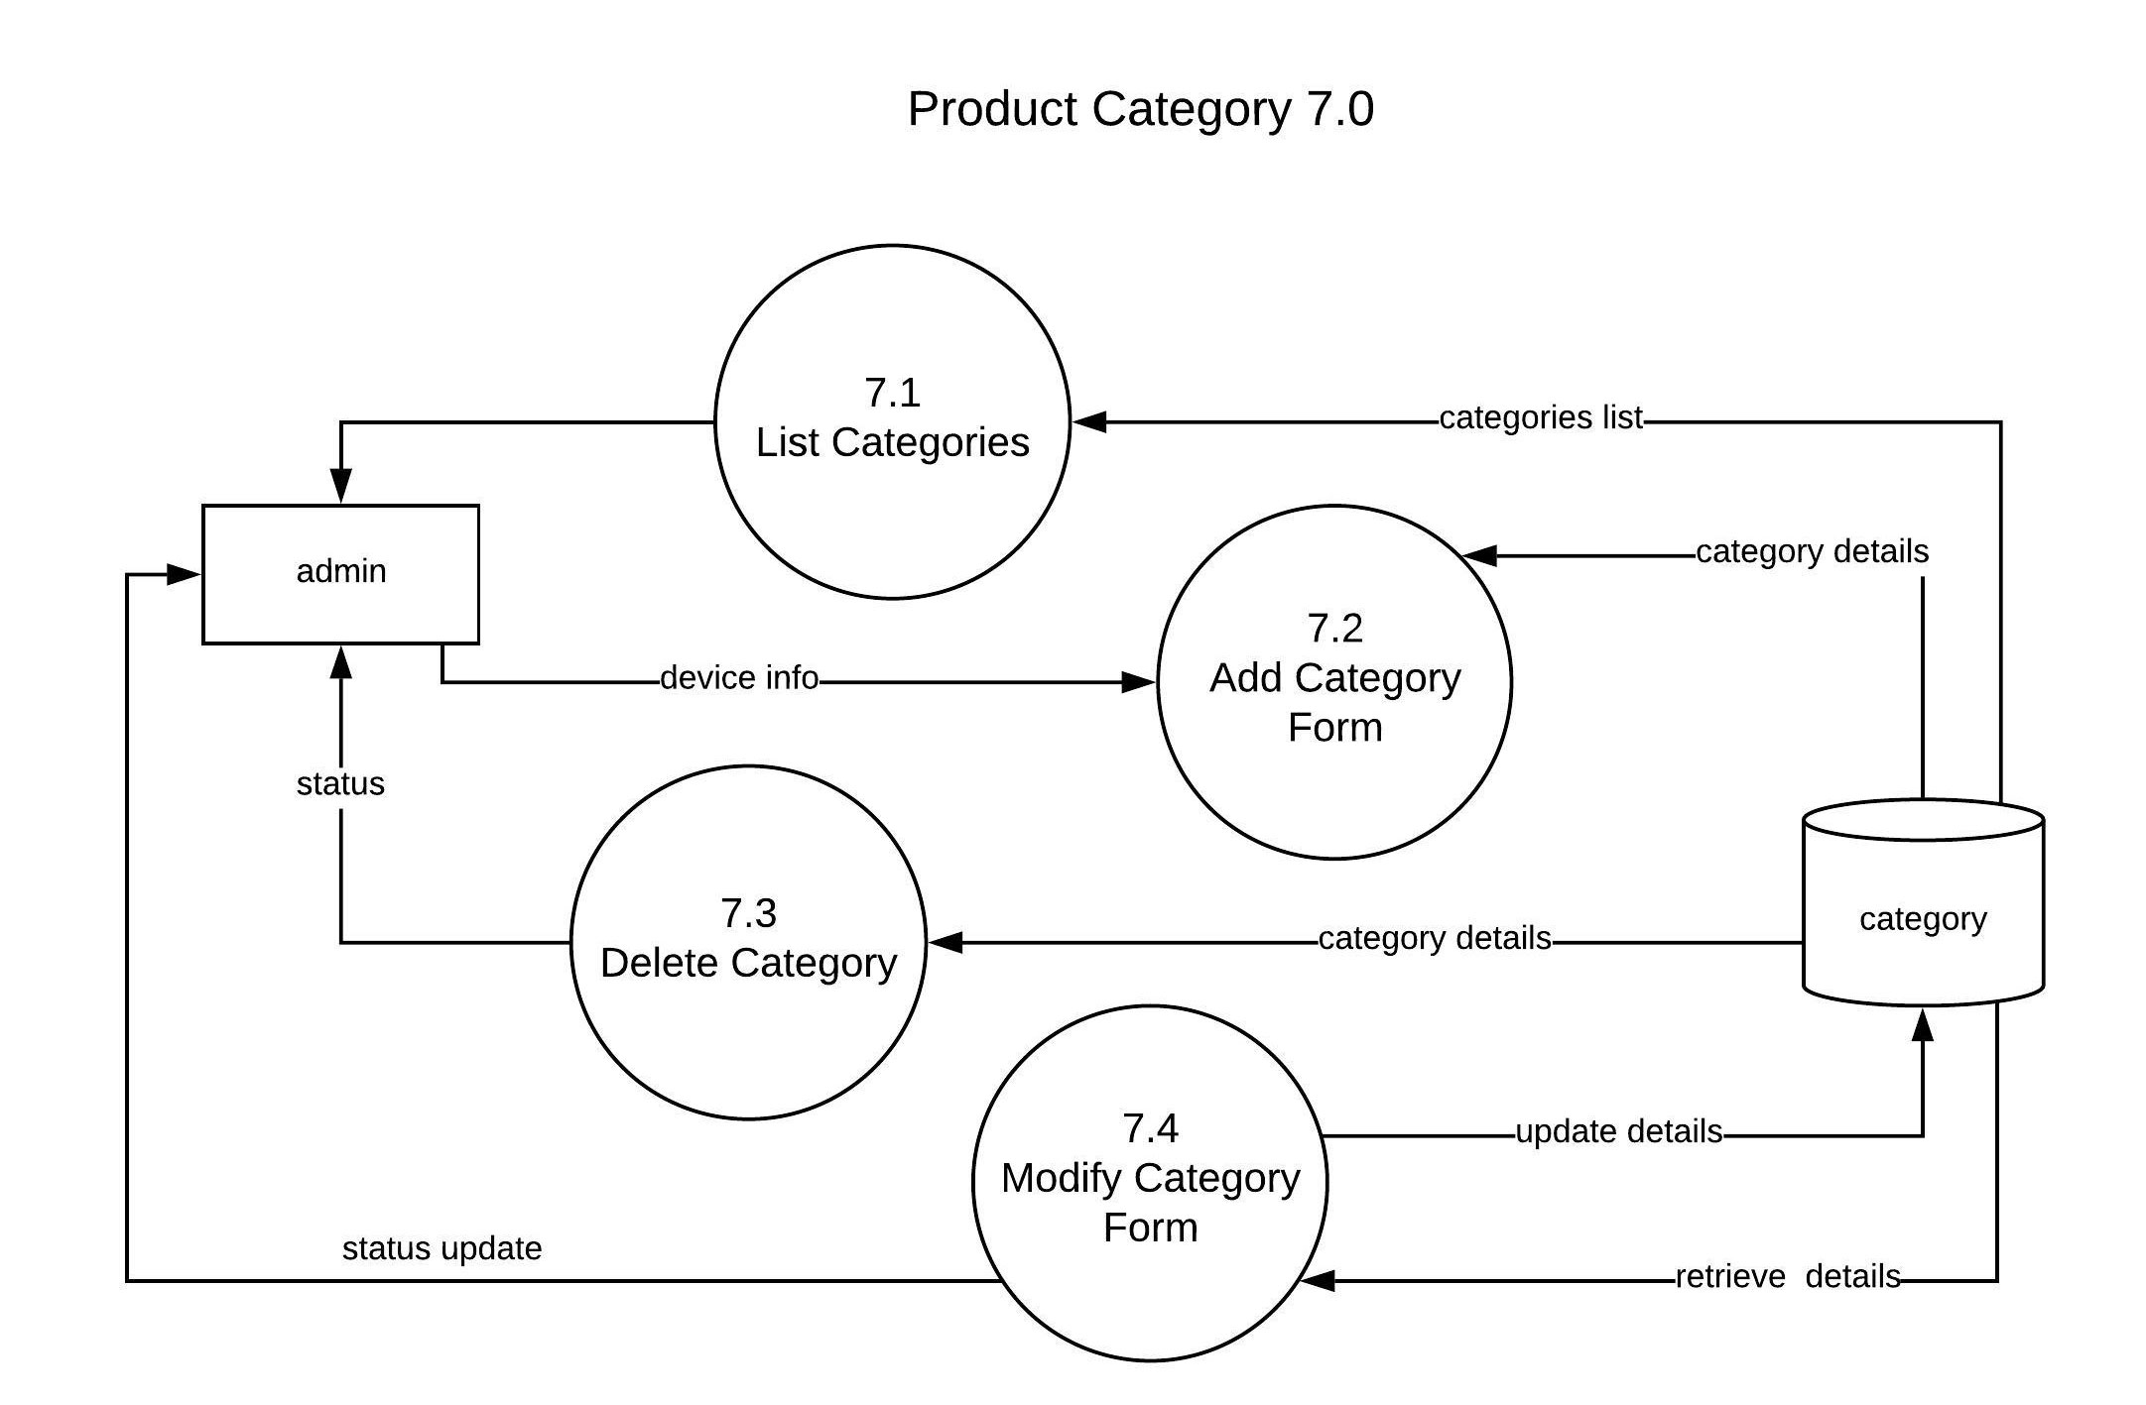

Figure – DFD Level-2 Product Category 7.0

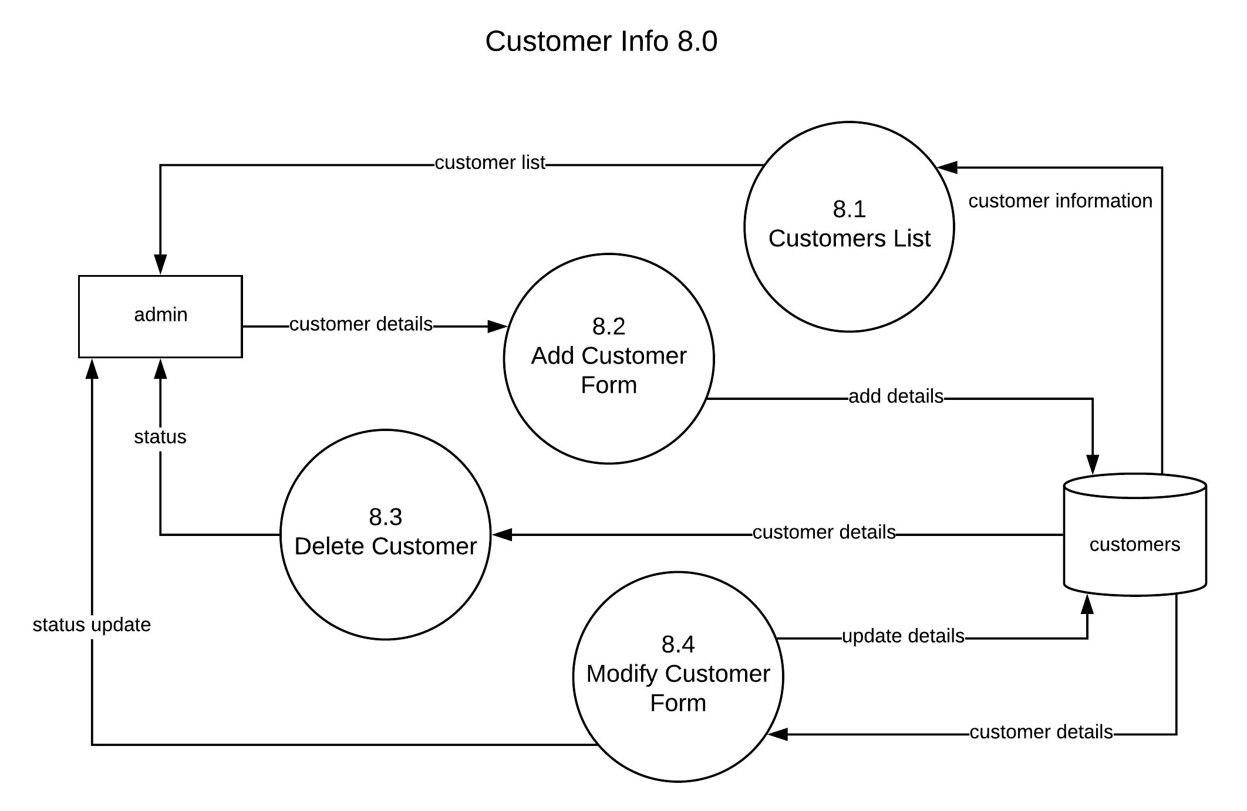

Figure – DFD Level-2 Customer Info 8.0

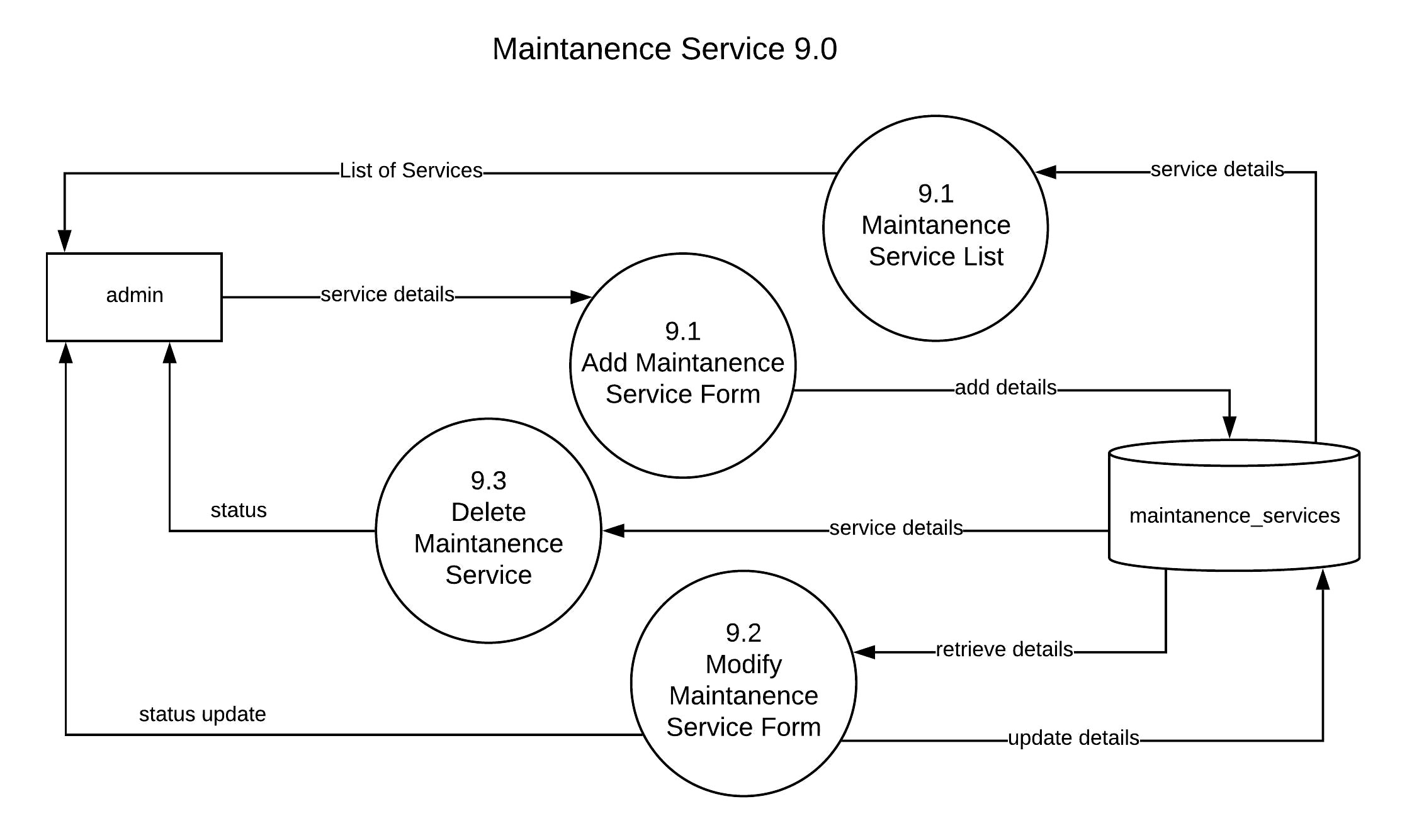

Figure – DFD Level-2 Maintenance Service 9.0

### 3.6.2. ER DIAGRAM

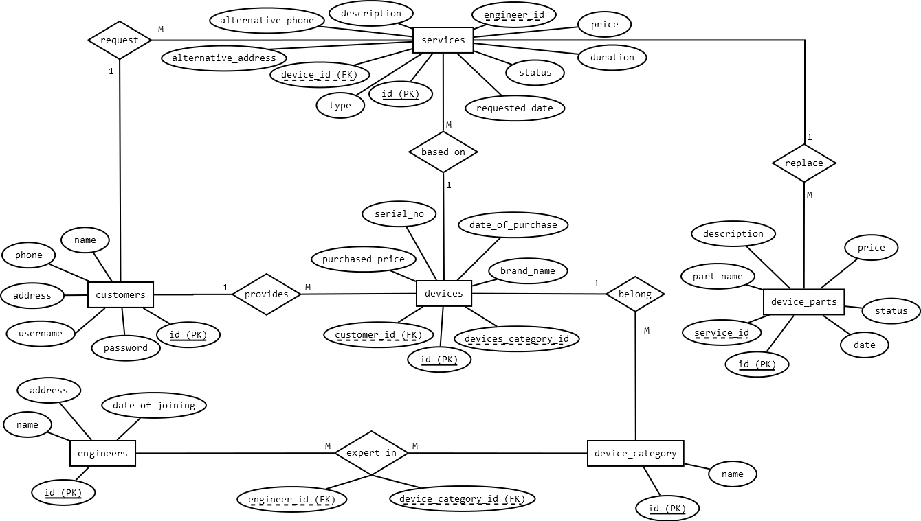

Figure - ER Diagram

# 4. SYSTEM DESIGN

## 4.1. Basic Modules

* **Admin Module :** This System is going to be supervise by System Admin, who is responsible for providing specialized engineers within organization based on customer request. Admin module will give administrator full control over managing customers & their devices, engineers & their category. He is also responsible for managing the team of engineers, therefore contacting customer and assigning engineer to repair device.
* **Customer Module :** Every customer must register first by filling information like username, password, name, address, phone number then login to system for requesting a maintenance services or fault repair service with details about device like brand name, product category, serial number, purchased price, date of purchase then his request will be viewed by administrator of site and contact back with support on provided phone number.
* **Website Module :** Those are some additional pages of Service Centre, that i think would be nice for telling about organization, like history, achievements, services offering, etc. Those will be simple static html pages.

## 4.2. Data Design

### 4.2.1. Schema Design

**Table 1:**

***customers ( id, username, password, name, address, phone )***

This table contains all records for customer, admin can add new customer based on there existing records, any customer can register online.

|  |  |  |  |
| --- | --- | --- | --- |
| **Field Name** | **Data Type** | **Description** | **Relation** |
| id | int(8) | Unique id for each record | Primary key |
| username | varchar(255) | It will be used for login after registration | Not Null |
| password | varchar(255) | It will be used for login after registration | Not Null |
| name | varchar(255) | Full Name of customer | Not Null |
| address | varchar(255) | Full Address of customer | Not Null |
| phone | varchar(50) | Contact details of customer | Not Null |

**Table 2:**

***devices ( id, customer_id, device_category_id, brand_name, serial_no, purchase_price, date_of_purchase )***

This table contains each device input by any customer or by admin.

|  |  |  |  |
| --- | --- | --- | --- |
| **Field Name** | **Data Type** | **Description** | **Relation** |
| id | int(8) | Unique id for each record | Primary key |
| customer_id | int(8) | Refer to owner of device, who requested repair | Foreign key |
| device_category_id | Int(8) | Category like, TV, Washine Machine, Regfrigerator, etc, which describe the product category | Foreign key |
| brand_name | varchar(255) | Name of manufacturer | Not Null |
| serial_no | varchar(255) | Serial Number of product if any. | Not Null |
| purchase_price | decimal(8,2) | Purchase price of product. | Not Null |
| date_of_purchase | Date | Date of purchase of product. | Not Null |

**Table 3:**

***device_category ( id, name )***

This table will be used to save device category as defined by administrator because he know what kinds of devices their staff can repair.

|  |  |  |  |
| --- | --- | --- | --- |
| **Field Name** | **Data Type** | **Description** | **Relation** |
| id | int(8) | Unique id for each record | Primary key |
| name | varchar(255) | Name of product category like, TV, Washing Machine, Refrigerator, Air Conditioners, Air Coolers, Microwave Ovens etc. | Not Null |

**Table 4:**

***services ( id, type, device_id, message, alternate_address, alternate_phone, status, requested_date )***

This table contains details of services requested by customer, specifically the fault repair services for their products.

|  |  |  |  |
| --- | --- | --- | --- |
| **Field Name** | **Data Type** | **Description** | **Relation** |
| id | int(8) | Unique Id for each record | Primary key |
| type | varchar(100) | A string value for identification of service type, for example ‘fault_repair’ or ‘maintenance’ | Not Null |
| device_id | int(8) | Reference of product that needed to be repaired | Foreign key |
| alternative_address | varchar(255) | An optional address if he request a service that have different address then his account | Not Null |
| alternative_phone | varchar(255) | An Optional phone number field if his phone is different | Not Null |
| description | varchar(255) | Customer describe about problems that are facing in device | Not Null |
| engineer_id | int(8) | Assigned engineer reference | Foreign Key |
| price | decimal(8,2) | Charged amount | Not Null |
| duration | int(8) | Number of years | Not Null |
| status | varchar(255) | This field indicate numbers of specific status message.  REQUESTED | ACCEPTED | IN PROGRESS | COMPLETE | COMPLETE & PAID | Not Null |
| requested_date | Date | Date or requesting for service | Current Date |

**Table 5:**

**engineers ( id, name, address, date_of_joining )**

This table keep track of available engineers.

|  |  |  |  |
| --- | --- | --- | --- |
| **Field Name** | **Data Type** | **Description** | **Relation** |
| id | int(8) | Reference of maintenance_service | Primary key |
| name | varchar(255) | Name of engineer | Not Null |
| address | varchar(255) | Address of engineer | Not Null |
| date_of_joining | Date | Date in which join the organisation | Date |

**Table 6:**

**engineers_expertise ( device_category_id, engineer_id )**

This table keep track our engineer skill set, for example one engineer can repair only TV, other can repair TV and Microwaves, etc. This table will contains relationship between engineers and device_category table.

|  |  |  |  |
| --- | --- | --- | --- |
| **Field Name** | **Data Type** | **Description** | **Relation** |
| device_category_id | int(8) | Reference of device_category | Foreign key |
| engineer_id | int(8) | Reference of engineer | Foreign key |

**Table 7:**

**device_parts ( id, service_id, part_name, description, price, status, date )**

This table is goint to maintain records for parts repaired during both fault reqair, and maintenance of devices.

|  |  |  |  |
| --- | --- | --- | --- |
| **Field Name** | **Data Type** | **Description** | **Relation** |
| id | int(8) | Unique id of part | Primary key |
| service_id | int(8) | Reference of requested service, in which replaced | Foreign key |
| part_name | varchar(255) | Name of part | Not Null |
| description | varchar(255) | Any engineer notes, like if he had repair part at component level, etc | Not Null |
| price | decimal(8,2) | Total cost of part or total charged amount in case of repaired one | Not Null |
| status | varchar(100) | This is used to defined only payments in maintenance of service, because part replacement is not free of cost in that service, we have to collect each of them, if leave blanked means not paid or if paied then string “PAID” | Not Null |
| date | date | This date will be used to calculate 2 month warrenty of each replaced or repaired parts within customer’s devices | CURRENT DATE |

## 4.4. User interface design

Model View Controller or MVC as it is popularly called, is a software design pattern for developing web applications. A Model View Controller pattern is made up of the following three parts:

* **Model :** The lowest level of the pattern which is responsible for maintaining data.
* **View :** This is responsible for displaying all or a portion of the data to the user.
* **Controller :** Software Code that controls the interactions between the Model and View.

MVC is popular as it isolates the application logic from the user interface layer and supports separation of concerns. Here the Controller receives all requests for the application and then works with the Model to prepare any data needed by the View. The View then uses that data prepared by the Controller to generate a final representable response. The MVC abstraction can be graphically represented as follows.

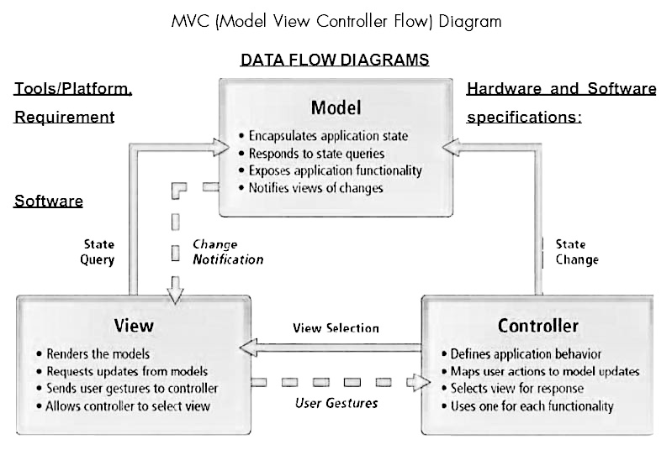

Figure - MVC Diagram

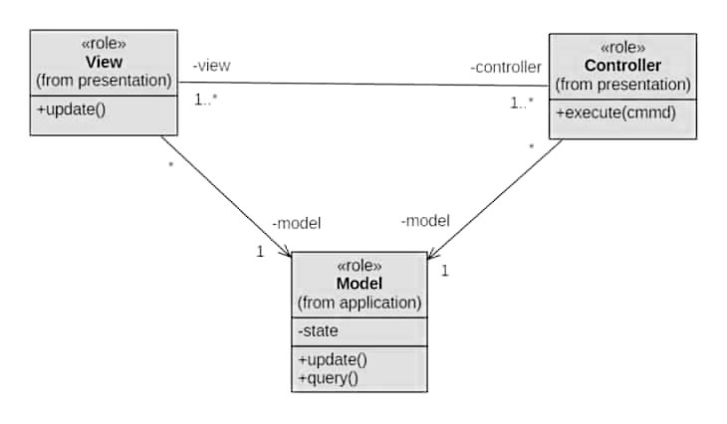

Figure MVC class-diagram

## 4.6. Test Cases Design

**What is Test Case?**

A Test Case is a set of actions executed to verify a particular feature or functionality of your software application.

Now, consider the Test Scenario Check Login Functionality there many possible cases like

**Test Case 1:** Check results on entering valid Username& Password

**Test Case 2:** Check results on entering Invalid Username & Password

**Test Case 3:** Check response when Username is Empty & Login Button is pressed, and many more.

|  |  |  |  |  |
| --- | --- | --- | --- | --- |
| **Test Case ID** | **Test Data** | **Expected Result** | **Actual Result** | **Pass/Fail** |
| TU01 | username:sorabh,  password:sorabh | User should login into system | As Expected | Pass |
| TU02 | username:sorabh,  password:12345 | User shouldn’t login to system | As Expected | Pass |

# 5. IMPLEMENTATION AND TESTING

## 5.1. Implementation Approaches

Waterfall approach was first SDLC Model to be used widely in Software Engineering to ensure success of the project. In "The Waterfall" approach, the whole process of software development is divided into separate phases. In this Waterfall model, typically, the outcome of one phase acts as the input for the next phase sequentially.



Figure - Water Fall Model

The sequential phases in Waterfall model are −

* **Requirement Gathering and analysis** − All possible requirements of the system to be developed are captured in this phase and documented in a requirement specification document.
* **System Design** − The requirement specifications from first phase are studied in this phase and the system design is prepared. This system design helps in specifying hardware and system requirements and helps in defining the overall system architecture.
* **Implementation** − With inputs from the system design, the system is first developed in small programs called units, which are integrated in the next phase. Each unit is developed and tested for its functionality, which is referred to as Unit Testing.
* **Integration and Testing** − All the units developed in the implementation phase are integrated into a system after testing of each unit. Post integration the entire system is tested for any faults and failures.
* **Deployment of system** − Once the functional and non-functional testing is done; the product is deployed in the customer environment or released into the market.
* **Maintenance** − There are some issues which come up in the client environment. To fix those issues, patches are released. Also to enhance the product some better versions are released. Maintenance is done to deliver these changes in the customer environment.

**Why to choose WATER FALL MODEL?**

It is always a good choice to go with water fall model, where all requirements are clear and probabilities of risk factor is minimal.

In this project, we had to organized data of a service centre which didn’t have any relation to creating a big algorithm implementation. After visiting a service centre, I understands most important problem in a service provider is to maintain records of data. That is conclude that, we are good with water fall model here.

## 5.2. Coding Details and Code Efficiency

### 5.2.1. Coding Details

**Folder Structure :**

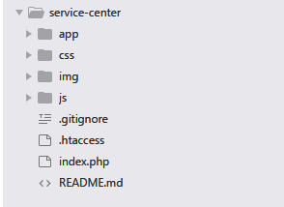

Code are well maintained on GitHub, you can download via link : <https://github.com/sorabh86/servicecenter/tree/sideways>

Here, i am going to explain short description about folder structure of our project. More description will be explained later with source code of each files.

1. **app folder** is contains our custom MVC workflow, it have all php files, classes, controllers, models, views, and database files

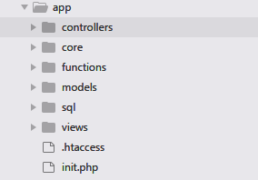

**controllers folder :** This folder contains controllers, role of a controller class is to behave like an interface between model and view, based on request, each request will be first received by a controller class and then based on request class call a method automatically, this method collects data from models and pass it to views and render views as a HTML web page.

We have following controllers in our folder

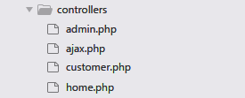

*admin.php*

<?php

*/\*\**

*\* Your All admin Modules will be handled by this controller*

*\*/*

**class** **Admin** **extends** Controller {

**public** **function** index () {

$this->checklogin();

$this->managecategory();

}

*// important function for checking if login or not*

**private** **function** checklogin() {

**if**(!isset($_SESSION['admin'])) {

$this->redirect('admin/login');

**exit**();

}

}

**public** **function** login () {

**if**(isset($_SESSION['admin']))

$this->redirect('admin/index');

**if**(isset($_POST['username']) && isset($_POST['password'])) {

$admin = $this->model('AdminModel');

**if**($_POST['username'] == $admin->username && $_POST['password'] == $admin->password) {

$_SESSION['admin'] = [

'name' => $admin->name,

'post' => $admin->post

];

$this->redirect('admin');

**exit**();

} **else** {

$this->view('admin/layout/header');

$this->view('admin/login', **array**(

'error' => "Invalid Username or Password."

));

$this->view('admin/layout/footer');

**exit**();

}

}

$this->view('admin/layout/header');

$this->view('admin/login');

$this->view('admin/layout/footer');

}

**public** **function** logout (){

**if**(isset($_SESSION['admin']))

unset($_SESSION['admin']);

$this->redirect('admin/login');

}

*/\*\**

*\* Manage Category of devices that organization repairs*

*\*/*

**public** **function** managecategory() {

$this->checklogin();

$catModel = $this->model('CategoryModel');

**if**(isset($_POST['submit'])) {

$name = $_POST['name'];

**if**($name != '') {

$catModel->insert_category($name);

}

}

$cat = $catModel->get_categories();

*// just rendering static html view*

$this->view('admin/layout/header');

*// rendering html view, based on passing array values*

$this->view('admin/layout/sidelink', **array**(

"mcat" => **true**

));

$this->view('admin/managecategory', **array**(

'cat' => $cat

));

$this->view('admin/layout/footer');

}

**public** **function** deletecategory() {

$this->checklogin();

**if**(isset($_GET['id'])) {

$catModel = $this->model('CategoryModel');

$catModel->delete_by_id($_GET['id']);

}

$this->redirect('admin/managecategory');

**exit**();

}

*/\*\**

*\* Manage devices or device added by customer or added by admin*

*\*/*

**public** **function** managedevice() {

$this->checklogin();

$prodModel = $this->model('DeviceModel');

$devices = $prodModel->get_devices();

$this->view('admin/layout/header');

$this->view('admin/layout/sidelink', **array**(

"mdevice" => **true**

));

$this->view('admin/managedevice', **array**(

'devices' => $devices

));

$this->view('admin/layout/footer');

}

**public** **function** adddevice() {

$this->checklogin();

$post = $_POST;

**if**(isset($post['submit'])) {

$prodModel = $this->model('DeviceModel');

$status =$prodModel->insert_device($post);

**if**($status->error) {

**echo** '<br> fail'.$status->message;

} **else** {

**echo** '<br> success';

$this->redirect('admin/managedevice');

**exit**();

}

}

$catModel = $this->model('CategoryModel');

$categories = $catModel->get_categories();

$custModel = $this->model('CustomerModel');

$customers = $custModel->get_customers();

$this->view('admin/layout/header');

$this->view('admin/adddevice', **array**(

'customers' => $customers,

'cat' => $categories

));

$this->view('admin/layout/footer');

}

**public** **function** editdevice() {

$this->checklogin();

**if**(!isset($_GET['id']))

$this->redirect('admin/managedevice');

$prodModel = $this->model('DeviceModel');

$device = $prodModel->get_by_id($_GET['id']);

**if**(isset($_POST['submit'])) {

$status = $prodModel->update_device($_POST);

**if**($status->error) {

**echo** '<br> fail:'.$status->message;

} **else** {

**echo** "<br> success";

$this->redirect('admin/managedevice');

**exit**();

}

}

$catModel = $this->model('CategoryModel');

$categories = $catModel->get_categories();

$custModel = $this->model('CustomerModel');

$customers = $custModel->get_customers();

$this->view('admin/layout/header');

$this->view('admin/editdevice', **array**(

'customers' => $customers,

'cat' => $categories,

'device' => $device

));

$this->view('admin/layout/footer');

}

**public** **function** deletedevice() {

$this->checklogin();

**if**(!isset($_GET['id']))

$this->redirect('admin/managedevice');

$prodModel = $this->model('DeviceModel');

$status = $prodModel->delete_by_id($_GET['id']);

**if**($status->error) {

**echo** '<br> fail:'.$status->message;

} **else** {

**echo** "<br> success";

$this->redirect('admin/managedevice');

**exit**();

}

}

*/\*\**

*\* Manage customers*

*\*/*

**public** **function** managecustomer() {

$this->checklogin();

$custModel = $this->model('CustomerModel');

$customers = $custModel->get_customers();

$this->view('admin/layout/header');

$this->view('admin/layout/sidelink', **array**(

"mcustomers" => **true**

));

$this->view('admin/managecustomer', **array**(

'customers' => $customers

));

$this->view('admin/layout/footer');

}

**public** **function** viewcustomer() {

$this->checklogin();

**if**(!isset($_GET['id']))

$this->redirect('admin/managecustomer');

$custModel = $this->model('CustomerModel');

$customer = $custModel->get_by_id($_GET['id']);

$prodModel = $this->model('DeviceModel');

$devices = $prodModel->get_by_customer_id($_GET['id']);

$serModel = $this->model('ServiceModel');

$faults = $serModel->get_by_customer_id('fault_repair', $_GET['id']);

$services = $serModel->get_by_customer_id('maintenance', $_GET['id']);

$this->view('admin/layout/header');

$this->view('admin/layout/sidelink', **array**(

"mcustomers" => **true**

));

$this->view('admin/viewcustomer', **array**(

'customer' => $customer,

'devices' => $devices,

'faults' => $faults,

'services' => $services

));

$this->view('admin/layout/footer');

}

**public** **function** addcustomer() {

$this->checklogin();

**if**(isset($_POST['submit'])) {

$custModel = $this->model('CustomerModel');

$status = $custModel->insert_customer($_POST);

**if**($status->error) {

**echo** 'Fail : '.$status->message;

} **else** {

**echo** 'Success';

$this->redirect('admin/managecustomer');

**exit**();

}

}

$this->view('admin/layout/header');

$this->view('admin/addcustomer');

$this->view('admin/layout/footer');

}

**public** **function** editcustomer() {

$this->checklogin();

**if**(!isset($_GET['id']))

$this->redirect('admin/managecustomer');

$custModel = $this->model('CustomerModel');

**if**(isset($_POST['submit'])) {

$status = $custModel->update_customer($_POST);

**if**($status->error) {

**echo** 'Fail : '.$status->message;

} **else** {

**echo** 'Success';

$this->redirect('admin/managecustomer');

**exit**();

}

}

$customer = $custModel->get_by_id($_GET['id']);

$this->view('admin/layout/header');

$this->view('admin/editcustomer', **array**(

'customer' => $customer

));

$this->view('admin/layout/footer');

}

*/\*\**

*\* Manage engineers*

*\*/*

**public** **function** manageengineer() {

$this->checklogin();

$engModel = $this->model('EngineerModel');

$engineers = $engModel->get_engineers();

$this->view('admin/layout/header');

$this->view('admin/layout/sidelink', **array**(

"mengineers" => **true**

));

$this->view('admin/manageengineer', **array**(

'engineers' => $engineers

));

$this->view('admin/layout/footer');

}

**public** **function** addengineer() {

$this->checklogin();

**if**(isset($_POST['submit'])) {

$engModel = $this->model('EngineerModel');

$engineer = $engModel->insert_engineer($_POST);

**foreach**($_POST['expertise'] **as** $cat_id) {

$engModel->insert_expertise($engineer->id, $cat_id);

}

$this->redirect('admin/manageengineer');

**exit**();

}

$catModel = $this->model('CategoryModel');

$cat = $catModel->get_categories();

$this->view('admin/layout/header');

$this->view('admin/addEngineer', **array**(

'cat' => $cat

));

$this->view('admin/layout/footer');

}

**public** **function** editengineer() {

$this->checklogin();

**if**(!isset($_GET['id']))

$this->redirect('admin/manageengineer');

$engModel = $this->model('EngineerModel');

$engineer = $engModel->get_by_id($_GET['id']);

**if**(isset($_POST['submit'])) {

$status = $engModel->update_engineer($_POST);

**if**($status->error) {

**echo** $status->message;

**exit**();

}

$this->redirect('admin/manageengineer');

**exit**();

}

$this->view('admin/layout/header');

$this->view('admin/editEngineer', **array**('engineer'=>$engineer));

$this->view('admin/layout/footer');

}

**public** **function** deleteengineer() {

$this->checklogin();

**if**(!isset($_GET['id']))

$this->redirect('admin/manageengineer');

$engModel = $this->model('EngineerModel');

$status = $engModel->delete_by_id($_GET['id']);

**if**(!$status->error) {

$st = $engModel->delete_expertise_by_engineer_id($_GET['id']);

**if**(!$st->error) {

$this->redirect('admin/manageengineer');

} **else** {

**die**('#Error : '.$st->message.' <a href="'.SC_URL.'admin/manageengineer">go back</a>');

}

} **else** {

**die**('#Error : '.$status->message.' <a href="'.SC_URL.'admin/manageengineer">go back</a>');

}

}

*/\*\**

*\* Manage Fault Request*

*\*/*

**public** **function** managefault() {

$this->checklogin();

$serviceModel = $this->model('ServiceModel');

$faults = $serviceModel->get_services('fault_repair');

$this->view('admin/layout/header');

$this->view('admin/layout/sidelink', **array**(

"mfault" => **true**

));

$this->view('admin/managefault',**array**(

'faults' => $faults

));

$this->view('admin/layout/footer');

}

**public** **function** addfault() {

$this->checklogin();

**if**(isset($_POST['submit'])) {

$serModel = $this->model('ServiceModel');

$status = $serModel->request_service($_POST);

**if**($status->error) {

**die**('#Error: '.$status->message.'; Go Back <a href="'.SC_URL.'admin/managefault">here</a>');

}

$this->redirect('admin/managefault');

**exit**();

}

$prodModel = $this->model('DeviceModel');

$devices = $prodModel->get_devices();

$this->view('admin/layout/header');

$this->view('admin/addfault', **array**(

'devices' => $devices

));

$this->view('admin/layout/footer');

}

**public** **function** viewfault() {

$this->checklogin();

**if**(!isset($_GET['id']))

$this->redirect('admin/managefault');

$serModel = $this->model('ServiceModel');

*// change status to paid*

**if**(isset($_POST['submit-paid'])) {

$serModel->set_status($_POST);

}

*// assign engineer, service charge and give approval*

**if**(isset($_POST['submit-approve'])) {

$serModel->fault_approve($_POST);

}

$parts = **null**;

$engineers = **null**;

$stat = $serModel->get_status('fault_repair', $_GET['id']);

**if**($stat->status == 'REQUESTED') {

$fault = $serModel->get_by_id('fault_repair', $_GET['id']);

**if**(isset($fault->error) && $fault->error) **die**('Error: '.$fault->message);

$engModel = $this->model('EngineerModel');

$engineers = $engModel->get_by_device_category_id($fault->device_category_id);

} **else** {

$fault = $serModel->get_by_id_approved('fault_repair', $_GET['id']);

**if**(isset($fault->error) && $fault->error) **die**('Error: '.$fault->message);

$devModel = $this->model('DeviceModel');

$parts = $devModel->get_part_by_service_id($_GET['id']);

}

$this->view('admin/layout/header');

$this->view('admin/viewfault',**array**(

'fault' => $fault,

'engineers' => $engineers,

'parts' => $parts

));

$this->view('admin/layout/footer');

}

**public** **function** adddevicepart() {

$this->checklogin();

**if**(!isset($_GET['id']))

$this->redirect('admin');

$serModel = $this->model('ServiceModel');

$type = $serModel->get_type($_GET['id'])->type;

$page= 'managefault';

$redpage = 'viewfault';

**if**(isset($type)) {

**if**($type == 'maintenance') {

$page = 'managemaintain';

$redpage = 'viewmaintain';

}

}

**if**(isset($_POST['submit'])) {

$devModel = $this->model('DeviceModel');

$stat = $devModel->insert_part($_POST);

**if**($stat->error)

**die**('Error: '.$stat->message.'. <a href="'.SC_URL.'admin/viewfault?id='.$_GET['id'].'" >goback</a>');

$this->redirect('admin/'.$redpage.'?id='.$_GET['id']);

**exit**();

}

$this->view('admin/layout/header');

$this->view('admin/adddevicepart',**array**('page'=>$page));

$this->view('admin/layout/footer');

}

**public** **function** deletedevicepart() {

$this->checklogin();

**if**(isset($_GET['id'])) {

$serModel = $this->model('ServiceModel');

$type = $serModel->get_type($_GET['sid'])->type;

$redpage = 'viewfault';

**if**(isset($type)) {

**if**($type == 'maintenance')

$redpage = 'viewmaintain';

}

$devModel = $this->model('DeviceModel');

$stat = $devModel->delete_part_by_id($_GET['id']);

**if**($stat->error)

**die**('Error: '.$stat->message.'. <a href="'.SC_URL.'admin/'.$redpage.'?id='.$_GET['sid'].'" >goback</a>');

$this->redirect('admin/'.$redpage.'?id='.$_GET['sid']);

**exit**();

}

}

**public** **function** rejectfault() {

$this->checklogin();

**if**(isset($_GET['id'])) {

$serModel = $this->model('ServiceModel');

$status = $serModel->reject($_GET['id']);

**if**(isset($status->error) && $status->error)

**die**('#Error: '.$status->message.' occured: go back <a href="'.SC_URL.'admin">here</a>');

}

$this->redirect('admin/managefault');

**exit**();

}

**public** **function** faultbill() {

$this->checklogin();

$serModel = $this->model('ServiceModel');

$stat = $serModel->get_status('fault_repair', $_GET['id']);

$service = $serModel->get_by_id_approved('fault_repair', $_GET['id']);

**if**(isset($service->error) && $service->error) **die**('Error: '.$fault->message);

$devModel = $this->model('DeviceModel');

$parts = $devModel->get_part_by_service_id($_GET['id']);

**if**(isset($parts->error) && $parts->error) **die**('Error: '.$parts->message);

$this->view('admin/billtemplate',**array**(

'page' => 'viewfault',

'status' => $stat->status,

'service' => $service,

'parts' => $parts

));

}

*/\*\**

*\* Manage maintenance services*

*\*/*

**public** **function** managemaintain() {

$this->checklogin();

$serviceModel = $this->model('ServiceModel');

$services = $serviceModel->get_services('maintenance');

**if**(isset($services->error) && $services->error) **die**('Error:'.$services->message.'. <a href="admin/managemaintain">go back</a>');

$this->view('admin/layout/header');

$this->view('admin/layout/sidelink', **array**(

"mmaintain" => **true**

));

$this->view('admin/managemaintain',**array**(

'services' => $services

));

$this->view('admin/layout/footer');

}

**public** **function** addmaintain() {

$this->checklogin();

**if**(isset($_POST['submit'])) {

$serviceModel = $this->model('ServiceModel');

$_POST['alternative_address'] = '';

$_POST['alternative_phone'] = '';

$stat = $serviceModel->insert_approved($_POST);

**if**(isset($stat) && $stat->error) **die**('Error: '.$stat->message.'. <a href="'.SC_URL.'admin/managemaintain">goback</a>');

$this->redirect('admin/managemaintain');

**exit**();

}

$devModel = $this->model('DeviceModel');

$devices = $devModel->get_devices();

**if**(isset($devices->error) && $devices->error) **die**('Error: '.$devices->message.'. <a href="'.SC_URL.'admin/managemaintain">go back</a>');

$engModel = $this->model('EngineerModel');

$device_category_id = $devices[0]->device_category_id;

$engineers = $engModel->get_by_device_category_id($device_category_id);

**if**($engineers->error) **die**('#Error: '.$engineers->message.' <a href="'.SC_URL.'admin/managemaintain">go back</a>');

$this->view('admin/layout/header');

$this->view('admin/addmaintain',**array**(

'devices'=>$devices,

'engineers'=>$engineers

));

$this->view('admin/layout/footer');

}

**public** **function** viewmaintain() {

$this->checklogin();

**if**(!isset($_GET['id']))

$this->redirect('admin/managefault');

$serModel = $this->model('ServiceModel');

*// assign engineer, service charge and give approval*

**if**(isset($_POST['submit-approve'])) {

$serModel->maintain_approve($_POST);

**if**($stat->error) **die**('#Error: '.$stat->message.' <a href="'.SC_URL.'admin/viewmaintain?id='.$_GET['id'].'">go back</a>');

}

$parts = **null**;

$service = **null**;

$service = $serModel->get_by_id('maintenance', $_GET['id']);

**if**(isset($service->error) && $service->error) **die**('Error: '.$service->message);

$devModel = $this->model('DeviceModel');

$parts = $devModel->get_part_by_service_id($_GET['id']);

*// change status to paid*

**if**(isset($_POST['submit-part'])) {

$stat = $devModel->set_status($_POST);

**if**($stat->error) **die**('#Error: '.$stat->message.' <a href="'.SC_URL.'admin/viewmaintain?id='.$_GET['id'].'">go back</a>');

}

$this->view('admin/layout/header');

$this->view('admin/viewmaintain',**array**(

'service' => $service,

'parts' => $parts

));

$this->view('admin/layout/footer');

}

**public** **function** rejectmaintain() {

$this->checklogin();

**if**(isset($_GET['id'])) {

$serModel = $this->model('ServiceModel');

$status = $serModel->reject($_GET['id']);

**if**(isset($status->error) && $status->error) **die**('#Error: '.$status->message.' occured: go back <a href="'.SC_URL.'admin">here</a>');

}

$this->redirect('admin/managemaintain');

**exit**();

}

**public** **function** maintainbill() {

$this->checklogin();

*/* generate bill for only selected parts */*

**if**(isset($_POST['part-submit'])) {

$id = $_GET['id'];

$serModel = $this->model('ServiceModel');

$str = '<html>

<head><title>bill</title></head>

<body style="background:#eee">

<div style="margin:auto;width:800px;background:#fff;padding:10px">

<div style="padding:20px;overflow:hidden">

<a href="'.SC_URL.'admin/viewmaintain?id='.$id.'">< go back</a>

<button onclick="window.print()" style="float:right;margin-left:20px">print</button>

</div>

<table style="width:100%;">

<tr style="border-bottom:1px solid #ddd;">

<td><image height="60" src="'.SC_URL.'img/logo.png" alt="Service Center"></td>

<td></td>

<td align="right">Date : '.date('Y-m-d').'</td>

</tr>

</table>';

**if**(isset($_POST['parts']) && !**empty**($_POST['parts'])) {

$parts = $_POST['parts'];

$service = $serModel->get_by_id('maintenance', $id);

**if**(isset($service->error) && $service->error) **die**('Error: '.$service->message);

$address = (isset($service->alternative_address) && $service->alternative_address!='')?$service->alternative_address:$service->address;

$phone = (isset($service->alternative_phone) && $service->alternative_phone!='')?$service->alternative_phone:$service->phone;

$total = 0;

$devModel = $this->model('DeviceModel');

$date = strtotime($service->requested_date);

$startdate = date('d F Y', $date);

$enddate = date('d F Y', strtotime($startdate.' + '.(365*$service->duration).' days'));

$str .= '<div style="padding:20px;border:1px solid #ccc;">

<div>

<strong style="display:inline-block;width:150px;">Name: </strong>

<span>'.$service->customer_name.'</span>

</div>

<div>

<strong style="display:inline-block;width:150px;">Address: </strong>

<span>'.$address.'</span>

</div>

<div>

<strong style="display:inline-block;width:150px;">Phone: </strong>

<span>'.$phone.'</span>

</div>

<div>

<strong style="display:inline-block;width:150px;">Description: </strong>

<span>'.$service->description.'</span>

</div>

<div>

<strong style="display:inline-block;width:150px;">Start Date: </strong>

<span>'.$startdate.'</span>

</div>

<div>

<strong style="display:inline-block;width:150px;">End Date: </strong>

<span>'.$enddate.'</span>

</div>

<div>

<strong style="display:inline-block;width:150px;">Duration: </strong>

<span>'.$service->duration.' Year\'s</span>

</div>

<div style="margin-bottom:10px;">

<strong style="display:inline-block;width:150px;">Device: </strong>

<span>'.$service->device_category_name.': '.$service->brand_name.' '.$service->serial_no.'('.$service->date_of_purchase.')</span>

</div>

</div>

<table style="width:100%;padding:10px;">';

**foreach**($parts **as** $part) {

$devPart = $devModel->get_part_by_id($part);

**if**(isset($devPart->error) && $devPart->error) **die**('Error: '.$devPart->message);

$str .= '<tr>

<td align="right">'.$devPart->part_name.' </td>

<td align="center">____________________</td>

<td align="right">'.$devPart->price.'</td>

</tr>';

$total += $devPart->price;

}

$str .= '<tr>

<td></td>

<td align="right"><strong>TOTAL:</strong></td>

<td align="right"><strong>'.number_format($total,2).'</strong></td>

</tr>

</table>';

} **else** {

$str .= '<p>You have to checked any of replaced parts first, Bill couldn\'t be generated, if their is no replaced parts for generating bill.</p>';

}

$str .= '</div>

</body>

</html>';

**die**($str);

}

*/* this runs on creating bill for subscription fee only */*

**if**(isset($_POST['submit'])) {

$id = $_POST['id'];

$serModel = $this->model('ServiceModel');

$str = '<html>

<head><title>bill</title></head>

<body style="background:#eee">

<div style="margin:auto;width:800px;background:#fff;padding:10px">

<div style="padding:20px;overflow:hidden">

<a href="'.SC_URL.'admin/viewmaintain?id='.$id.'">< go back</a>

<button onclick="window.print()" style="float:right;margin-left:20px">print</button>

</div>

<table style="width:100%;">

<tr style="border-bottom:1px solid #ddd;">

<td><image height="60" src="'.SC_URL.'img/logo.png" alt="Service Center"></td>

<td></td>

<td align="right">Date : '.date('Y-m-d').'</td>

</tr>

</table>';

$stat = $serModel->get_status('maintenance', $id);

**if**($stat->status != 'APPROVED') {

$str .= "<p>Bill cannot be generated for non approved service</p>";

} **else** {

$service = $serModel->get_by_id('maintenance', $id);

**if**(isset($service->error) && $service->error) **die**('Error: '.$service->message);

$address = (isset($service->alternative_address) && $service->alternative_address!='')?$service->alternative_address:$service->address;

$phone = (isset($service->alternative_phone) && $service->alternative_phone!='')?$service->alternative_phone:$service->phone;

$total = $service->price;

$date = strtotime($service->requested_date);

$startdate = date('d F Y', $date);

$enddate = date('d F Y', strtotime($startdate.' + '.(365*$service->duration).' days'));

$str .= '<div style="padding:20px;border:1px solid #ccc;">

<div>

<strong style="display:inline-block;width:150px;">Name: </strong>

<span>'.$service->customer_name.'</span>

</div>

<div>

<strong style="display:inline-block;width:150px;">Address: </strong>

<span>'.$address.'</span>

</div>

<div>

<strong style="display:inline-block;width:150px;">Phone: </strong>

<span>'.$phone.'</span>

</div>

<div>

<strong style="display:inline-block;width:150px;">Description: </strong>

<span>'.$service->description.'</span>

</div>

<div>

<strong style="display:inline-block;width:150px;">Start Date: </strong>

<span>'.$startdate.'</span>

</div>

<div>

<strong style="display:inline-block;width:150px;">End Date: </strong>

<span>'.$enddate.'</span>

</div>

<div>

<strong style="display:inline-block;width:150px;">Duration: </strong>

<span>'.$service->duration.' Year\'s</span>

</div>

<div style="margin-bottom:10px;">

<strong style="display:inline-block;width:150px;">Device: </strong>

<span>'.$service->device_category_name.': '.$service->brand_name.' '.$service->serial_no.'('.$service->date_of_purchase.')</span>

</div>

</div>

<table style="width:100%;padding:10px;">

<tr>

<td align="right">Subscription Fee: </td>

<td align="center">____________________</td>

<td align="right">'.$service->price.'</td>

</tr>';

$str .= '<tr>

<td></td>

<td align="right"><strong>TOTAL:</strong></td>

<td align="right"><strong>'.number_format($total,2).'</strong></td>

</tr>

</table>';

}

$str .= ' </div>

</body>

</html>';

**die**($str);

}

}

}

*ajax.php*

<?php

*/\*\**

*\* This class help ajax callbacks for javascript*

*\*/*

**class** **Ajax** **extends** Controller {

**public** **function** login(){

$username = isset($_POST['username'])?$_POST['username']:'';

$password = isset($_POST['password'])?$_POST['password']:'';

**if**($username!='' || $password!='') {

$custModel = $this->model('CustomerModel');

**if**($user = $custModel->authenticate($_POST)) {

$_SESSION['user'] = $user;

**echo** json_encode(**array**(

'success'=>'Login Successful'

));

} **else** {

**echo** json_encode(**array**(

'error'=>'Username or Password did not matched'

));

}

} **else** {

**echo** json_encode(**array**(

'error'=>'Username or Password is blank'

));

}

}

**public** **function** get_engineer_by_expertise() {

**if**(!isset($_POST['device_category_id']) && **empty**($_POST['device_category_id'])) {

**echo** json_encode(**array**(

'error'=>'No device category id pass.'

));**exit**();

}

$engModel = $this->model('EngineerModel');

$result = $engModel->get_by_device_category_id($_POST['device_category_id']);

**echo** json_encode($result);

}

**public** **function** add_device() {

}

**public** **function** raise_fault() {

}

}

*customer.php*

<?php

*/\*\**

*\* This is used to control customer specific actions & services*

*\*/*

**class** **Customer** **extends** Controller {

*/\*\**

*\* Dashboard for customer*

*\*/*

**public** **function** index() {

$this->checklogin();

$this->view('layouts/header');

$this->view('customer/index');

$this->view('layouts/footer');

}

**private** **function** checklogin() {

**if**(!isset($_SESSION['user'])) {

$this->redirect('customer/login');

**exit**();

}

}

**public** **function** register() {

$post = $_POST;

**if**(isset($post['submit']) ) {

$customerModel = $this->model('CustomerModel');

**if**($customerModel->customer_exist($post['username'])) {

$this->view("layouts/header");

$this->view("customer/register", **array**(

"error"=>"Username already Exist, Please try again."

));

$this->view("layouts/footer");

**exit**();

} **else** {

**if**($customerModel->insert_customer($post)) {

$this->redirect('customer/login');

} **else** {

$this->view("layouts/header");

$this->view("customer/register", **array**(

"error"=>"Database Error, Please try again."

));

$this->view("layouts/footer");

**exit**();

}

}

}

$this->view("layouts/header");

$this->view("customer/register");

$this->view("layouts/footer");

}

**public** **function** login() {

**if**(isset($_SESSION['user'])) {

$this->redirect('customer');

**exit**();

}

$post = $_POST;

**if**(isset($post['submit'])) {

$customerModel = $this->model('CustomerModel');

**if**($user = $customerModel->authenticate($post)) {

$_SESSION['user'] = $user;

unset($_SESSION['user']->password);

$this->redirect('customer');

**exit**();

} **else** {

$this->view("layouts/header");

$this->view("customer/login",**array**(

'error' => 'Invalid Username or Password'

));

$this->view("layouts/footer");

**exit**();

}

}

$this->view("layouts/header");

$this->view("customer/login");

$this->view("layouts/footer");

}

**public** **function** logout() {

unset($_SESSION['user']);

$this->redirect('customer/login');

}

**public** **function** profile() {

$this->checklogin();

$this->view("layouts/header");

$this->view("customer/profile");

$this->view("layouts/footer");

}

**public** **function** editprofile() {

$this->checklogin();

**if**(isset($_POST['submit'])) {

$customerModel = $this->model('CustomerModel');

$stat = $customerModel->update_customer($_POST);

**if**($stat->error) **die**('Error: '.$stat->message.'. <a href="'.SC_URL.'customer/editprofile">goback</a>');

$user = $_SESSION['user'];

$user->name = $_POST['name'];

$user->address = $_POST['address'];

$user->phone = $_POST['phone'];

$this->redirect('customer/profile');

}

$this->view("layouts/header");

$this->view("customer/editprofile");

$this->view("layouts/footer");

}

**public** **function** changepassword() {

$this->checklogin();

**if**(isset($_POST['submit'])) {

$customerModel = $this->model('CustomerModel');

$stat = $customerModel->change_password($_POST);

**if**($stat->error) **die**('Error: '.$stat->message.'. <a href="'.SC_URL.'customer/editprofile">goback</a>');

$this->redirect('customer/logout');

}

$this->view("layouts/header");

$this->view("customer/changepassword");

$this->view("layouts/footer");

}

*/\*\**

*\* Manage customer devices*

*\*/*

**public** **function** devices() {

$this->checklogin();

$limit = 10;

$offset = 0;

**if**(isset($_POST['limit']) && !**empty**($_POST['limit']))

(int)$limit = $_POST['limit'];

**if**(isset($_POST['offset']) && !**empty**($_POST['offset']))

(int)$limit = $_POST['offset'];

$customer_id = $_SESSION['user']->id;

$devModel = $this->model('DeviceModel');

*// $devices = $devModel->get_by_customer_id($customer_id);*

$devices = $devModel->get_pagination_by_customer_id(**array**(

'id' => $customer_id,

'limit' => $limit,

'offset' => $offset

));

$totalRow = $devModel->get_total_page_by_customer_id();

$totalPage = ($totalRow<$limit)?1:ceil($totalRow/$limit);

$currentPage = $offset+1;

*// echo $totalPage, $currentPage;*

$this->view("layouts/header");

$this->view("customer/devices",**array**(

'devices' => $devices,

'totalPages' => $totalPage,

'currentPage' => $currentPage,

'limit' => $limit

));

$this->view("layouts/footer");

}

**public** **function** adddevice() {

$this->checklogin();

**if**(isset($_POST['submit'])) {

$devModel = $this->model('DeviceModel');

$devModel->insert_device($_POST);

$this->redirect('customer/devices');

**exit**();

}

$customer_id = $_SESSION['user']->id;

$catModel = $this->model('CategoryModel');

$categories = $catModel->get_categories();

$this->view("layouts/header");

$this->view("customer/adddevice", **array**(

'customer_id' => $customer_id,

'categories' => $categories

));

$this->view("layouts/footer");

}

**public** **function** editdevice() {

$this->checklogin();

**if**(!isset($_GET['id']))

$this->redirect('customer/devices');

$devModel = $this->model('DeviceModel');

$device = $devModel->get_by_id($_GET['id']);

**if**(isset($_POST['submit'])) {

$status = $devModel->update_device($_POST);

$this->redirect('customer/devices');

**exit**();

}

$customer_id = $_SESSION['user']->id;

$catModel = $this->model('CategoryModel');

$categories = $catModel->get_categories();

$this->view("layouts/header");

$this->view("customer/editdevice", **array**(

'device' => $device,

'customer_id' => $customer_id,

'categories' => $categories

));

$this->view("layouts/footer");

}

*/\*\**

*\* Manage customer fault Service Request*

*\*/*

**public** **function** faultservice() {

$this->checklogin();

$serviceModel = $this->model('ServiceModel');

$services = $serviceModel->get_by_customer_id('fault_repair',$_SESSION['user']->id);

$this->view("layouts/header");

$this->view("customer/faultservice",**array**(

'services' => $services

));

$this->view("layouts/footer");

}

**public** **function** addfault() {

$this->checklogin();

**if**(isset($_POST['submit'])) {

$serviceModel = $this->model('ServiceModel');

$stat = $serviceModel->request_service($_POST);

**if**(isset($stat->error) && $stat->error) **die**('#Error'.$stat->message.'. <a href="'.SC_URL.'customer/addfault">go back</a>');

$this->redirect('customer/faultservice');

}

$devModel = $this->model('DeviceModel');

$devices = $devModel->get_by_customer_id($_SESSION['user']->id);

$this->view("layouts/header");

$this->view("customer/addfault",**array**(

'devices' => $devices

));

$this->view("layouts/footer");

}

*/\*\**

*\* Manage customer maintenance services*

*\*/*

**public** **function** maintenance() {

$this->checklogin();

$serviceModel = $this->model('ServiceModel');

$services = $serviceModel->get_by_customer_id('maintenance', $_SESSION['user']->id);

$this->view("layouts/header");

$this->view("customer/maintenance", **array**(

'services' => $services

));

$this->view("layouts/footer");

}

**public** **function** addmaintenance() {

$this->checklogin();

**if**(isset($_POST['submit'])) {

$serviceModel = $this->model('ServiceModel');

$status = $serviceModel->request_service($_POST);

*// echo $status->message;*

$this->redirect('customer/maintenance');

}

$devModel = $this->model('DeviceModel');

$devices = $devModel->get_by_customer_id($_SESSION['user']->id);

$this->view("layouts/header");

$this->view("customer/addmaintenance", **array**(

'devices' => $devices

));

$this->view("layouts/footer");

}

}

*home.php*

<?php

*/\*\**

*\* This module is controlling Static Pages on Website*

*\*/*

**class** **Home** **extends** Controller {

*// just rendering static html view*

**public** **function** index() {

$this->view('layouts/header');

$this->view('home/index');

$this->view('layouts/footer-1');

$this->view('layouts/footer');

}

**public** **function** about() {

$this->view('layouts/header');

$this->view('home/about');

$this->view('layouts/footer-1');

$this->view('layouts/footer');

}

**public** **function** contact() {

$this->view('layouts/header');

$this->view('home/contact');

$this->view('layouts/footer-1');

$this->view('layouts/footer');

}

}

**core folder** : This folder contains basic core concepts, which helps controllers, model, view to handle by base class methods, and contains classes are extends to our controller classes.

*App.php* : This class provide basic application features like detecting which class to be loaded and in which, what method to be called.

<?php

*/\*\**

*\* This file provide basic functionality for url parsing*

*\* This files help over all system to distribute url params to load subsequent controllers*

*\*/*

**class** **App**

{

**protected** $controller = 'home';

**protected** $method = 'index';

**protected** $params = [];

**public** **function** __construct()

{

$url = $this->parseUrl();

**if**(file_exists(SC_DIR.'/app/controllers/' . $url[0] . '.php')) {

$this->controller = $url[0];

unset($url[0]);

}

**require_once** SC_DIR.'/app/controllers/' . $this->controller . '.php';

$this->controller = **new** $this->controller;

**if**(isset($url[1])) {

**if**(method_exists($this->controller, $url[1])) {

$this->method = $url[1];

unset($url[1]);

}

}

$this->params = $url ? array_values($url) : [];

call_user_func_array([$this->controller, $this->method], $this->params);

}

**protected** **function** parseUrl() {

**if**(isset($_GET['url'])) {

**return** explode('/', filter_var(rtrim($_GET['url'], '/'), FILTER_SANITIZE_URL));

}

}

}

*Controller.php* : This is base file for our MVC Architechture, every controller class must extends this class, such that they had its properties and methods.

<?php

*/\*\**

*\* This class help to provide a standard base to all of our controllers*

*\*/*

**class** **Controller**

{

**private** **static** $db;

**public** **static** **function** getDB() {

**if**(!self::$db) {

$driver_options = **array**(

PDO::MYSQL_ATTR_INIT_COMMAND => "SET NAMES 'utf8'",

PDO::ATTR_ERRMODE => PDO::ERRMODE_EXCEPTION,

PDO::ATTR_DEFAULT_FETCH_MODE => PDO::FETCH_OBJ,

);

self::$db = **new** PDO("mysql:host=".DB_SERVER.";dbname=".DB_DATA, DB_USER, DB_PASS, $driver_options);

}

**return** self::$db;

}

**protected** **function** model($model) {

**require_once** SC_DIR.'/app/models/'.$model.'.php';

**return** **new** $model(self::getDB());

}

**protected** **function** view($view, $data = []) {

**require_once** SC_DIR.'/app/views/'.$view.'.php';

}

**protected** **function** redirect($arr) {

**if**(gettype($arr) == "array") {

**echo** '<div style="width:80%;margin:20px auto;padding:20px;color:#999;background:#fefefe;"><h2>'.$arr['title'].'</h2>';

**echo** '<p>'.$arr['message'].'</p>';

**echo** '<p>Your will be redirected within in <span class="time">2</span> second...</p></div>';

**echo** '<script>var rt = 2000;setTimeout(function(){window.location.href="'.SC_URL.$arr['url'].'"},rt);</script>';

} **else** {

header("Location: ".SC_URL.$arr);

}

**die**();

}

**protected** **function** setFlash($type, $msg) {

**echo** '<script>console.log("set flash",window);window.onload = function(){so.flash("'.$type.'", "'+$msg+'")}</script>';

}

}

**functions folder** : this folder only contains a single file, functions.php, we write some useful methods, those methods can be accessed/called from anywhere in our code.

*functions.php* : If we have some global functions, then this file is right place to write your code, we are creating a little algorithm to find out that, if current page is_home ( is home page ) or not.

<?php

**function** is_home($action) {

**if**(isset($_GET['url'])) {

$url = explode('/', filter_var(rtrim($_GET['url'], '/'), FILTER_SANITIZE_URL));

**if**($url[0] == "home") {

**if**(isset($action)) {

**if**($url[1] == $action) {

**return** **true**;

} **else** {

**return** **false**;

}

}

**return** **true**;

} **else** {

**return** **false**;

}

} **else** {

**return** **true**;

}

}

**models folder** : Purpose of this folder to contains, those files which retrieved data from database, and provide it to any of our controller files.

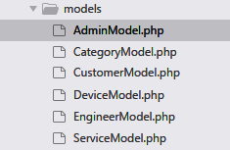

*AdminModel.php* : We have admin credentials in this file.

<?php

*/\*\**

*\* This model only contains hardcorded values for administrator*

*\*/*

**class** **AdminModel** {

**public** $username = 'admin';

**public** $password = 'admin';

**public** $name = 'Sorabh';

**public** $post = "System Administrator";

}

*CategoryModel.php*

<?php

*/\*\**

*\* This Model dedicated to get information related to Device Category*

*\*/*

**class** **CategoryModel** {

**protected** $db;

**function** __construct(PDO $db) {

$this->db = $db;

}

*/\*\**

*\* return all records from database*

*\*/*

**function** get_categories() {

**try** {

$sql = "SELECT * FROM device_category ORDER BY id DESC";

$stmt = $this->db->prepare($sql);

$stmt->execute();

**return** $stmt->fetchAll();

} **catch**(PDOException $e) {

**return** (object)**array**('error'=>**true**,'message'=>$e.getMessage());

}

}

*/\*\**

*\* insert new record to database*

*\* @param name String*

*\*/*

**function** insert_category($name) {

**try** {

$stmt = $this->db->prepare("INSERT INTO device_category (`name`) VALUES (?)");

$stmt->execute(**array**($name));

} **catch**(PDOException $e) {

**return** (object)**array**('error'=>**true**,'message'=>$e.getMessage());

}

}

*/\*\**

*\* delete a selected record by id*

*\* @param id Integer*

*\*/*

**function** delete_by_id($id) {

**try** {

$stmt = $this->db->prepare("DELETE FROM `device_category` WHERE id=?");

$stmt->execute(**array**($id));

} **catch**(PDOException $e) {

**return** (object)**array**('error'=>**true**,'message'=>$e.getMessage());

}

}

}

*CustomerModel.php*

<?php

*/\*\**

*\* All customer related data will be handle by this model*

*\*/*

**class** **CustomerModel** {

**protected** $db;

**function** __construct(PDO $db) {

$this->db = $db;

}

**public** **function** customer_exist($username) {

$stmt = $this->db->prepare("SELECT id FROM customers WHERE username=?");

$stmt->execute(**array**($username));

**if**($stmt->rowCount() == 0) {

**return** **false**;

} **else** {

**return** **true**;

}

}

**public** **function** authenticate($post) {

$stmt = $this->db->prepare("SELECT * FROM customers WHERE username=? AND password=?");

$stmt->execute(**array**(

$post['username'],

$post['password']

));

**if**($stmt->rowCount() == 0) {

**return** **false**;

} **else** {

**return** $stmt->fetch();

}

}

**public** **function** insert_customer($post) {

$sql = "INSERT INTO customers (username, password, name, phone, address) VALUES (?,?,?,?,?)";

$stmt = $this->db->prepare($sql);

**if**($stmt->execute(**array**(

$post['username'],

$post['password'],

$post['name'],

$post['phone'],

$post['address']

))) {

**return** **true**;

} **else** {

**return** **false**;

};

}

**public** **function** change_password($post) {

**try** {

$sql = "UPDATE customers SET password=? WHERE id=?";

$stmt = $this->db->prepare($sql);

$stmt->execute(**array**(

$post['password'],

$post['id']

));

**return** (object)**array**('error'=>**false**,'message'=>'Update Successfully');

} **catch**(PDOException $e) {

**return** (object)**array**('error'=>**true**,'message'=>$e->getMessage());

}

}

**public** **function** update_customer($post) {

**try** {

$sql = "UPDATE customers SET name=?, phone=?, address=? WHERE id=?";

$stmt = $this->db->prepare($sql);

$stmt->execute(**array**(

$post['name'],

$post['phone'],

$post['address'],

$post['id']

));

**return** (object)**array**('error'=>**false**,'message'=>'Update Successfully');

} **catch**(PDOException $e) {

**return** (object)**array**('error'=>**true**,'message'=>$e->getMessage());

}

}

**public** **function** get_by_id($id) {

**try** {

$stmt = $this->db->prepare("SELECT * FROM customers WHERE id=?");

$stmt->execute(**array**($id));

**return** $stmt->fetch();

} **catch**(PDOException $e) {

**return** (object)**array**('error'=>**true**,'message'=>$e->getMessage());

}

}

**public** **function** get_customers() {

**try** {

$stmt = $this->db->prepare("SELECT * FROM customers ORDER BY id DESC");

$stmt->execute();

**return** $stmt->fetchAll();

} **catch** (PDOException $e) {

**return** (object)**array**('error'=>**true**,'message'=>$e->getMessage());

}

}

**public** **function** delete_customer() {

}

}

*DeviceModel.php* : All Model files are almost same, a constructor function received a MySQL resource, and we are making different SQL queries and returning result to our controllers.

<?php

*/\*\**

*\* Details of Device and related information*

*\*/*

**class** **DeviceModel** {

**protected** $db;

**function** __construct($db) {

$this->db = $db;

}

**public** **function** get_devices() {

**try** {

$stmt = $this->db->prepare('SELECT P.*, C.name AS customer_name,

PD.name AS device_category_name FROM devices P

INNER JOIN customers C ON P.customer_id=C.id

INNER JOIN device_category PD ON P.device_category_id=PD.id

ORDER BY P.id DESC');

$stmt->execute();

**return** $stmt->fetchAll();

} **catch** (PDOException $e) {

**return** (object)**array**(

'error' => **true**,

'message' => $e->getMessage()

);

}

}

**public** **function** get_by_customer_id($id) {

**try** {

$stmt = $this->db->prepare('SELECT P.*, C.name AS customer_name,

PD.name AS device_category_name FROM devices P

INNER JOIN customers C ON P.customer_id=C.id

INNER JOIN device_category PD ON P.device_category_id=PD.id

WHERE customer_id=?

ORDER BY P.id DESC');

$stmt->execute(**array**($id));

**return** $stmt->fetchAll();

} **catch** (PDOException $e) {

**return** (object)**array**(

'error' => **true**,

'message' => $e->getMessage()

);

}

}

**public** **function** get_total_page_by_customer_id() {

**try** {

$stmt = $this->db->query('SELECT count(*) AS c FROM devices');

**return** $stmt->fetch()->c;

} **catch**(PDOException $e) {

**return** (object)**array**(

'error' => **true**,

'message' => $e->getMessage()

);

}

}

**public** **function** get_pagination_by_customer_id($arr) {

**try** {

$stmt = $this->db->prepare('SELECT P.*, C.name AS customer_name,

PD.name AS device_category_name FROM devices P

INNER JOIN customers C ON P.customer_id=C.id

INNER JOIN device_category PD ON P.device_category_id=PD.id

WHERE customer_id=:id

ORDER BY P.id DESC

LIMIT :limit OFFSET :offset');

$stmt->bindValue(':id', $arr['id']);

$stmt->bindValue(':limit', (int)$arr['limit'], PDO::PARAM_INT);

$stmt->bindValue(':offset', (int)$arr['offset'], PDO::PARAM_INT);

$stmt->execute();

**return** $stmt->fetchAll();

} **catch** (PDOException $e) {

**return** (object)**array**(

'error' => **true**,

'message' => $e->getMessage()

);

}

}

**public** **function** get_by_id($id) {

**try** {

$stmt = $this->db->prepare('SELECT * FROM devices WHERE id=?');

$stmt->execute(**array**($id));

**return** $stmt->fetch();

} **catch** (PDOException $e) {

**return** (object)**array**(

'error' => **true**,

'message' => $e->getMessage()

);

}

}

**public** **function** update_device($post) {

**try** {

$stmt = $this->db->prepare('UPDATE devices SET customer_id=?, device_category_id=?,

brand_name=?, serial_no=?, purchase_price=?, date_of_purchase=? WHERE id=?');

$stmt->execute(**array**(

$post['customer_id'],

$post['device_category_id'],

$post['brand_name'],

$post['serial_no'],

$post['purchase_price'],

$post['date_of_purchase'],

$post['id']

));

**return** (object)**array**(

'error' => **false**,

'message' => 'Update Successfully'

);

} **catch** (PDOException $e) {

**return** (object)**array**(

'error' => **true**,

'message' => $e->getMessage()

);

}

}

**public** **function** insert_device($post) {

**try** {

$stmt = $this->db->prepare('INSERT INTO devices (customer_id, device_category_id, brand_name, serial_no, purchase_price, date_of_purchase) VALUES (?,?,?,?,?,?)');

$stmt->execute(**array**(

$post['customer_id'],

$post['device_category_id'],

$post['brand_name'],

$post['serial_no'],

$post['purchase_price'],

$post['date_of_purchase']

));

**return** (object)**array**(

'error' => **false**,

'message' => 'success'

);

} **catch** (PDOException $e) {

**return** (object)**array**(

'error' => **true**,

'message' => $e->getMessage()

);

}

}

**public** **function** delete_by_id($id) {

**try** {

$stmt = $this->db->prepare("DELETE FROM `devices` WHERE id=?");

$stmt->execute(**array**($id));

**return** (object)**array**(

'error' => **false**,

'message' => 'success'

);

} **catch**(PDOException $e) {

**return** (object)**array**(

'error' => **true**,

'message' => $e->getMessage()

);

}

}

**public** **function** get_part_by_id($id) {

**try** {

$stmt = $this->db->prepare('SELECT * FROM device_parts WHERE id=?');

$stmt->execute(**array**($id));

**return** $stmt->fetch();

} **catch**(PDOException $e) {

**return** (object)**array**('error'=>**true**,'message'=>$e->getMessage());

}

}

**public** **function** get_part_by_service_id($id) {

**try** {

$stmt = $this->db->prepare('SELECT * FROM device_parts WHERE service_id=?');

$stmt->execute(**array**($id));

**return** $stmt->fetchAll();

} **catch**(PDOException $e) {

**return** (object)**array**('error'=>**true**,'message'=>$e->getMessage());

}

}

**public** **function** set_status($post) {

**try** {

$stmt = $this->db->prepare('UPDATE device_parts SET status=? WHERE id=?');

$stmt->execute(**array**(

$post['status'],

$post['id']

));

**return** (object)**array**('error'=>**false**,'message'=>'Successful');

} **catch**(PDOException $e) {

**return** (object)**array**('error'=>**true**,'message'=>$e->getMessage());

}

}

**public** **function** insert_part($post) {

**try** {

$stmt = $this->db->prepare('INSERT INTO device_parts (service_id,part_name,description,price,date) VALUES (?,?,?,?,NOW())');

$stmt->execute(**array**(

$post['service_id'],

$post['part_name'],

$post['description'],

$post['price']

));

**return** (object)**array**('error'=>**false**,'message'=>'Successfully Added');

} **catch** (PDOException $e) {

**return** (object)**array**('error'=>**true**,'message'=>$e->getMessage());

}

}

**public** **function** delete_part_by_id($id) {

**try** {

$stmt = $this->db->prepare('DELETE FROM device_parts WHERE id=?');

$stmt->execute(**array**($id));

**return** (object)**array**('error'=>**false**,'message'=>'Deleted Successfully');

} **catch**(PDOException $e) {

**return** (object)**array**('error'=>**true**,'message'=>$e->getMessage());

}

}

}

*EngineerModel.php*

<?php

*/\*\**

*\* Engineer Related data handle, like fetch, insert, update, delete*

*\*/*

**class** **EngineerModel** {

**protected** $db;

**function** __construct($db) {

$this->db = $db;

}

**public** **function** get_engineers() {

**try** {

$stmt = $this->db->prepare('SELECT E.*, GROUP_CONCAT(PC.name SEPARATOR " | ") AS

expertise FROM `engineers` E

INNER JOIN `engineers_expertise` EE ON E.id=EE.engineer_id

INNER JOIN device_category PC ON EE.device_category_id=PC.id

GROUP BY E.id

ORDER BY E.id DESC');

$stmt->execute();

**return** $stmt->fetchAll();

} **catch** (PDOException $e) {

**return** (object)**array**(

'error' => **true**,

'message' => $e->getMessage()

);

}

}

**public** **function** get_by_id($id) {

**try**{

$stmt = $this->db->prepare('SELECT * FROM engineers WHERE id=?');

$stmt->execute(**array**($id));

**return** $stmt->fetch();

} **catch**(PDOException $e) {

**return** (object)**array**(

'error' => **true**,

'message' => $e->getMessage()

);

}

}

**public** **function** get_by_device_category_id($id) {

**try** {

$stmt = $this->db->prepare('SELECT e.*, EE.device_category_id FROM engineers E

INNER JOIN engineers_expertise EE ON EE.engineer_id=E.id

WHERE EE.device_category_id=?');

$stmt->execute(**array**($id));

**return** $stmt->fetchAll();

} **catch**(PDOException $e) {

**return** (object)**array**(

'error' => **true**,

'message' => $e->getMessage()

);

}

}

**public** **function** insert_engineer($post) {

**try** {

$stmt = $this->db->prepare('INSERT INTO engineers (name, address, date_of_joining) VALUES (?,?,NOW())');

$stmt->execute(**array**(

$post['name'],

$post['address']

));

**return** (object)**array**(

'error' => **false**,

'message' => 'Engineer is inserted',

'id' => $this->db->lastInsertId()

);

} **catch** (PDOException $e) {

**return** (object)**array**(

'error' => **true**,

'message' => $e->getMessage()

);

}

}

**public** **function** update_engineer($post) {

**try** {

$stmt = $this->db->prepare('UPDATE engineers SET name=?, address=? WHERE id=?');

$stmt->execute(**array**($post['name'], $post['address'], $post['id']));

**return** (object)**array**(

'error' => **false**,

'message' => 'success'

);

} **catch**(PDOException $e) {

**return** (object)**array**(

'error' => **true**,

'message' => $e->getMessage()

);

}

}

**public** **function** delete_by_id($id) {

**try** {

$stmt = $this->db->prepare('DELETE FROM engineers WHERE id=?');

$stmt->execute(**array**($id));

**return** (object)**array**(

'error' => **false**,

'message' => 'Engineer is deleted successfully'

);

} **catch** (PDOException $e) {

**return** (object)**array**(

'error' => **true**,

'message' => $e.getMessage()

);

}

}

**public** **function** insert_expertise($id, $cat_id) {

**try** {

$stmt = $this->db->prepare('INSERT INTO engineers_expertise (device_category_id, engineer_id) VALUES (?,?)');

$stmt->execute(**array**($cat_id, $id));

**return** (object)**array**(

'error' => **false**,

'message' => 'Engineer expertise inserted'

);

} **catch** (PDOException $e) {

**return** (object)**array**(

'error' => **true**,

'message' => $e.getMessage()

);

}

}

**public** **function** delete_expertise_by_engineer_id($id) {

**try** {

$stmt = $this->db->prepare('DELETE FROM engineers_expertise WHERE engineer_id=?');

$stmt->execute(**array**($id));

**return** (object)**array**(

'error' => **false**,

'message' => 'Delete Success'

);

} **catch**(PDOException $e) {

**return** (object)**array**(

'error' => **true**,

'message' => $e.getMessage()

);

}

}

}

*ServiceModel.php*

<?php

*/\*\**

*\* Service request, fault repair data managed by this model*

*\*/*

**class** **ServiceModel** {

**protected** $db;

**function** __construct($db) {

$this->db = $db;

}

**public** **function** get_services($type) {

**try** {

$stmt = $this->db->prepare('SELECT FS.*, P.customer_id, C.name AS customer_name,

P.id AS device_id, CONCAT(PC.name,": ",P.brand_name," ",P.serial_no) AS device_name

FROM services FS

INNER JOIN devices P ON P.id=FS.device_id

INNER JOIN customers C ON C.id=P.customer_id

INNER JOIN device_category PC ON PC.id=P.device_category_id

WHERE FS.type=?

ORDER BY FS.id DESC');

$stmt->execute(**array**($type));

**return** $stmt->fetchAll();

} **catch** (PDOException $e) {

**return** (object)**array**(

'error' => **true**,

'message' => $e->getMessage()

);

}

}

**public** **function** get_type($id) {

**try** {

$stmt = $this->db->prepare('SELECT type FROM services WHERE id=?');

$stmt->execute(**array**($id));

**return** $stmt->fetch();

} **catch**(PDOException $e) {

**return** (object)**array**(

'error' => **true**,

'message' => $e->getMessage()

);

}

}

**public** **function** get_status($type, $id) {

**try** {

$stmt=$this->db->prepare('SELECT status FROM services

WHERE type=? AND id=?');

$stmt->execute(**array**($type, $id));

**return** $stmt->fetch();

} **catch**(PDOException $e) {

**return** (object)**array**('error' => **true**,'message' => $e->getMessage());

}

}

**public** **function** set_status($post) {

**try** {

$stmt=$this->db->prepare('UPDATE services SET status=? WHERE id=?');

$stmt->execute(**array**(

$post['status'],

$post['id']

));

**return** $stmt->fetch();

} **catch**(PDOException $e) {

**return** (object)**array**('error' => **true**,'message' => $e->getMessage());

}

}

**public** **function** get_by_id($type, $id) {

**try** {

$stmt=$this->db->prepare('SELECT S.*, D.customer_id, C.name AS customer_name,

C.address, C.phone, D.brand_name, D.date_of_purchase, D.device_category_id,

D.serial_no, DC.name AS device_category_name

FROM services S

INNER JOIN devices D ON D.id=S.device_id

INNER JOIN device_category DC ON DC.id=D.device_category_id

INNER JOIN customers C ON C.id=D.customer_id

WHERE S.type=? AND S.id=?');

$stmt->execute(**array**($type, $id));

**return** $stmt->fetch();

} **catch**(PDOException $e) {

**return** (object)**array**('error' => **true**,'message' => $e->getMessage());

}

}

**public** **function** get_by_id_approved($type, $id) {

**try** {

$stmt=$this->db->prepare('SELECT S.*, D.customer_id, C.name AS customer_name,

C.address, C.phone, D.brand_name, D.date_of_purchase, D.device_category_id,

D.serial_no, DC.name AS device_category_name, E.name AS engineer_name

FROM services S

INNER JOIN devices D ON D.id=S.device_id

INNER JOIN device_category DC ON DC.id=D.device_category_id

INNER JOIN customers C ON C.id=D.customer_id

INNER JOIN engineers E ON E.id=S.engineer_id

WHERE S.type=? AND S.id=?

ORDER BY S.id DESC');

$stmt->execute(**array**($type, $id));

**return** $stmt->fetch();

} **catch**(PDOException $e) {

**return** (object)**array**('error' => **true**,'message' => $e->getMessage());

}

}

*// return service_id to device_category_id*

**public** **function** get_categoryid_by_id($id) {

**try** {

$stmt=$this->db->prepare('SELECT device_category_id FROM services

INNER JOIN devices ON services.device_id=devices.id

WHERE services.id=?');

$stmt->execute(**array**($id));

**return** $stmt->fetch();

} **catch**(PDOException $e) {

**return** (object)**array**('error' => **true**,'message' => $e->getMessage());

}

}

**public** **function** get_by_customer_id($type, $customer_id) {

**try** {

$stmt = $this->db->prepare('SELECT FS.*, P.customer_id, C.name AS customer_name,

CONCAT(PC.name,": ",P.brand_name," ",P.serial_no) AS device_name

FROM services FS

INNER JOIN devices P ON FS.device_id=P.id

INNER JOIN customers C ON P.customer_id=C.id

INNER JOIN device_category PC ON PC.id=P.device_category_id

WHERE type=? AND C.id=?

ORDER BY FS.id DESC');

$stmt->execute(**array**($type, $customer_id));

**return** $stmt->fetchAll();

} **catch** (PDOException $e) {

**return** (object)**array**('error' => **true**,'message' => $e->getMessage());

}

}

**public** **function** insert_approved($post) {

**try** {

$stmt = $this->db->prepare('INSERT INTO services(type, device_id, alternative_address,

alternative_phone, description, engineer_id, price, status, requested_date)

VALUES(?,?,?,?,?,?,?,?,NOW())');

$stmt->execute(**array**(

$post['type'],

$post['device_id'],

$post['alternative_address'],

$post['alternative_phone'],

$post['description'],

$post['engineer_id'],

$post['price'],

$post['status']

));

**return** (object)**array**('error'=>**false**,'message'=>'successfully inserted');

} **catch** (PDOException $e) {

**return** (object)**array**('error'=>**true**,'message'=>$e->getMessage());

}

}

**public** **function** fault_approve($post) {

**try** {

$stmt = $this->db->prepare("UPDATE services SET status='APPROVED', engineer_id=?, price=? WHERE id=?");

$stmt->execute(**array**(

$post['engineer_id'],

$post['price'],

$post['id'],

));

**return** (object)**array**('error'=>**false**,'message'=>'Successfully updated');

} **catch**(PDOException $e) {

**return** (object)**array**('error'=>**true**,'message'=>$e->getMessage());

}

}

**public** **function** maintain_approve($post) {

**try** {

$stmt = $this->db->prepare("UPDATE services SET status='APPROVED' WHERE id=?");

$stmt->execute(**array**(

$post['id']

));

**return** (object)**array**('error'=>**false**,'message'=>'Successfully updated');

} **catch**(PDOException $e) {

**return** (object)**array**('error'=>**true**,'message'=>$e->getMessage());

}

}

**public** **function** reject($id) {

**try** {

$stmt = $this->db->prepare("UPDATE services SET status='REJECTED' WHERE id=?");

$stmt->execute(**array**($id));

**return** (object)**array**('error'=>**false**,'message'=>'Successfully updated');

} **catch**(PDOException $e) {

**return** (object)**array**('error'=>**true**,'message'=>$e->getMessage());

}

}

**public** **function** request_service($post) {

**try** {

$stmt = $this->db->prepare('INSERT INTO services

(device_id, type, alternative_address, alternative_phone, description,

price, duration, status, requested_date)

VALUES (?,?,?,?,?,?,?,?,NOW())');

$stmt->execute(**array**(

$post['device_id'],

$post['type'],

$post['alternative_address'],

$post['alternative_phone'],

$post['description'],

isset($post['price'])?$post['price']:'',

isset($post['duration'])?$post['duration']:'',

'REQUESTED'

));

**return** (object)**array**(

'error' => **false**,

'message' => "Successfully inserted!"

);

} **catch** (PDOException $e) {

**return** (object)**array**(

'error' => **true**,

'message' => $e->getMessage()

);

}

}

}

**sql folder** : This folder only contains an example sql database schema, written in SQL language for MySQL database, as bellow :

*-- SQL*

*-- Table structure for table `customers`*

**CREATE** **TABLE** `customers` (

`id` int(8) **NOT** **NULL**,

`username` varchar(255) **NOT** **NULL**,

`password` varchar(255) **NOT** **NULL**,

`name` varchar(255) **NOT** **NULL**,

`phone` varchar(50) **NOT** **NULL**,

`address` varchar(255) **NOT** **NULL**

) ENGINE=InnoDB **DEFAULT** CHARSET=latin1;

*-- data for table `customers`*

**INSERT** **INTO** `customers` (`id`, `username`, `password`, `name`, `phone`, `address`) **VALUES**

(1, 'sorabh', 'sorabh', 'Sorabh Sharma', '349-834-3959', 'D-Block, Flat 23, Delhi'),

(2, 'admin', 'admin', 'John Smith', '3498343959', '555 Main Street'),

(3, 'ramasankar', 'ramasankar', 'ramasankar', '943857434', '2134 Street'),

(4, 'monica', 'monica', 'Monica Kumari', '3498343959', '123, Main street');

*-- Table structure for table `devices`*

**CREATE** **TABLE** `devices` (

`id` int(8) **NOT** **NULL**,

`customer_id` int(8) **NOT** **NULL**,

`device_category_id` int(8) **NOT** **NULL**,

`brand_name` varchar(255) **NOT** **NULL**,

`serial_no` varchar(255) **NOT** **NULL**,

`purchase_price` decimal(8,2) **NOT** **NULL**,

`date_of_purchase` date **NOT** **NULL**

) ENGINE=InnoDB **DEFAULT** CHARSET=latin1;

*-- data for table `devices`*

**INSERT** **INTO** `devices` (`id`, `customer_id`, `device_category_id`, `brand_name`, `serial_no`, `purchase_price`, `date_of_purchase`) **VALUES**

(1, 1, 9, 'LG', 'L34254', '5000.00', '2005-01-02'),

(3, 2, 6, 'SONY', 'S3343', '8000.00', '2013-01-31'),

(4, 1, 3, 'Okinava', 'OKI4551', '8499.00', '2014-05-28'),

(5, 4, 11, 'Whirlpool', 'W93484', '8790.00', '2010-02-05'),

(6, 4, 11, 'Godrej 7 kg', 'G3465', '18840.00', '2011-03-05'),

(7, 1, 11, 'Okinavas', '34kdjf', '343.00', '1998-03-09'),

(8, 1, 5, 'SONY', 'DS4384', '3883.00', '1999-09-08');

*-- Table structure for table `device_category`*

**CREATE** **TABLE** `device_category` (

`id` int(8) **NOT** **NULL**,

`name` varchar(255) **NOT** **NULL**

) ENGINE=InnoDB **DEFAULT** CHARSET=latin1;

*-- data for table `device_category`*

**INSERT** **INTO** `device_category` (`id`, `name`) **VALUES**

(3, 'Refrigerator'),

(4, 'Air Conditioners'),

(5, 'Air Coolers'),

(6, 'Microwave Ovens'),

(9, 'TV'),

(11, 'Washing Machine');

*-- Table structure for table `device_parts`*

**CREATE** **TABLE** `device_parts` (

`id` int(11) **NOT** **NULL**,

`service_id` int(8) **NOT** **NULL**,

`part_name` varchar(255) **NOT** **NULL**,

`description` varchar(255) **NOT** **NULL**,

`price` decimal(8,2) **NOT** **NULL**,

`status` varchar(100) **NOT** **NULL**,

`date` date **NOT** **NULL**

) ENGINE=InnoDB **DEFAULT** CHARSET=latin1;

*-- data for table `device_parts`*

**INSERT** **INTO** `device_parts` (`id`, `service_id`, `part_name`, `description`, `price`, `status`, `date`) **VALUES**

(3, 1, 'Front LED Panel', 'Backlight was not working.', '1200.00', '', '2018-10-05'),

(4, 1, 'Motherboard Heat sink module', 'Module was old and not working', '250.00', '', '2018-10-05'),

(5, 3, 'Power socket', 'Power source is not working', '480.23', '', '2018-10-05'),

(10, 9, 'Motherboard Heat sink module', 'Module memory', '1000.00', 'PAID', '2018-10-07'),

(11, 9, 'Power socket', 'Power source is not working', '480.23', '', '2018-10-07');

*-- Table structure for table `engineers`*

**CREATE** **TABLE** `engineers` (

`id` int(8) **NOT** **NULL**,

`name` varchar(255) **NOT** **NULL**,

`address` varchar(255) **NOT** **NULL**,

`date_of_joining` date **NOT** **NULL**

) ENGINE=InnoDB **DEFAULT** CHARSET=latin1;

*-- data for table `engineers`*

**INSERT** **INTO** `engineers` (`id`, `name`, `address`, `date_of_joining`) **VALUES**

(6, 'Gaurav Sharma', '555 Main Street', '2018-09-28'),

(14, 'Mohan Kumar', '123 noida', '2018-09-30'),

(15, 'Rajiv Mohan', '123 appartment noida', '2018-10-04'),

(16, 'Ompal Gupta', '44 morta, sector 28 noida', '2018-10-04'),

(18, 'John Smith', '123 appartment noida', '2018-10-04'),

(19, 'Bindal Singh', '333 street delhi', '2018-10-04');

*-- Table structure for table `engineers_expertise`*

**CREATE** **TABLE** `engineers_expertise` (

`device_category_id` int(8) **NOT** **NULL**,

`engineer_id` int(8) **NOT** **NULL**

) ENGINE=InnoDB **DEFAULT** CHARSET=latin1;

*-- data for table `engineers_expertise`*

**INSERT** **INTO** `engineers_expertise` (`device_category_id`, `engineer_id`) **VALUES**

(9, 6),(11, 6),(5, 14),(9, 15),(11, 15),(5, 16),(6, 16),(3, 18),(4, 18),(5, 18),(6, 18),(9, 18),(11, 18),(3, 19),(4, 19),(6, 19);

*-- Table structure for table `services`*

**CREATE** **TABLE** `services` (

`id` int(8) **NOT** **NULL**,

`**type**` varchar(100) **NOT** **NULL**,

`device_id` int(8) **NOT** **NULL**,

`alternative_address` varchar(255) **NOT** **NULL**,

`alternative_phone` varchar(50) **NOT** **NULL**,

`description` varchar(255) **NOT** **NULL**,

`engineer_id` int(11) **NOT** **NULL**,

`price` decimal(8,2) **NOT** **NULL**,

`duration` int(11) **NOT** **NULL**,

`status` varchar(255) **NOT** **NULL**,

`requested_date` date **NOT** **NULL**

) ENGINE=InnoDB **DEFAULT** CHARSET=latin1;

*-- data for table `services`*

**INSERT** **INTO** `services` (`id`, `**type**`, `device_id`, `alternative_address`, `alternative_phone`, `description`, `engineer_id`, `price`, `duration`, `status`, `requested_date`) **VALUES**

(1, 'fault_repair', 4, '', '', 'Freezer not cooling Ice.', 18, '100.00', 0, 'PAID', '2018-09-29'),

(3, 'fault_repair', 1, '', '', 'Screen is broken', 18, '500.00', 0, 'PAID', '2018-10-01'),

(4, 'fault_repair', 4, '', '', 'Cooling issue in freezer', 18, '1200.00', 0, 'APPROVED', '2018-10-01'),

(5, 'fault_repair', 3, '', '', 'Power supply is not working', 0, '0.00', 0, 'REQUESTED', '2018-10-04'),

(6, 'maintenance', 1, '', '', 'Maintenance service required for 4 years', 0, '1000.00', 1, 'REQUESTED', '2018-10-04'),

(7, 'maintenance', 4, '', '', 'I want this to be serviced', 0, '1000.00', 1, 'REQUESTED', '2018-10-06'),

(8, 'maintenance', 1, '', '', 'Not working fine', 18, '1000.00', 1, 'PAID', '2018-10-06'),

(9, 'maintenance', 1, '', '', 'well, i have not special request', 0, '1000.00', 5, 'APPROVED', '2018-10-07'),

(10, 'fault_repair', 5, '', '', 'dryer not working\r\n', 0, '0.00', 0, 'REQUESTED', '2018-10-11'),

(11, 'maintenance', 6, '', '', 'please send me bill, i will pay you.', 0, '1000.00', 1, 'REQUESTED', '2018-10-11'),

(12, 'maintenance', 3, '', '', 'i need this as soon as possible, starting today', 0, '1000.00', 3, 'REQUESTED', '2018-10-11');

*-- Indexes for table `customers`*

**ALTER** **TABLE** `customers`

**ADD** **PRIMARY** **KEY** (`id`);

*-- Indexes for table `devices`*

**ALTER** **TABLE** `devices`

**ADD** **PRIMARY** **KEY** (`id`);

*-- Indexes for table `device_category`*

**ALTER** **TABLE** `device_category`

**ADD** **PRIMARY** **KEY** (`id`);

*-- Indexes for table `device_parts`*

**ALTER** **TABLE** `device_parts`

**ADD** **PRIMARY** **KEY** (`id`);

*-- Indexes for table `engineers`*

**ALTER** **TABLE** `engineers`

**ADD** **PRIMARY** **KEY** (`id`);

*-- Indexes for table `services`*

**ALTER** **TABLE** `services`

**ADD** **PRIMARY** **KEY** (`id`);

*-- AUTO_INCREMENT for table `customers`*

**ALTER** **TABLE** `customers`

**MODIFY** `id` int(8) **NOT** **NULL** AUTO_INCREMENT, AUTO_INCREMENT=5;

*-- AUTO_INCREMENT for table `devices`*

**ALTER** **TABLE** `devices`

**MODIFY** `id` int(8) **NOT** **NULL** AUTO_INCREMENT, AUTO_INCREMENT=9;

*-- AUTO_INCREMENT for table `device_category`*

**ALTER** **TABLE** `device_category`

**MODIFY** `id` int(8) **NOT** **NULL** AUTO_INCREMENT, AUTO_INCREMENT=12;

*-- AUTO_INCREMENT for table `device_parts`*

**ALTER** **TABLE** `device_parts`

**MODIFY** `id` int(11) **NOT** **NULL** AUTO_INCREMENT, AUTO_INCREMENT=12;

*-- AUTO_INCREMENT for table `engineers`*

**ALTER** **TABLE** `engineers`

**MODIFY** `id` int(8) **NOT** **NULL** AUTO_INCREMENT, AUTO_INCREMENT=20;

*-- AUTO_INCREMENT for table `services`*

**ALTER** **TABLE** `services`

**MODIFY** `id` int(8) **NOT** **NULL** AUTO_INCREMENT, AUTO_INCREMENT=13;

**COMMIT**;

**views folder** : This folder is managed based on modules of this project specifications, have following structure :

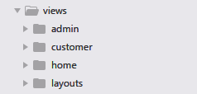

*admin folder* : This folder contains different parts of views related to admin module.

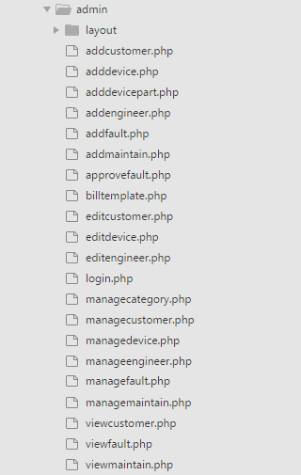

***Layout folder* :** This folder contains header, sidebar, footer block of elements for pages.

*footer.php*

<footer class="footer navbar-inverse" style="padding:20px 0;color:#fff;">

<div class="copyright">

<div class="container">

<p>&copy; Copyright at <a href="http://github.com/sorabh86">SORABH</a>, <a href="http://www.ignou.ac.in/">IGNOU</a> Student, **for** MCA course MSCP-044 Mini Project</p>

</div>

</div>

</footer>

<!-- Latest compiled **and** minified JS -->

<script src="<?= SC_URL ?>js/jquery.min.js"></script>

<script src="<?= SC_URL ?>js/bootstrap.min.js"></script>

<script src="<?= SC_URL ?>js/admin-script.js"></script>

</body>

</html>

*header.php*

<!DOCTYPE html>

<html lang="en">

<head>

<meta charset="utf-8">

<meta http-equiv="X-UA-Compatible" content="IE=edge">

<meta name="viewport" content="width=device-width, initial-scale=1">

<!-- The above 3 meta tags *must* come first in the head; any other head content must come *after* these tags -->

<meta name="description" content="">

<meta name="author" content="">

<link rel="icon" href="<?= SC_URL ?>img/favicon.png">

<title>Service Center Admin</title>

<!-- Bootstrap core CSS -->

<link href="<?= SC_URL ?>css/bootstrap.min.css" rel="stylesheet">

<link href="<?= SC_URL ?>css/admin-style.css" rel="stylesheet">

<script>

**var** SC_URL = "<?= SC_URL ?>";

</script>

</head>

<body>

<nav class="navbar navbar-inverse" style="padding:20px 0;margin-bottom:0;">

<div class="container">

<div class="navbar-header">

<button type="button" class="navbar-toggle collapsed" data-toggle="collapse" data-target="#navbar" aria-expanded="false" aria-controls="navbar">

<span class="sr-only">Toggle navigation</span>

<span class="icon-bar"></span>

<span class="icon-bar"></span>

<span class="icon-bar"></span>

</button>

<a href="<?= SC_URL ?>">

<img height="45" src="<?= SC_URL ?>img/logo-white.png" alt="Service Center Admin Logo">

</a>

</div>

<div id="navbar" class="collapse navbar-collapse">

<ul class="nav navbar-nav pull-right">

<?php **if**(isset($_SESSION['admin'])): ?>

<li><a href="<?= SC_URL ?>admin/logout">LOGOUT</a></li>

<?php **endif**; ?>

</ul>

</div><!--/.nav-collapse -->

</div>

</nav>

*sidelink.php*

<div class="container-fluid" style="margin-top:20px">

<div class="row">

<div class="col-md-2">

<ul class="list-group">

<a class="list-group-item <?php echo (**$data['mcat']**)?'active':'' ?>" href="<?= SC_URL ?>admin/managecategory">

Categories

<span class="badge"></span>

</a>

<a class="list-group-item <?php echo (**$data['mdevice']**)?'active':'' ?>" href="<?= SC_URL ?>admin/managedevice">

Devices

<span class="badge"></span>

</a>

<a class="list-group-item <?php echo (**$data['mcustomers']**)?'active':'' ?>" href="<?= SC_URL ?>admin/managecustomer">

Customers

<span class="badge"></span>

</a>

<a class="list-group-item <?php echo (**$data['mengineers']**)?'active':'' ?>" href="<?= SC_URL ?>admin/manageengineer">

<span class="badge"></span>

Engineers

</a>

<a class="list-group-item <?php echo (**$data['mfault']**)?'active':'' ?>" href="<?= SC_URL ?>admin/managefault">

<span class="badge"></span>

Fault Request

</a>

<a class="list-group-item <?php echo (**$data['mmaintain']**)?'active':'' ?>" href="<?= SC_URL ?>admin/managemaintain">

Services

</a>

</li>

</ul>

</div>

*addcustomer.php*

<div class="container">

<h2 class="page-header">Add Customer</h2>

<form name="customer-register" action="" method="POST">

<div class="form-group">

<label **for**="username" class="control-label">Username :</label>

<input name="username" type="text" class="form-control" placeholder="Username" required>

</div>

<div class="form-group">

<label **for**="password" class="control-label">Password :</label>

<input name="password" type="password" class="form-control" placeholder="Password" required>

</div>

<div class="form-group">

<label **for**="name" class="control-label">Name :</label>

<input id="name" name="name" type="text" class="form-control" placeholder="Your Full Name" required>

</div>

<div class="form-group">

<label **for**="address" class="control-label">Address :</label>

<input id="address" name="address" type="text" class="form-control" placeholder="Your Full Address" required>

</div>

<div class="form-group">

<label **for**="phone" class="control-label">Phone No :</label>

<input id="phone" name="phone" type="text" class="form-control" placeholder="+91 5555-555-555" required>

</div>

<div class="form-group">

<button name="submit" class="btn btn-success" type="submit">ADD</button>

<a href="<?= SC_URL ?>admin/managecustomer" class="btn btn-default">Cancel</a>

</div>

</form>

</div>

*adddevice.php*

<div class="container">

<h2 class="page-header">Add Device/Product</h2>

<form action="" method="POST">

<div class="form-group">

<label class="control-label">Customer :</label>

<?php **if**(isset($data['customers'])) : ?>

<select name="customer_id" class="form-control" required>

<?php **foreach**($data['customers'] **as** $customer) : ?>

<option value="<?= $customer->id ?>"><?= $customer->name ?></option>

<?php **endforeach**; ?>

</select>

<?php **else** : ?>

<p class="alert alert-info">Organization didn't have any customer, please add manually or wait for someone to register</p>

<?php **endif**; ?>

</div>

<div class="form-group">

<label class="control-label">Product Type :</label>

<?php **if**(isset($data['cat'])) : ?>

<select name="device_category_id" class="form-control" required>

<?php **foreach**($data['cat'] **as** $category) : ?>

<option value="<?= $category->id ?>"><?= $category->name ?></option>

<?php **endforeach**; ?>

</select>

<?php **else** : ?>

<p class="alert alert-info">You didn't add any device categories in admin area</p>

<?php **endif**; ?>

</div>

<div class="form-group">

<label class="control-label">Brand Name :</label>

<input name="brand_name" type="text" class="form-control" placeholder="Brand Name" required>

</div>

<div class="form-group">

<label class="control-label">Serial No :</label>

<input name="serial_no" type="text" class="form-control" placeholder="Serial No" required>

</div>

<div class="form-group">

<label class="control-label">Purchased Price :</label>

<input name="purchase_price" type="text" class="form-control" placeholder="Purchased Price" required>

</div>

<div class="form-group">

<label class="control-label">Purchased Date :</label>

<input name="date_of_purchase" type="date" class="form-control" placeholder="Date of Purchase" required>

</div>

<div class="form-group">

<button name="submit" class="btn btn-success" type="submit">ADD</button>

<a href="<?= SC_URL ?>admin/managedevice" class="btn btn-default">Cancel</a>

</div>

</form>

</div>

*adddevicepart.php*

<div class="container" style="margin-bottom:40px">

<h2 class="page-heading">Add Device Part</h2>

<form action="" method="POST" role="form">

<input name="service_id" type="hidden" value="<?= **$_GET['id']** ?>">

<div class="form-group">

<label>Part Name:</label>

<input name="part_name" type="text" class="form-control" placeholder="Part Name" required>

</div>

<div class="form-group">

<label>Part Description:</label>

<input name="description" type="text" class="form-control" placeholder="Description for part, reasoning for change" required>

</div>

<div class="form-group">

<label>Price (Rs):</label>

<input name="price" type="text" class="form-control" placeholder="100.00" required>

</div>

<button name="submit" type="submit" class="btn btn-primary">Submit</button>

<a href="<?= SC_URL ?>admin/<?= **$data['page']** ?>?id=<?= **$_GET['id']** ?>" class="btn btn-default">Cancel</a>

</form>

</div>

*addengineer.php*

<div class="container">

<h2 class="page-header">Add Engineer</h2>

<form name="engineer-form" action="" method="POST">

<div class="form-group">

<label class="control-label">Name :</label>

<input name="name" type="text" class="form-control" placeholder="Your Full Name" required>

</div>

<div class="form-group">

<label class="control-label">Address :</label>

<input name="address" type="text" class="form-control" placeholder="Your Full Address" required>

</div>

<div class="form-group">

<label class="control-label">Expert In :</label>

<div class="alert alert-warning skill-notice hide">

Please check atleast one skill **for** engineer

</div>

<?php **if**(isset($data['cat']) && count($data['cat'])>0) :

**foreach**($data['cat'] **as** $category): ?>

<div class="checkbox">

<label>

<input type="checkbox" name="expertise[]" value="<?= $category->id ?>"> <?= $category->name ?>

</label>

</div>

<?php **endforeach**;

**else** : ?>

<p class="alert alert-info">You didn't add any device categories in admin area</p>

<?php **endif**; ?>

</div>

<div class="form-group">

<button name="submit" class="btn btn-success" type="submit">ADD</button>

<a href="<?= SC_URL ?>admin/manageengineer" class="btn btn-default">Cancel</a>

</div>

</form>

</div>

*addfault.php*

<div class="container" style="margin-bottom:40px">

<h1 class="page-header">Add Fault Request</h1>

<form action="" method="POST" role="form">

<input type="hidden" name="type" value="fault_repair">

<div class="form-group">

<label>Product/Device :</label>

<?php **if**(isset($data['devices'])) : ?>

<select class="form-control" name="device_id">

<?php **foreach**($data['devices'] **as** $device): ?>

<option value="<?= $device->id ?>"><?= $device->customer_name.'; '.$device->device_category_name.' : '.$device->brand_name.' '.$device->serial_no ?></option>

<?php **endforeach**; ?>

</select>

<?php **else** : ?>

<div class="alert alert-info">

No Product/Device found, Please Add your device from <strong><a href="<?= SC_URL ?>customer/devices">here</a></strong>, then come back to add your repair request.

</div>

<?php **endif**; ?>

</div>

<div class="form-group">

<label>Description :</label>

<textarea name="description" class="form-control" placeholder="Describe those problems"></textarea>

</div>

<div class="row">

<div class="col-md-4">

<div class="checkbox">

<label>

<input id="alt-address" type="checkbox" checked>

Address and Phone Same as your Profile

</label>

</div>

</div>

<div id="alt-address-box" class="col-md-8 hide">

<div class="form-group">

<label>Alternative Address :</label>

<input name="alternative_address" type="text" class="form-control" placeholder="If address is not same as your profile address">

</div>

<div class="form-group">

<label>Alternative Phone :</label>

<input name="alternative_phone" type="text" class="form-control" placeholder="If phone no. is not same as your profile phone no.">

</div>

</div>

</div>

<button name="submit" type="submit" class="btn btn-primary">Add</button>

<a href="<?= SC_URL ?>admin/managefault" class="btn btn-default">cancel</a>

</form>

</div>

*addmaintain.php*

<div class="container" style="margin-bottom:40px">

<h1 class="page-header">Add Service</h1>

<form name="add_maintenanceservice_form" action="" method="POST" role="form">

<input name="type" type="hidden" value="maintenance">

<input name="status" type="hidden" value="APPROVED">

<div class="form-group">

<label>Customer & Device :</label>

<?php **if**(isset($data['devices']) && !**empty**($data['devices'])): ?>

<select name="device_id" class="form-control">

<?php **foreach**($data['devices'] **as** $device): ?>

<option value="<?= $device->id ?>" data-catid="<?= $device->device_category_id ?>"><?= $device->customer_name.' : '.$device->device_category_name.' ('.

$device->brand_name.' '.$device->serial_no.')' ?></option>

<?php **endforeach**; ?>

</select>

<?php **else**: ?>

<div class="alert alert-info">No Device found for any customer</div>

<?php **endif**; ?>

</div>

<div class="form-group">

<label>Engineers :</label>

<?php **if**(isset($data['engineers']) && !**empty**($data['engineers'])): ?>

<select name="engineer_id" class="form-control">

<?php **foreach**($data['engineers'] **as** $engineer): ?>

<option value="<?= $engineer->id ?>"><?= $engineer->name ?></option>

<?php **endforeach**; ?>

</select>

<?php **else**: ?>

<div class="alert alert-info">No Engineer found to repair this device, please hire one.</div>

<?php **endif**; ?>

</div>

<div class="form-group">

<label>Description :</label>

<textarea name="description" class="form-control" placeholder="Some notes to inform" required></textarea>

</div>

<div class="form-group">

<label>Duration (Years):</label>

<select name="duration" class="form-control" required>

<option value="1">1 Year</option>

<option value="2">2 Year</option>

<option value="3">3 Year</option>

<option value="4">4 Year</option>

<option value="5">5 Year</option>

</select>

</div>

<div class="form-group">

<label>Service Charge (Rs/year):</label>

<input type="text" name="price" class="form-control" value="1000.00" required></textarea>

</div>

<button name="submit" type="submit" class="btn btn-primary">Add</button>

<a href="<?= SC_URL ?>admin/managemaintain" class="btn btn-default">cancel</a>

</form>

</div>

*approvefault.php*

<div class="container" style="margin-top:40px;margin-bottom:40px">

<h3 class="page-header">Assign Engineer to Work</h3>

<form action="" method="POST" role="form">

<div class="form-group">

<label >Choose an Engineer</label>

<?php **if**(isset($data['engineers'])) : ?>

<select class="form-control" name="engineer_id">

<?php **foreach**($data['engineers'] **as** $engineer) : ?>

<option value="<?= $engineer->id ?>"><?= $engineer->name ?></option>

<?php **endforeach**; ?>

</select>

<?php **else** : ?>

<div class="alert alert-info">No Enginner found</div>

<?php **endif**; ?>

</div>

<div class="form-group">

<label>Replace Parts : </label>

<textarea class="form-control" rowspan="4" ></textarea>

</div>

<button type="submit" class="btn btn-primary">Submit</button>

<a href="<?= SC_URL ?>admin/managefault" class="btn btn-default">Cancel</a>

</form>

</div>

*billtemplate.php*

<?php

$status = $data['status'];

$service = $data['service'];

$parts = $data['parts'];

$page = isset($data['page'])?$data['page']:'viewfault';

$address = (isset($service->alternative_address) && $service->alternative_address!='')?$service->alternative_address:$service->address;

$phone = (isset($service->alternative_phone) && $service->alternative_phone!='')?$service->alternative_phone:$service->phone;

$total = $service->price;

?>

<html>

<head><title>Bill</title></head>

<body style="background:#eee">

<form name="bill-form" method="POST">

<div style="margin:auto;width:800px;background:#fff;padding:10px">

<div style="padding:20px;overflow:hidden">

<a href="<?= SC_URL ?>admin/<?= $page ?>?id=<?= $_GET['id'] ?>">< go back</a>

<button name="submit" style="float:right;margin-left:20px">Save Bill</button>

<button onclick="window.print()" style="float:right;margin-left:20px">print</button>

</div>

<table style="width:100%;">

<tr style="border-bottom:1px solid #ddd;">

<td><img height="60" src="<?= SC_URL ?>img/logo.png" alt="Service Center"></td>

<td></td>

<td align="right">Date : <?= date('Y-m-d') ?></td>

</tr>

</table>

<?php **if**(isset($status) && $status != 'APPROVED') : ?>

<p>Bill cannot be generated for non approved service</p>

<?php **else** : ?>

<div style="padding:20px;border:1px solid #ccc;">

<div>

<strong style="display:inline-block;width:150px;">Name: </strong>

<span><?= $service->customer_name ?></span>

</div>

<div>

<strong style="display:inline-block;width:150px;">Address: </strong>

<span><?= $address ?></span>

</div>

<div>

<strong style="display:inline-block;width:150px;">Phone: </strong>

<span><?= $phone ?></span>

</div>

<div>

<strong style="display:inline-block;width:150px;">Description: </strong>

<span><?= $service->description ?></span>

</div>

<div>

<strong style="display:inline-block;width:150px;">Requested Date: </strong>

<span><?= $service->requested_date ?></span>

</div>

<div style="margin-bottom:10px;">

<strong style="display:inline-block;width:150px;">Device: </strong>

<span><?= $service->device_category_name ?>: <?= $service->brand_name ?> <?= $service->serial_no ?>(<?= $service->date_of_purchase ?>)</span>

</div>

</div>

<table style="width:100%;padding:10px;">

<tr>

<td align="right">Service Charge: </td>

<td align="center">____________________</td>

<td align="right"><?= $service->price ?></td>

</tr>

<?php **if**(isset($parts) && !**empty**($parts)) :

**foreach**($parts **as** $part) : ?>

<tr>

<td align="right"><?= $part->part_name ?></td>

<td align="center">____________________</td>

<td align="right"><?= $part->price ?></td>

</tr>

<?php $total += $part->price;

**endforeach**;

**endif**; ?>

<tr>

<td></td>

<td align="right"><strong>TOTAL:</strong></td>

<td align="right"><strong><?= number_format($total,2,'.','') ?></strong></td>

</tr>

</table>

<?php **endif**; ?>

</div>

</form>

</body>

</html>

*editcustomer.php*

<div class="container">

<h2 class="page-header">Update Customer</h2>

<?php **if**(isset($data['customer']) && !**empty**($data['customer'])): ?>

<form name="customer-register" action="" method="POST">

<div class="form-group">

<label for="username" class="control-label">Username :</label>

<input name="username" type="text" class="form-control"

value="<?= $data['customer']->username ?>"

placeholder="Username" required>

</div>

<div class="form-group">

<label for="password" class="control-label">Password :</label>

<input name="password" type="password" class="form-control"

value="<?= $data['customer']->password ?>"

placeholder="Password" required>

</div>

<div class="form-group">

<label for="name" class="control-label">Name :</label>

<input id="name" name="name" type="text" class="form-control"

value="<?= $data['customer']->name ?>"

placeholder="Your Full Name" required>

</div>

<div class="form-group">

<label for="address" class="control-label">Address :</label>

<input id="address" name="address" type="text" class="form-control"

value="<?= $data['customer']->address ?>"

placeholder="Your Full Address" required>

</div>

<div class="form-group">

<label for="phone" class="control-label">Phone No :</label>

<input id="phone" name="phone" type="text" class="form-control"

value="<?= $data['customer']->phone ?>"

placeholder="+91 5555-555-555" required>

</div>

<div class="form-group">

<button name="submit" class="btn btn-success" type="submit">ADD</button>

<a href="<?= SC_URL ?>admin/managecustomer" class="btn btn-default">Cancel</a>

</div>

</form>

<?php **else**: ?>

<p class="alert alert-danger"> No Customer found for this id </p>

<?php **endif**; ?>

</div>

*editdevice.php*

<div class="container">

<h2 class="page-header">Edit Device/Product</h2>

<?php $device = $data['device'];

**if**(isset($device)) : ?>

<form action="" method="POST">

<input type="hidden" name="id" value="<?= $device->id ?>">

<div class="form-group">

<label class="control-label">Customer :</label>

<?php **if**(isset($data['customers'])) : ?>

<select name="customer_id" class="form-control" required>

<?php **foreach**($data['customers'] **as** $customer) :

$selected = ($customer->id==$device->customer_id)?'selected':''; ?>

<option value="<?= $customer->id ?>" <?= $selected ?>><?= $customer->name ?></option>

<?php **endforeach**; ?>

</select>

<?php **else** : ?>

<p class="alert alert-info">Organization didn't have any customer, please add manually or wait for someone to register</p>

<?php **endif**; ?>

</div>

<div class="form-group">

<label class="control-label">Product Type :</label>

<?php **if**(isset($data['cat'])) : ?>

<select name="device_category_id" class="form-control" required>

<?php **foreach**($data['cat'] **as** $category) :

$selected = ($category->id==$device->device_category_id)?'selected':''; ?>

<option value="<?= $category->id ?>" <?= $selected ?>><?= $category->name ?></option>

<?php **endforeach**; ?>

</select>

<?php **else** : ?>

<p class="alert alert-info">You didn't add any device categories in admin area</p>

<?php **endif**; ?>

</div>

<div class="form-group">

<label class="control-label">Brand Name :</label>

<input name="brand_name" type="text" class="form-control"

value="<?= $device->brand_name ?>"

placeholder="Brand Name" required>

</div>

<div class="form-group">

<label class="control-label">Serial No :</label>

<input name="serial_no" type="text" class="form-control"

value="<?= $device->serial_no ?>"

placeholder="Serial No" required>

</div>

<div class="form-group">

<label class="control-label">Purchased Price :</label>

<input name="purchase_price" type="text" class="form-control"

value="<?= $device->purchase_price ?>"

placeholder="Purchased Price" required>

</div>

<div class="form-group">

<label class="control-label">Purchased Date :</label>

<input name="date_of_purchase" type="date" class="form-control"

value="<?= $device->date_of_purchase ?>"

placeholder="Date of Purchase" required>

</div>

<div class="form-group">

<button name="submit" class="btn btn-success" type="submit">UPDATE</button>

<a href="<?= SC_URL ?>admin/managedevice" class="btn btn-default">Cancel</a>

</div>

</form>

<?php **else** : ?>

<p>No Product Data found</p>

<?php **endif**; ?>

</div>

*editengineer.php*

<div class="container">

<h2 class="page-header">Edit Engineer</h2>

<form action="" method="POST">

<input type="hidden" name="id" value="<?= **$data['engineer']**->id ?>">

<div class="form-group">

<label class="control-label">Name :</label>

<input name="name" type="text" class="form-control"

value="<?= **$data['engineer']**->name ?>"

placeholder="Your Full Name" required>

</div>

<div class="form-group">

<label class="control-label">Address :</label>

<input name="address" type="text" class="form-control"

value="<?= **$data['engineer']**->address ?>"

placeholder="Your Full Address" required>

</div>

<div class="form-group">

<button name="submit" class="btn btn-success" type="submit">Update</button>

<a href="<?= SC_URL ?>admin/manageengineer" class="btn btn-default">Cancel</a>

</div>

</form>

</div>

*login.php*

<div class="wrapper">

<div class="container">

<div class="panel panel-primary col-md-6 col-md-offset-3">

<div class="panel-header">

<h2 class="text-center panel-heading">Admin Login</h2>

</div>

<div class="panel-body">

<?php **if**(isset($data['error'])): ?>

<div class="alert alert-danger">

<button type="button" class="close" data-dismiss="alert" aria-hidden="true">&times;</button>

<?= $data['error'] ?>

</div>

<?php **endif**; ?>

<form method="POST" class="">

<div class="form-group">

<label for="username" class="control-label">Username :</label>

<input class="form-control" type="text" name="username" id="username">

</div>

<div class="form-group">

<label for="password" class="control-label">Password :</label>

<input class="form-control" type="password" name="password" id="password">

</div>

<div class="form-group">

<button class="col-md-offset-4 col-md-4 btn btn-primary btn-lg" type="submit">LOGIN</button>

</div>

</form>

</div>

</div>

</div>

</div>

<style>

.wrapper {

padding:60px;

}

</style>

*managecategory.php*

<div class="col-md-10">

<h2 class="page-header">Manage Categories</h2>

<div class="row">

<div class="col-md-4" style="padding:20px;border:1px solid #ddd;">

<form action="" method="POST" role="form">

<div class="form-group">

<label **for**="">Name</label>

<input type="text" class="form-control" name="name" placeholder="Name of Category, i.e. TV, AC, etc." required>

</div>

<button name="submit" type="submit" class="btn btn-primary">ADD **NEW**</button>

</form>

</div>

<div class="col-md-8">

<table class="table table-responsive">

<thead>

<tr>

<th>id</th>

<th>name</th>

<th>options</th>

</tr>

</thead>

<tbody>

<?php **if**(isset($data['cat'])):

**foreach** ($data['cat'] **as** $category) : ?>

<tr>

<td><?= $category->id ?></td>

<td><?= $category->name ?></td>

<td><a href="<?= SC_URL ?>admin/deletecategory?id=<?= $category->id ?>" class="btn btn-delete btn-danger">Delete</a></td>

</tr>

<?php **endforeach**;

**else** : ?>

<tr><td colspan=6>No device category found</td><tr>

<?php **endif**; ?>

</tbody>

</table>

</div>

</div>

</div>

</div>

</div>

*managecustomer.php*

<div class="col-md-10">

<h2 class="page-header">Manage Customers <a href="<?= SC_URL ?>admin/addcustomer" class="pull-right btn btn-primary">ADD</a></h2>

<table class="table table-hover">

<thead>

<tr>

<th>id</th>

<th>Full Name</th>

<th>username</th>

<th>phone</th>

<th>address</th>

<th>options</th>

</tr>

</thead>

<tbody>

<?php **if**(isset($data['customers'])):

**foreach**($data['customers'] **as** $customer) : ?>

<tr>

<td><?= $customer->id ?></td>

<td><?= $customer->name ?></td>

<td><?= $customer->username ?></td>

<td><?= $customer->phone ?></td>

<td><?= $customer->address ?></td>

<td><a href="<?= SC_URL ?>admin/viewcustomer?id=<?= $customer->id ?>">view</a></td>

</tr>

<?php **endforeach**;

**else** : ?>

<tr><td colspan=6>No customer found</td><tr>

<?php **endif**; ?>

</tbody>

</table>

</div>

</div>

</div>

*managedevice.php*

<div class="col-md-10">

<h2 class="page-header">Manage Devices/Product

<a href="<?= SC_URL ?>admin/adddevice" class="btn btn-primary pull-right">ADD</a>

</h2>

<table class="table table-responsive">

<thead>

<tr>

<th>id</th>

<th>Customer Name</th>

<th>Product Category</th>

<th>Brand Name</th>

<th>Serial No</th>

<th>Purchase Price</th>

<th>Purchase Date</th>

<th>options</th>

</tr>

</thead>

<tbody>

<?php **if**(isset($data['devices'])):

**foreach** ($data['devices'] **as** $device) : ?>

<tr>

<!-- <pre><?php print_r($device) ?></pre> -->

<td><?= $device->id ?></td>

<td><?= $device->customer_name.' ('.$device->customer_id.')' ?></td>

<td><?= $device->device_category_name.' ('.$device->device_category_id.')' ?></td>

<td><?= $device->brand_name ?></td>

<td><?= $device->serial_no ?></td>

<td><?= $device->purchase_price ?></td>

<td><?= $device->date_of_purchase ?></td>

<td><a href="<?= SC_URL ?>admin/editdevice?id=<?= $device->id ?>" class="btn btn-success">Edit</a>

<a href="<?= SC_URL ?>admin/deletedevice?id=<?= $device->id ?>" class="btn btn-delete btn-danger">Delete</a></td>

</tr>

<?php **endforeach**;

**else** : ?>

<tr><td colspan=6>No device device found</td><tr>

<?php **endif**; ?>

</tbody>

</table>

</div>

</div>

</div>

*manageengineer.php*

<div class="col-md-10">

<h2 class="page-header">Manage Engineers <a href="<?= SC_URL ?>admin/addengineer" class="pull-right btn btn-primary">ADD</a></h2>

<table class="table table-hover">

<thead>

<tr>

<th>id</th>

<th>name</th>

<th>address</th>

<th>join date</th>

<th>expertise</th>

<th>options</th>

</tr>

</thead>

<tbody>

<?php **if**(isset($data['engineers']) && !**empty**($data['engineers'])):

**foreach**($data['engineers'] **as** $engineer) :?>

<tr>

<td><?= $engineer->id ?></td>

<td><?= $engineer->name ?></td>

<td><?= $engineer->address ?></td>

<td><?= $engineer->date_of_joining ?></td>

<td><?= $engineer->expertise ?></td>

<td><a href="<?= SC_URL ?>admin/editengineer?id=<?= $engineer->id ?>">edit</a> |

<a class="btn-delete" href="<?= SC_URL ?>admin/deleteengineer?id=<?= $engineer->id ?>">delete</a></td>

</tr>

<?php **endforeach**;

**else** : ?>

<tr><td colspan=6>No Engineer found.</td><tr>

<?php **endif**; ?>

</tbody>

</table>

</div>

</div>

</div>

*managefault.php*

<div class="col-md-10">

<h2 class="page-header">Manage Fault Request <a href="<?= SC_URL ?>admin/addfault" class="pull-right btn btn-primary">ADD</a></h2>

<table class="table table-hover">

<thead>

<tr>

<th>ID</th>

<th>Customer</th>

<th>Product</th>

<th>Status</th>

<th>Date of Request</th>

<th>options</td>

</tr>

</thead>

<tbody>

<?php **if**(isset($data['faults']) && !**empty**($data['faults'])) :

**foreach**($data['faults'] **as** $fault) : ?>

<tr>

<td><?= $fault->id ?></td>

<td><?= $fault->customer_name ?> (<a href="<?= SC_URL ?>admin/viewcustomer?id=<?= $fault->customer_id ?>"><?= $fault->customer_id ?></a>)</td>

<td><?= $fault->device_name ?> (<a href="<?= SC_URL ?>admin/editdevice?id=<?= $fault->id ?>"><?= $fault->id ?></a>)</td>

<td class="<?=($fault->status=='REQUESTED')?'alert alert-info':(($fault->status=='PAID')?'alert alert-success':'alert alert-warning') ?>"><?= $fault->status ?></td>

<td><?= $fault->requested_date ?></td>

<td><a href="<?= SC_URL ?>admin/viewfault?id=<?= $fault->id ?>">view</a></td>

</tr>

<?php **endforeach**;

**else** : ?>

<tr><td class="alert alert-info" colspan=7>No Past Fault Repair Request found.</td><tr>

<?php **endif**; ?>

</tbody>

</table>

</div>

</div>

</div>

*managemaintain.php*

<div class="col-md-10">

<h2 class="page-header">Manage Maintenance Request <a href="<?= SC_URL ?>admin/addmaintain" class="pull-right btn btn-primary">ADD</a></h2>

<table class="table table-hover">

<thead>

<tr>

<th>ID</th>

<th>Customer</th>

<th>Product</th>

<th>Status</th>

<th>Date of Request</th>

<th>Duration (Years)</th>

<th>options</td>

</tr>

</thead>

<tbody>

<?php **if**(isset($data['services']) && !**empty**($data['services'])) :

**foreach**($data['services'] **as** $service) : ?>

<tr>

<td><?= $service->id ?></td>

<td><?= $service->customer_name ?> (<a href="<?= SC_URL ?>admin/viewcustomer?id=<?= $service->customer_id ?>"><?= $service->customer_id ?></a>)</td>

<td><?= $service->device_name ?> (<a href="<?= SC_URL ?>admin/editdevice?id=<?= $service->id ?>"><?= $service->id ?></a>)</td>

<td class="<?=($service->status=='REQUESTED')?'alert alert-info':(($service->status=='PAID')?'alert alert-success':'alert alert-warning') ?>"><?= $service->status ?></td>

<td><?= $service->requested_date ?></td>

<td><?= $service->duration ?></td>

<td><a href="<?= SC_URL ?>admin/viewmaintain?id=<?= $service->id ?>">view</a></td>

</tr>

<?php **endforeach**;

**else** : ?>

<tr><td class="alert alert-info" colspan=7>No Past Fault Repair Request found.</td><tr>

<?php **endif**; ?>

</tbody>

</table>

</div>

</div>

</div>

*viewcustomer.php*

<div class="col-md-10">

<h2 class="page-header">Basic Information <a href="<?= SC_URL ?>admin/editcustomer?id=<?= **$_GET['id']** ?>" class="btn btn-success pull-right" >Edit</a></h2>

<?php **if**(isset($data['customer'])) : ?>

<p><strong>Full Name :</strong> <?= $data['customer']->name ?></p>

<p><strong>Username :</strong> <?= $data['customer']->username ?> </p>

<p><strong>Phone :</strong> <?= $data['customer']->phone ?> </p>

<p><strong>Address :</strong> <?= $data['customer']->address ?> </p>

<?php **else**: ?>

<div class="alert alert-info">

No basic Information for this customer

</div>

<?php **endif**; ?>

<h4 class="page-header">Customer Devices</h4>

<?php **if**(isset($data['devices']) && !**empty**($data['devices'])) :?>

<table class="table table-responsive">

<thead>

<tr>

<th>id</th>

<th>Product Category</th>

<th>Brand Name</th>

<th>Serial No</th>

<th>Purchase Price</th>

<th>Purchase Date</th>

<th>options</th>

</tr>

</thead>

<tbody>

<?php **foreach**($data['devices'] **as** $device) : ?>

<tr>

<td><?= $device->id ?></td>

<td><?= $device->device_category_name.' ('.$device->device_category_id.')' ?></td>

<td><?= $device->brand_name ?></td>

<td><?= $device->serial_no ?></td>

<td><?= $device->purchase_price ?></td>

<td><?= $device->date_of_purchase ?></td>

<td><a href="<?= SC_URL ?>admin/editdevice?id=<?= $device->id ?>" class="btn btn-success">Edit</a>

<a href="<?= SC_URL ?>admin/deletedevice?id=<?= $device->id ?>" class="btn btn-delete btn-danger">Delete</a></td>

</tr>

<?php **endforeach**; ?>

</tbody>

</table>

<?php **else**: ?>

<div class="alert alert-info">

No added device found for this customer.

</div>

<?php **endif**; ?>

<h4 class="page-header">Customer Fault Request</h4>

<?php **if**(isset($data['faults']) && !**empty**($data['faults'])) : ?>

<table class="table table-responsive">

<thead>

<tr>

<th>ID</th>

<th>Product</th>

<th>Status</th>

<th>Date of Request</th>

<th>options</td>

</tr>

</thead>

<tbody>

<?php **foreach**($data['faults'] **as** $fault) : ?>

<tr>

<td><?= $fault->id ?></td>

<td><?= $fault->device_name ?> (<a href="<?= SC_URL ?>admin/editdevice?id=<?= $fault->id ?>"><?= $fault->id ?></a>)</td>

<td><?= $fault->status ?></td>

<td><?= $fault->requested_date ?></td>

<td><a href="<?= SC_URL ?>admin/viewfault?id=<?= $fault->id ?>">view</a></td>

</tr>

<?php **endforeach**; ?>

</tbody>

</table>

<?php **else**: ?>

<div class="alert alert-info">

No fault service found for this customer.

</div>

<?php **endif**; ?>

<h4 class="page-header">Customer Maintenance Services</h4>

<?php **if**(isset($data['services']) && !**empty**($data['services'])) : ?>

<table class="table table-hover">

<thead>

<tr>

<th>ID</th>

<th>Customer</th>

<th>Product</th>

<th>Status</th>

<th>Date of Request</th>

<th>Duration (Years)</th>

<th>options</td>

</tr>

</thead>

<tbody>

<?php **if**(isset($data['services']) && !**empty**($data['services'])) :

**foreach**($data['services'] **as** $service) : ?>

<tr>

<td><?= $service->id ?></td>

<td><?= $service->customer_name ?> (<a href="<?= SC_URL ?>admin/viewcustomer?id=<?= $service->customer_id ?>"><?= $service->customer_id ?></a>)</td>

<td><?= $service->device_name ?> (<a href="<?= SC_URL ?>admin/editdevice?id=<?= $service->id ?>"><?= $service->id ?></a>)</td>

<td><?= $service->status ?></td>

<td><?= $service->requested_date ?></td>

<td><?= $service->duration ?></td>

<td><a href="<?= SC_URL ?>admin/viewmaintain?id=<?= $service->id ?>">view</a></td>

</tr>

<?php **endforeach**;

**else** : ?>

<tr><td class="alert alert-info" colspan=7>No Past Fault Repair Request found.</td><tr>

<?php **endif**; ?>

</tbody>

</table>

<?php **else**: ?>

<div class="alert alert-info">

No maintenances subscription found for this customer.

</div>

<?php **endif**; ?>

</div>

</div>

</div>

*viewfault.php*

<?php $fault = $data['fault'];

$total = $fault->price;

**if**(isset($data['parts']))

**foreach** ($data['parts'] **as** $part) {

$total += $part->price;

}

*// echo '<pre>'; print_r($fault); echo '</pre>'; ?>*

<div class="container" style="margin-bottom:40px;">

<h2 class="page-header">

<a href="<?= SC_URL ?>admin/managefault" class="btn btn-default">&lt; go back</a>

<span style="margin-left:40px">Fault Request Details</span>

<?php **if**($fault->status=='PAID'): ?>

<span class="alert-info pull-right" >PAID</span>

<?php **else**: ?>

<a class="btn btn-warning pull-right" href="<?= SC_URL ?>admin/faultbill?id=<?= $_GET['id'] ?>">Generate Bill</a>

<?php **endif**; ?>

</h2>

<div class="row">

<div class="basic-desc col-md-8" style="border:1px solid #eee;padding:10px;">

<p><strong class="col-md-3 text-right">Name: </strong> <?= $fault->customer_name ?></p>

<p><strong class="col-md-3 text-right">Address: </strong> <?= (isset($fault->alternative_address)

&& $fault->alternative_address!='')?$fault->alternative_address:$fault->address ?></p>

<p><strong class="col-md-3 text-right">Phone: </strong> <?= (isset($fault->alternative_phone) && $fault->alternative_phone!='')?

$fault->alternative_phone:$fault->phone ?></p>

<p><strong class="col-md-3 text-right">Description: </strong> <?= $fault->description ?></p>

<p><strong class="col-md-3 text-right">Requested Date: </strong> <?= $fault->requested_date ?></p>

<p><strong class="col-md-3 text-right">Device: </strong> <i><?= $fault->device_category_name ?> : </i><?= $fault->brand_name.' '.$fault->serial_no.' ( '.$fault->date_of_purchase.' ) ' ?></p>

<p class="text-warning bg-warning"><strong class="col-md-3 text-right">Status: </strong> <i><?= $fault->status ?></p>

</div>

<div class="col-md-4">

<?php **if**($fault->status == 'REQUESTED') : ?>

<form class="form" action="" method="POST" role="form">

<input name="id" type="hidden" value="<?= $_GET['id'] ?>">

<div class="form-group">

<label class="">Service Charge (Rs.) : </label>

<input name="price" required class="form-control" type="text" placeholder="200">

</div>

<div class="form-group">

<label class="">Engineer : </label>

<?php **if**(isset($data['engineers']) && !**empty**($data['engineers'])) : ?>

<select name="engineer_id" class="form-control">

<?php **foreach**($data['engineers'] **as** $engineer) : ?>

<option value="<?= $engineer->id ?>"><?= $engineer->name ?></option>

<?php **endforeach**; ?>

</select>

<?php **else**: ?>

<span class="alert alert-warning">No Engineer available to repair this device, please hire one</span>

<?php **endif**; ?>

</div>

<div class="form-group">

<button name="submit-approve" class="btn btn-success">approve</button>

<a class="btn btn-danger" href="<?= SC_URL ?>admin/rejectfault?id=<?= $_GET['id'] ?>">reject</a>

</div>

</form>

<?php **elseif**($fault->status == 'APPROVED' || $fault->status == 'PAID') : ?>

<div class="alert alert-info">

<p><strong class="col-md-5 text-right">Service Charge: </strong> Rs.<?= $fault->price ?></p>

<p><strong class="col-md-5 text-right">Engineer Name: </strong> <?= $fault->engineer_name ?></p>

<?php **if**($fault->status == 'APPROVED') : ?>

<br>

<form action="" method="POST">

<input type="hidden" name="id" value="<?= $_GET['id'] ?>">

<input type="hidden" name="status" value="PAID">

<button name="submit-paid" type="submit" class="btn btn-success" >Paid</button>

<form>

<?php **elseif**($fault->status == 'PAID') : ?>

<p class="btn-lg bg-warning"><strong>Total Amount: </strong> <?= number_format($total,2,'.','') ?></p>

<?php **endif**; ?>

</div>

<?php **endif**; ?>

</div>

</div>

<?php **if**($fault->status == 'APPROVED' || $fault->status == 'PAID') : ?>

<h3 class="page-header">Replaced Parts

<?php **if**($fault->status == 'APPROVED'): ?>

<a class="btn btn-primary pull-right" href="<?= SC_URL ?>admin/adddevicepart?id=<?= $_GET['id'] ?>">Add</a>

<?php **endif**; ?>

</h3>

<table class="table">

<thead>

<tr>

<th>ID</th>

<th>Name</th>

<th>Description</th>

<th>Price (Rs)</th>

<th>Date</th>

<?php **if**($fault->status != 'PAID'): ?>

<th>Option</th>

<?php **endif**; ?>

</tr>

</thead>

<tbody>

<?php **if**(isset($data['parts']) && !**empty**($data['parts'])) :

**foreach**($data['parts'] **as** $part) : ?>

<tr>

<td><?= $part->id ?></td>

<td><?= $part->part_name ?></td>

<td><?= $part->description ?></td>

<td><?= $part->price ?></td>

<td><?= $part->date ?></td>

<?php **if**($fault->status != 'PAID'): ?>

<td><a href="<?= SC_URL ?>admin/deletedevicepart?sid=<?= $_GET['id'] ?>&id=<?= $part->id ?>">delete</a></td>

<?php **endif**; ?>

</tr>

<?php **endforeach**;

**else** : ?>

<tr><td colspan=6 class="alert alert-info">No Replaced Parts Found.</td></tr>

<?php **endif**; ?>

</tbody>

</table>

<?php **endif**; ?>

</div>

*viewmaintain.php*

<?php

**if**(!isset($data['service']) && **empty**($data['service'])) **die**('Error:Service Not defined. <a href="'.SC_URL.'admin/managemaintain">goback</a>');

$service = $data['service'];

*// echo '<pre>'; print_r($service); echo '</pre>'; ?>*

<div class="container" style="margin-bottom:40px;">

<h2 class="page-header">

<a href="<?= SC_URL ?>admin/managemaintain" class="btn btn-default">&lt; go back</a>

<span style="margin-left:40px">Maintenance Request Details</span>

<?php **if**($service->status == 'APPROVED') : ?>

<form class="pull-right" action="<?= SC_URL ?>admin/maintainbill" method="POST">

<input name="id" type="hidden" value="<?= $_GET['id'] ?>">

<button name="submit" class="btn btn-warning" href="">Generate Bill</button>

</form>

<?php **elseif**($service->status == 'PAID'): ?>

<p class="alert-info pull-right">PAID</p>

<?php **endif**;?>

</h2>

<div class="row">

<div class="basic-desc col-md-9" style="border:1px solid #eee;padding:10px;">

<?php

$date = strtotime($service->requested_date);

$startdate = date('d F Y', $date);

$enddate = date('d F Y', strtotime($startdate.' + '.(365*$service->duration).' days'));

?>

<p><strong class="col-md-3 text-right">Name: </strong> <?= $service->customer_name ?></p>

<p><strong class="col-md-3 text-right">Address: </strong> <?= (isset($service->alternative_address)

&& $service->alternative_address!='')?$service->alternative_address:$service->address ?></p>

<p><strong class="col-md-3 text-right">Phone: </strong> <?= (isset($service->alternative_phone) && $service->alternative_phone!='')?

$service->alternative_phone:$service->phone ?></p>

<p><strong class="col-md-3 text-right">Description: </strong> <?= $service->description ?></p>

<p><strong class="col-md-3 text-right">Start Date: </strong> <?= $startdate ?></p>

<p><strong class="col-md-3 text-right">End Date: </strong> <?= $enddate ?></p>

<p><strong class="col-md-3 text-right">Duration: </strong> <?= $service->duration ?> Year's</p>

<p><strong class="col-md-3 text-right">Device: </strong> <i><?= $service->device_category_name ?> : </i><?= $service->brand_name.' '.$service->serial_no.' ( '.$service->date_of_purchase.' ) ' ?></p>

<p><strong class="col-md-3 text-right">Subscription Fee (Rs): </strong> <?= number_format($service->price*$service->duration, 2, '.', '') ?></p>

<p class="text-warning bg-warning"><strong class="col-md-3 text-right">Status: </strong> <i><?= $service->status ?></p>

</div>

<div class="col-md-3">

<?php **if**($service->status == 'REQUESTED') : ?>

<form class="form" action="" method="POST" role="form">

<input name="id" type="hidden" value="<?= $_GET['id'] ?>">

<div class="form-group">

<button name="submit-approve" class="btn btn-success">approve</button>

<a class="btn btn-danger" href="<?= SC_URL ?>admin/rejectmaintain?id=<?= $_GET['id'] ?>">reject</a>

</div>

</form>

<?php **elseif**($service->status == 'APPROVED' || $service->status == 'PAID') : ?>

<div class="alert alert-info">

<strong class="col-md-6 text-right">Fee : </strong> Rs.<?= $service->price ?>

<?php **if**($service->status == 'APPROVED') : ?>

<br>

<form action="" method="POST">

<input type="hidden" name="id" value="<?= $_GET['id'] ?>">

<input type="hidden" name="status" value="PAID">

<button name="submit-paid" type="submit" class="btn btn-success" >Paid</button>

<form>

<?php **endif**; ?>

</div>

<?php **endif**; ?>

</div>

</div>

<?php **if**($service->status == 'APPROVED' || $service->status == 'PAID') : ?>

<form name="part-bill-form" action="<?= SC_URL ?>admin/maintainbill?id=<?= $_GET['id'] ?>" method="POST" role="form">

<h3 class="page-header">Replaced Parts

<div class="pull-right">

<small class="text-muted">Choose checkbox from Add bill, then click [Generate Bill]</small>

<button name="part-submit" class="btn btn-warning" >Generate Bill</button>

<a class="btn btn-primary" href="<?= SC_URL ?>admin/adddevicepart?id=<?= $_GET['id'] ?>">Add Part</a>

</div>

</h3>

<style>th,tr{text-align:center;vertical-align:middle;}</style>

<table class="table table-hover table-bordered">

<thead>

<tr>

<th>ID</th>

<th>Name</th>

<th>Description</th>

<th>Price (Rs)</th>

<th>Date</th>

<th>Status</th>

<th>Option</th>

<th>Add Bill</th>

</tr>

</thead>

<tbody>

<?php **if**(isset($data['parts']) && !**empty**($data['parts'])) :

**foreach**($data['parts'] **as** $part) : ?>

<tr>

<td><?= $part->id ?></td>

<td><?= $part->part_name ?></td>

<td><?= $part->description ?></td>

<td><?= $part->price ?></td>

<td><?= $part->date ?></td>

<td class="alert <?= ($part->status=='')?'alert-danger':'alert-success' ?>"><?= ($part->status=='')?'PENDING':$part->status ?></td>

<td>

<form style="display:inline-block" action="" method="POST">

<input type="hidden" name="id" value="<?= $part->id ?>">

<input type="hidden" name="status" value="PAID">

<button name="submit-part" class="btn btn-success">paid</button>

</form>

<a class="btn btn-danger btn-delete" href="<?= SC_URL ?>admin/deletedevicepart?sid=<?= $_GET['id'] ?>&id=<?= $part->id ?>">delete</a>

</td>

<td>

<?php **if**($part->status!='PAID'): ?>

<label style="display:block;margin:0">

<input name="parts[]" type='checkbox' value="<?= $part->id ?>" >

</label>

<?php **endif**; ?>

</td>

</tr>

<?php **endforeach**;

**else** : ?>

<tr><td colspan=8 class="alert alert-info">No Replaced Parts Found.</td></tr>

<?php **endif**; ?>

</tbody>

</table>

</form>

<?php **endif**; ?>

</div>

***customer folder*** : This folder contains files for customer module.

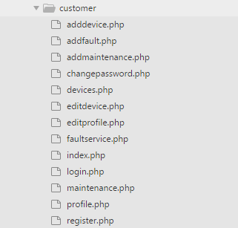

*adddevice.php*

<div class="container" style="margin-bottom:40px">

<h1 class="page-header">Add Device</h1>

<form action="" method="POST" role="form">

<input type="hidden" name="customer_id" value="<?= **$data['customer_id']** ?>">

<div class="form-group">

<label>Product Category</label>

<?php **if**(isset($data['categories'])) : ?>

<select class="form-control" name="device_category_id">

<?php **foreach**($data['categories'] **as** $category): ?>

<option value="<?= $category->id ?>"><?= $category->name ?></option>

<?php **endforeach**; ?>

</select>

<?php **else** : ?>

<div class="alert alert-info">

No Device/Product category found.

</div>

<?php **endif**; ?>

</div>

<div class="form-group">

<label>Brand Name</label>

<input type="text" name="brand_name" class="form-control" placeholder="Brand Name" required>

</div>

<div class="form-group">

<label>Serial No.</label>

<input type="text" name="serial_no" class="form-control" placeholder="Serial No." required>

</div>

<div class="form-group">

<label>Purchased Price</label>

<input type="text" name="purchase_price" class="form-control" placeholder="Purchased Price" required>

</div>

<div class="form-group">

<label>Date of purchase</label>

<input type="date" name="date_of_purchase" class="form-control" placeholder="Date of Purchase" required>

</div>

<button type="submit" name="submit" class="btn btn-primary">ADD</button>

<a href="<?= SC_URL ?>customer/devices" class="btn btn-default">cancel</a>

</form>

</div>

*addfault.php*

<div class="container" style="margin-bottom:40px">

<h1 class="page-header">Request Fault</h1>

<form action="" method="POST" role="form">

<input type="hidden" name="type" value="fault_repair">

<div class="form-group row">

<?php **if**(isset($data['devices'])) : ?>

<div class="col-md-9">

<label>Product/Device :</label>

<select class="form-control" name="device_id">

<?php **foreach**($data['devices'] **as** $device): ?>

<option value="<?= $device->id ?>"><?= $device->device_category_name.' : '.$device->brand_name.' '.$device->serial_no ?></option>

<?php **endforeach**; ?>

</select>

</div>

<div class="col-md-3">

<label style="margin:5px 25px 5px 5px;padding:15px" class="alert-danger">OR</label>

<a class="btn btn-success" href="<?= SC_URL ?>customer/adddevice">Add New Device</a>

</div>

<?php **else** : ?>

<label>Product/Device :</label>

<div class="alert alert-info">

No Product/Device found, Please Add your device from <strong><a href="<?= SC_URL ?>customer/devices">here</a></strong>, then come back to add your repair request.

</div>

<?php **endif**; ?>

</div>

<div class="form-group">

<label>Description :</label>

<textarea name="description" class="form-control" placeholder="Describe those problems"></textarea>

</div>

<div class="row">

<div class="col-md-4">

<div class="checkbox">

<label>

<input id="alt-address" type="checkbox" checked>

Address and Phone Same as your Profile

</label>

</div>

</div>

<div id="alt-address-box" class="col-md-8 hide">

<div class="form-group">

<label>Alternative Address :</label>

<input name="alternative_address" type="text" class="form-control" placeholder="If address is not same as your profile address">

</div>

<div class="form-group">

<label>Alternative Phone :</label>

<input name="alternative_phone" type="text" class="form-control" placeholder="If phone no. is not same as your profile phone no.">

</div>

</div>

</div>

<button name="submit" type="submit" class="btn btn-primary">Add</button>

<a href="<?= SC_URL ?>customer/faultservice" class="btn btn-default">cancel</a>

</form>

</div>

*addmaintenance.php*

<div class="container" style="margin-bottom:40px">

<h1 class="page-header">Add Maintenance</h1>

<form name="add-maintenance" action="" method="POST" role="form">

<input type="hidden" name="type" value="maintenance">

<input type="hidden" name="price" value="1000.00">

<div class="form-group row">

<?php **if**(isset($data['devices'])) : ?>

<div class="col-md-9">

<label>Choose Device :</label>

<select class="form-control" name="device_id">

<?php **foreach**($data['devices'] **as** $device): ?>

<option value="<?= $device->id ?>"><?= $device->device_category_name.' : '.$device->brand_name.' '.$device->serial_no ?></option>

<?php **endforeach**; ?>

</select>

</div>

<div class="col-md-3">

<label style="margin:5px 25px 5px 5px;padding:15px" class="alert-danger">OR</label>

<a class="btn btn-success" href="<?= SC_URL ?>customer/adddevice">Add New Device</a>

</div>

<?php **else** : ?>

<label>Choose Device :</label>

<div class="alert alert-info">

No Product/Device found, Please Add your device from <strong><a href="<?= SC_URL ?>customer/devices">here</a></strong>, then come back to add your repair request.

</div>

<?php **endif**; ?>

</div>

<div class="form-group">

<label>Any Special Note/Suggestion :</label>

<textarea name="description" class="form-control" placeholder="* You want this service based on appointment, etc.

* You want to negociate before purchasing.

* You to try our services, etc.

* Any Special notes to remember, during providing serives at home/office." rows=4></textarea>

</div>

<div class="form-group">

<label>Duration (Years):</label>

<select name="duration" class="form-control" required>

<option value="1">1 Year</option>

<option value="2">2 Year</option>

<option value="3">3 Year</option>

<option value="4">4 Year</option>

<option value="5">5 Year</option>

</select>

</div>

<div class="form-group">

<label>Amount to Pay(Rs):</label>

<span class="alert-warning form-control price">1000</span>

<input name="price" type="hidden" value="1000">

</div>

<div class="row">

<div class="col-md-4">

<div class="checkbox">

<label>

<input id="alt-address" type="checkbox" checked>

Address and Phone Same as your Profile

</label>

</div>

</div>

<div id="alt-address-box" class="col-md-8 hide">

<div class="form-group">

<label>Alternative Address :</label>

<input name="alternative_address" type="text" class="form-control" placeholder="If address is not same as your profile address">

</div>

<div class="form-group">

<label>Alternative Phone :</label>

<input name="alternative_phone" type="text" class="form-control" placeholder="If phone no. is not same as your profile phone no.">

</div>

</div>

</div>

<button name="submit" type="submit" class="btn btn-primary">Add</button>

<a href="<?= SC_URL ?>customer/maintenance" class="btn btn-default">cancel</a>

</form>

</div>

*changepassword.php*

<div class="wrapper">

<div class="container">

<form name="change-password" action="" class="form-horizontal" method="POST" role="form">

<legend class="page-header">Edit Profile</legend>

<input type="hidden" name="id" value="<?= **$_SESSION['user']**->id ?>">

<div class="form-group">

<label class="control-label col-md-2">**New** Password :</label>

<div class="col-md-10">

<input id="password" name="password" type="password" class="form-control" placeholder="New Password" required>

</div>

</div>

<div class="form-group">

<label class="control-label col-md-2">Confirm Password :</label>

<div class="col-md-10">

<input id="confirm_password" name="confirm_password" type="password" class="form-control" placeholder="Confirm Password" required>

</div>

</div>

<div class="form-group">

<div class="col-md-4 col-md-offset-2">

<button name="submit" type="submit" class="btn btn-lg btn-success">Update</button>

<a href="<?= SC_URL ?>customer/profile" class="btn btn-lg btn-default">cancel</a>

</div>

</div>

</form>

</div>

</div>

*devices.php*

<div class="container" style="margin-bottom:40px">

<a class="btn btn-default btn-back" href="<?= SC_URL ?>customer"><span class="glyphicon glyphicon-arrow-left"></span> back</a>

<h1 class="page-header">Devices <a class="btn btn-primary pull-right" href="<?= SC_URL ?>customer/adddevice">Add</a></h1>

<p class="alert alert-info">In order to access of different services, like <span class="alert-warning">FAULT REPAIR</span> **or** <span class="alert-warning">MAINTENANCE</span>, You must add your device in **this** **list**.</p>

<div class="clearfix" style="padding:0 0 20px 0">

<form name="pagination-form" class="pull-right form form-inline" action="" method="POST" role="form">

<input name="offset" type="hidden" value="0">

<div class="form-group">

<label **for**="">Number of records: </label>

<select name="limit" class="form-control">

<option value="10" <?= ($data['limit']==10)?'selected':'' ?>>10</option>

<option value="20" <?= ($data['limit']==20)?'selected':'' ?>>20</option>

<option value="50" <?= ($data['limit']==50)?'selected':'' ?>>50</option>

<option value="100" <?= ($data['limit']==100)?'selected':'' ?>>100</option>

</select>

</div>

</form>

</div>

<table class="table table-hover">

<thead>

<tr>

<th>ID</th>

<th>Product Category</th>

<th>Brand Name</th>

<th>Serial No.</th>

<th>Purchase Price</th>

<th>Date of Purchase</th>

<th>Option</th>

</tr>

</thead>

<tbody>

<?php **if**(isset($data['devices']) && count($data['devices'])>0) :

**foreach**($data['devices'] **as** $device) : ?>

<tr>

<td><?= $device->id ?></td>

<td><?= $device->device_category_name ?></td>

<td><?= $device->brand_name ?></td>

<td><?= $device->serial_no ?></td>

<td><?= $device->purchase_price ?></td>

<td><?= $device->date_of_purchase ?></td>

<td>

<a class="btn btn-success" href="<?= SC_URL ?>customer/editdevice?id=<?= $device->id ?>">edit</a></td>

</tr>

<?php **endforeach**;

**else**: ?>

<tr><td colspan="7" class="alert alert-info">No Product/Device found.</td></tr>

<?php **endif**;?>

</tbody>

</table>

<?php **if**(isset($data['totalPages']) && !**empty**($data['totalPages'])): ?>

<div class="clearfix">

<ul class="pagination pull-right">

<?php **for**($i = 0; $i < $data['totalPages']; $i++) : ?>

<li class="<?= ($data['currentPage']==$i+1)?'active':'' ?>"><a class="page-change" href=""><?= $i+1 ?></a></li>

<?php **endfor**; ?>

</ul>

</div>

<?php **endif**; ?>

</div>

*editdevice.php*

<div class="container" style="margin-bottom:40px">

<h1 class="page-header">Add Device</h1>

<form action="" method="POST" role="form">

<input type="hidden" name="id" value="<?= **$data['device']**->id ?>">

<input type="hidden" name="customer_id" value="<?= **$data['customer_id']** ?>">

<div class="form-group">

<label>Product Category</label>

<?php **if**(isset($data['categories'])) : ?>

<select class="form-control" name="device_category_id">

<?php **foreach**($data['categories'] **as** $category):

$selected=($category->id==$data['device']->device_category_id)?'selected':'';?>

<option value="<?= $category->id ?>" <?= $selected ?>><?= $category->name ?></option>

<?php **endforeach**; ?>

</select>

<?php **else** : ?>

<div class="alert alert-info">

No Device/Product category found.

</div>

<?php **endif**; ?>

</div>

<div class="form-group">

<label>Brand Name</label>

<input type="text" name="brand_name" class="form-control"

value="<?= $data['device']->brand_name ?>"

placeholder="Brand Name" required>

</div>

<div class="form-group">

<label>Serial No.</label>

<input type="text" name="serial_no" class="form-control"

value="<?= $data['device']->serial_no ?>"

placeholder="Serial No." required>

</div>

<div class="form-group">

<label>Purchased Price</label>

<input type="text" name="purchase_price" class="form-control"

value="<?= $data['device']->purchase_price ?>"

placeholder="Purchased Price" required>

</div>

<div class="form-group">

<label>Date of purchase</label>

<input type="date" name="date_of_purchase" class="form-control"

value="<?= $data['device']->date_of_purchase ?>"

placeholder="Date of Purchase" required>

</div>

<button type="submit" name="submit" class="btn btn-primary">update</button>

<a href="<?= SC_URL ?>customer/devices" class="btn btn-default">cancel</a>

</form>

</div>

*editprofile.php*

<div class="wrapper" >

<div class="container">

<form name="edit-profile" action="" class="form-horizontal" method="POST" role="form">

<legend class="page-header">Edit Profile</legend>

<input type="hidden" name="id" value="<?= **$_SESSION['user']**->id ?>">

<div class="form-group">

<label class="control-label col-md-2">Username :</label>

<div class="col-md-10">

<input name="name" type="text" class="form-control" placeholder="Your Full Name" value="<?= **$_SESSION['user']**->username ?>" readonly>

</div>

</div>

<div class="form-group">

<label class="control-label col-md-2">Name :</label>

<div class="col-md-10">

<input name="name" type="text" class="form-control" placeholder="Your Full Name" value="<?= **$_SESSION['user']**->name ?>" required>

</div>

</div>

<div class="form-group">

<label class="control-label col-md-2">Address :</label>

<div class="col-md-10">

<input name="address" type="text" class="form-control" placeholder="Your Full Address" value="<?= **$_SESSION['user']**->address ?>" required>

</div>

</div>

<div class="form-group">

<label class="control-label col-md-2">Phone No :</label>

<div class="col-md-10">

<input name="phone" type="text" class="form-control" placeholder="Your Phone No." value="<?= **$_SESSION['user']**->phone ?>" required>

</div>

</div>

<div class="form-group">

<div class="col-md-4 col-md-offset-2">

<button name="submit" type="submit" class="btn btn-lg btn-success">Update</button>

<a href="<?= SC_URL ?>customer/profile" class="btn btn-lg btn-default">cancel</a>

</div>

</div>

</form>

</div>

</div>

*faultservice.php*

<div class="container" style="margin-bottom:40px">

<a class="btn btn-default btn-back" href="<?= SC_URL ?>customer"><span class="glyphicon glyphicon-arrow-left"></span> back</a>

<h1 class="page-header">Fault Repair Request <a class="btn btn-primary pull-right" href="<?= SC_URL ?>customer/addfault">Add</a></h1>

<div class="row">

<div class="col-md-9">

<table class="table table-hover">

<thead>

<tr>

<th>ID</th>

<th>Product</th>

<!-- <th>Alternative Address</th>

<th>Alternative Phone</th> -->

<th>Status</th>

<th>Date of Request</th>

<!-- <th>options</td> -->

</tr>

</thead>

<tbody>

<?php **if**(isset($data['services']) && !**empty**($data['services'])) :

**foreach**($data['services'] **as** $service) : ?>

<tr>

<td><?= $service->id ?></td>

<td><?= $service->device_name ?> (<a href="<?= SC_URL ?>customer/editdevice?id=<?= $service->device_id ?>"><?= $service->device_id ?></a>)</td>

<!-- <td><?= $service->alternative_address ?></td>

<td><?= $service->alternative_phone ?></td> -->

<td class="<?=($service->status=='REQUESTED')?'alert alert-info':(($service->status=='PAID')?'alert alert-success':'alert alert-warning') ?>"><?= $service->status ?></td>

<td><?= $service->requested_date ?></td>

<!-- <td><a href="">view</a></td> -->

</tr>

<?php **endforeach**;

**else** : ?>

<tr><td class="alert alert-info" colspan=7>No Past Fault Repair Request found.</td><tr>

<?php **endif**; ?>

</tbody>

</table>

</div>

<div class="col-md-3">

<p>Repair means responding to the breakdown of equipment and undertaking work to correct the problem in order to return the equipment to a working condition.</p>

<ul>

<li>

<strong>Simple repairs</strong> can be done by the in-house or external maintenance and repair team. If the equipment is repaired where it is used, it is important that the team is trained to work safely and that they don't create hazards for customers or staff.

</li>

<li>

<strong>More complex repairs</strong> will be carried out by specialised maintenance personnel; they might come to the eye care unit or you may have to send the equipment to them for repairs.

</li>

</ul>

</div>

</div>

</div>

*index.php*

<div class="container dashboard">

<h1 class="page-header">Dashboard</h1>

<ul class="list-group list-inline clearfix">

<li class="col-md-3"><a href="<?= SC_URL ?>customer/profile">

<span class="glyphicon glyphicon-user"></span>

<br>

Manage Your Profile

</a></li>

<li class="col-md-3"><a href="<?= SC_URL ?>customer/devices">

<span class="glyphicon glyphicon-asterisk"></span>

<br>

Manage Your Device

</a></li>

<li class="col-md-3"><a href="<?= SC_URL ?>customer/faultservice">

<span class="glyphicon glyphicon-cog"></span>

<br>

Request Fault Service

</a></li>

<li class="col-md-3"><a href="<?= SC_URL ?>customer/maintenance">

<span class="glyphicon glyphicon-wrench"></span>

<br>

Subscribe Maintenance Service

</a></li>

</ul>

</div>

*login.php*

<div class="wrapper parallax-01">

<div class="container login">

<div class="row">

<div class="panel panel-danger col-md-8 col-md-offset-2">

<div class="panel-header">

<h1 class="title">Login</h1>

</div>

<div class="panel-body">

<?php **if**(isset($data['error'])) : ?>

<div class="alert alert-danger">

<button type="button" class="close" data-dismiss="alert" aria-hidden="true">&times;</button>

<?= $data['error'] ?>

</div>

<?php **endif**; ?>

<form name="customer-login" action="<?= SC_URL ?>customer/login" method="post" class="form-horizontal">

<div class="form-group">

<label class="control-label col-md-3">Username :</label>

<div class="col-md-9">

<input name="username" type="text" class="form-control" placeholder="Your Username" required>

</div>

</div>

<div class="form-group">

<label for="password" class="control-label col-md-3">Password :</label>

<div class="col-md-9">

<input name="password" type="password" class="form-control" placeholder="Your Password" required>

</div>

</div>

<div class="form-group">

<button name="submit" class="btn btn-success btn-lg btn-border-success col-md-6 col-md-offset-4" type="submit">Login</button>

</div>

</form>

<div class="not-mem">

<h4 style="text-align:center">Don't have account?

<a href="<?= SC_URL ?>customer/register" class="btn btn-lg btn-primary btn-border-primary">Register</a>

</h4>

</div>

</div>

</div>

</div>

</div>

</div>

*maintenance.php*

<div class="container" style="margin-bottom:40px">

<a class="btn btn-default btn-back" href="<?= SC_URL ?>customer"><span class="glyphicon glyphicon-arrow-left"></span> back</a>

<h1 class="page-header">Maintenance Request <a class="btn btn-primary pull-right" href="<?= SC_URL ?>customer/addmaintenance">Add</a></h1>

<div class="row">

<div class="col-md-9">

<table class="table table-hover">

<thead>

<tr>

<th>ID</th>

<th>Product</th>

<!-- <th>Alternative Address</th>

<th>Alternative Phone</th> -->

<th>Status</th>

<th>Date of Request</th>

<!-- <th>options</td> -->

</tr>

</thead>

<tbody>

<?php **if**(isset($data['services']) && !**empty**($data['services'])) :

**foreach**($data['services'] **as** $service) : ?>

<tr>

<td><?= $service->id ?></td>

<td><?= $service->device_name ?> (<a href="<?= SC_URL ?>customer/editdevice?id=<?= $service->device_id ?>"><?= $service->device_id ?></a>)</td>

<!-- <td><?= $service->alternative_address ?></td>

<td><?= $service->alternative_phone ?></td> -->

<td class="<?=($service->status=='REQUESTED')?'alert alert-info':(($service->status=='PAID')?'alert alert-success':'alert alert-warning') ?>"><?= $service->status ?></td>

<td><?= $service->requested_date ?></td>

<!-- <td><a href="">view</a></td> -->

</tr>

<?php **endforeach**;

**else** : ?>

<tr><td class="alert alert-info" colspan=7>No Past Maintenance Request found.</td><tr>

<?php **endif**; ?>

</tbody>

</table>

</div>

<div class="col-md-3">

<p>We Are providing Quater cycle of maintenance to your devices</p>

<p> These schedules should provide simple guidelines for all types of equipment, covering the tasks to be undertaken in the following areas:</p>

<ul>

<li>Care and cleaning</li>

<li>Safety checks</li>

<li>Functional and performance checks</li>

<li>Maintenance tasks (changing parts, lubricating moving parts, etc.)</li>

</ul>

</div>

</div>

</div>

*profile.php*

<div class="container">

<a class="btn btn-default btn-back" href="<?= SC_URL ?>customer"><span class="glyphicon glyphicon-arrow-left"></span> back</a>

<h1 class="page-header">Your Profile</h1>

<ul class="list-group">

<li class="list-group-item"><strong>Username:</strong> <?= $_SESSION['user']->username ?></li>

<li class="list-group-item"><strong>Name:</strong> <?= $_SESSION['user']->name ?></li>

<li class="list-group-item"><strong>Address:</strong> <?= $_SESSION['user']->address ?></li>

<li class="list-group-item"><strong>Phone:</strong> <?= $_SESSION['user']->phone ?></li>

<li class="list-group-item">

<a href="<?= SC_URL ?>customer/editprofile" class="btn btn-success">Edit Details</a>

<a href="<?= SC_URL ?>customer/changepassword" class="btn btn-danger">Change Password</a>

</li>

</ul>

</div>

*register.php*

<div class="wrapper parallax-01">

<div class="container register">

<div class="row">

<div class="panel panel-danger col-md-8 col-md-offset-2">

<div class="panel-header">

<h1 class="title">Register</h1>

</div>

<div class="panel-body">

<?php **if**(isset($data['error'])) : ?>

<div class="alert alert-danger">

<button type="button" class="close" data-dismiss="alert" aria-hidden="true">&times;</button>

<?= $data['error'] ?>

</div>

<?php **endif**; ?>

<form name="customer-register" action="" method="POST" class="form-horizontal">

<div class="form-group">

<label for="username" class="control-label col-md-3">Username :</label>

<div class="col-md-9">

<input name="username" type="text" class="form-control" placeholder="Username" required>

</div>

</div>

<div class="form-group">

<label for="password" class="control-label col-md-3">Password :</label>

<div class="col-md-9">

<input name="password" type="password" class="form-control" placeholder="Password" required>

</div>

</div>

<div class="form-group">

<label for="name" class="control-label col-md-3">Name :</label>

<div class="col-md-9">

<input id="name" name="name" type="text" class="form-control" placeholder="Your Full Name" required>

</div>

</div>

<div class="form-group">

<label for="address" class="control-label col-md-3">Address :</label>

<div class="col-md-9">

<input id="address" name="address" type="text" class="form-control" placeholder="Your Full Address" required>

</div>

</div>

<div class="form-group">

<label for="phone" class="control-label col-md-3">Phone No :</label>

<div class="col-md-9">

<input id="phone" name="phone" type="text" class="form-control" placeholder="+91 5555-555-555" required>

</div>

</div>

<div class="form-group">

<button name="submit" class="btn btn-success btn-lg col-md-4 col-md-offset-4 btn-border-success" type="submit">Register</button>

</div>

</form>

<div class="already-mem">

<h4 style="text-align:center">Already a member ?

<a href="<?= SC_URL ?>customer/login" class="btn btn-lg btn-primary btn-border-primary">login</a>

</h4>

</div>

</div>

</div>

</div>

</div>

</div>

***home folder*** : This folder contains Website modules files, basically those are some static html pages. It has 3 files, index.php, in which is our home page content is written, second is about.php that also have html representation about organization, third file is contact.php, that have a contact form for sending emails to administrator email.

*about.php*

<div class="wrapper">

<div class="about-us">

<div class="parallax-01" style="height:100px"></div>

<h2 class="parallax">ABOUT US</h2>

<div class="container">

<p class="welcome-txt">Our company provide Maintenance Services to our customers on different

household electrical **and** electronics devices such **as** TV, Washing Machine, Refrigerator,

Air Conditioners, Air Coolers, Microwave Ovens etc. The company takes maintenance contract

**for** various households **and** industry clients. They maintain all the information about these

devices including make, date of purchase, serial number of machine, original cost of the

machine etc. The company performs two kinds of maintenance services - preventive maintenance

which are done periodically once in every quarter **and** fault repair - **this** maintenance is done

whenever a call is made by the client. Company maintains the details of both these types of

services including visiting engineer details, name of part replaced **and** date of maintenance.

Company charges **for** replacement of parts. It also provides a two month warranty of replaced

parts. Analyse the requirements in details **and** design & develop the online system **for** the

appointments. You may visit some service centre **and** may study the problem domain. </p>

</div>

<div class="more-about parallax-01">

<div class="container">

<div class="row">

<div class="col-md-6">

<img src="<?= SC_URL ?>img/about.jpg" alt="about" class="img-responsive">

</div>

<div class="col-md-6">

<h2 class="title">More About Us</h2>

<p>We Provide Profesional Service.

Orem Ipsum is simply dummy text of the printing **and** typesetting industry. typesetting, loremIpsum has been the industry's</p>

<p>Lorem Ipsum is simply dummy text of the printing and typesetting industry. typesetting, loremIpsum has been the industry's. There are many variations of lorem passagei of Lorem Ipsum available but the majority have.</p>

<a href="#" class="btn btn-border btn-border-white">More About</a>

</div>

</div>

</div>

</div>

</div>

</div>

*contact.php*

<div class="wrapper">

<div class="contact-us">

<div class="container">

<h1 class="title">CONTACT US</h1>

<div class="panel">

<div class="panel-heading">

<h3>Leave a Message</h3>

</div>

<div class="panel-body">

<form name="contact-form" action="" method="POST" role="form" class="form-horizontal">

<div class="form-group">

<label **for**="name" class="control-label col-md-3">Name :</label>

<div class="col-md-9">

<input id="name" name="name" type="text" class="form-control" placeholder="Your Full Name" required>

</div>

</div>

<div class="form-group">

<label **for**="phone" class="control-label col-md-3">Phone No :</label>

<div class="col-md-9">

<input name="phone" type="text" class="form-control" id="phone" placeholder="Your Phone No" required>

</div>

</div>

<div class="form-group">

<label **for**="message" class="control-label col-md-3">Message :</label>

<div class="col-md-9">

<textarea name="message" id="message" class="form-control" placeholder="Your Message" cols="20" rows="4" required></textarea>

</div>

</div>

<button type="submit" class="btn btn-lg btn-border-primary col-md-4 col-md-offset-4 btn-primary">Submit</button>

</form>

</div>

</div>

</div>

</div>

</div>

*index.php*

<div id="home-carousal" class="carousel slide" > <!-- data-ride="carousel" -->

<div class="carousel-inner">

<div class="item active">

<img src="<?= SC_URL ?>img/carousal/01.jpg">

<div class="container">

<div class="carousel-caption">

<h1>FAULT REPAIR</h1>

<p><span>Our team of Expert Engineers.</span> Repair means responding to the breakdown of equipment **and** undertaking work to correct the problem in order to **return** the equipment to a working condition.</p>

<a class="btn btn-lg btn-primary btn-border btn-border-white" href="<?= SC_URL ?>customer/register" role="button">Register Now <i class="glyphicon glyphicon-arrow-right"></i></a>

</div>

</div>

</div>

<div class="item">

<img src="<?= SC_URL ?>img/carousal/02.jpg">

<div class="container">

<div class="carousel-caption">

<h1>Maintenance Services</h1>

<p><span>We offer quaterly Maintenance services **for** numberous customers around the world **for** both home **and** business.</span></p>

<a class="btn btn-lg btn-primary btn-border btn-border-white" href="<?= SC_URL ?>customer/register">Register Now <i class="glyphicon glyphicon-arrow-right"></i></a>

</div>

</div>

</div>

</div>

<a class="custom-control left" href="#home-carousal" data-slide="prev"><span class="glyphicon glyphicon-chevron-left"></span></a>

<a class="custom-control right" href="#home-carousal" data-slide="next"><span class="glyphicon glyphicon-chevron-right"></span></a>

<!-- <a class="left carousel-control" href="#home-carousal" data-slide="prev"><span class="glyphicon glyphicon-chevron-left"></span></a>

<a class="right carousel-control" href="#home-carousal" data-slide="next"><span class="glyphicon glyphicon-chevron-right"></span></a> -->

<a data-role="anchor" href="#scrollcontent" class="show-content"><span class="glyphicon glyphicon-chevron-down"></span></a>

</div>

<div class="wrapper">

<a id="scrollcontent"></a>

<div class="welcome">

<div class="container">

<h2 class="title">What We Offers?</h2>

<div class="row offer">

<div class="col-xs-4 col-sm-4 col-md-4 col-lg-4">

<div class="offer-icon">

<h4>Quick Repair</h4>

<img class="img-responsive" src="<?= SC_URL ?>img/01-icon.png">

</div>

</div>

<div class="col-xs-4 col-sm-4 col-md-4 col-lg-4">

<div class="offer-icon">

<h4>Home Service</h4>

<img class="img-responsive" src="<?= SC_URL ?>img/02-icon.png">

</div>

</div>

<div class="col-xs-4 col-sm-4 col-md-4 col-lg-4">

<div class="offer-icon">

<h4>Maintenance</h4>

<img class="img-responsive" src="<?= SC_URL ?>img/03-icon.png">

</div>

</div>

</div>

</div>

</div>

</div>

***layouts folder*** : This folder contains, block elements used in website module, like header, footers, variation of footer as footer-1, as follow:

*header.php*

<!DOCTYPE html>

<html lang="en">

<head>

<meta charset="utf-8">

<meta http-equiv="X-UA-Compatible" content="IE=edge">

<meta name="viewport" content="width=device-width, initial-scale=1">

<!-- The above 3 meta tags *must* come first in the head; any other head content must come *after* these tags -->

<meta name="description" content="">

<meta name="author" content="">

<link rel="icon" href="<?= SC_URL ?>img/favicon.png">

<title>Service Center</title>

<!-- Bootstrap core CSS -->

<link href="/bootstrap/3.3.7/css/bootstrap.min.css" rel="stylesheet">

<!-- Custom styles **for** **this** template -->

<link href="<?= SC_URL ?>css/style.css" rel="stylesheet">

<script>

**var** SC_URL = "<?= SC_URL ?>";

</script>

</head>

<body>

<nav class="navbar bg-red <?= is_home('index')?"navbar-fixed-top":""?>">

<div class="container">

<div class="navbar-header">

<button type="button" class="navbar-toggle collapsed" data-toggle="collapse" data-target="#navbar" aria-expanded="false" aria-controls="navbar">

<span class="sr-only">Toggle navigation</span>

<span class="icon-bar"></span>

<span class="icon-bar"></span>

<span class="icon-bar"></span>

</button>

<a class="navbar-brand" href="<?= SC_URL ?>"><img src="<?= SC_URL ?>img/logo-white.png" alt="Hospital Logo"></a>

</div>

<div id="navbar" class="collapse navbar-collapse">

<ul class="nav navbar-nav pull-left">

<li><a href="<?= SC_URL ?>">HOME</a></li>

<li><a href="<?= SC_URL ?>home/about">ABOUT</a></li>

<li><a href="<?= SC_URL ?>home/contact">CONTACT</a></li>

</ul>

<ul class="nav navbar-nav pull-right">

<?php **if**(!isset($_SESSION['user'])): ?>

<li class="dropdown login-dropdown">

<a href="#" class="dropdown-toggle" role="button" aria-haspopup="true" aria-expanded="false">

<span> <b class="glyphicon glyphicon-user"></b></span>

<span>ACCOUNT <b class="caret"></b></span>

</a>

<div class="dropdown-menu bg-red header-login">

<form name="widget-login" action="" method="POST" role="form">

<div class="form-group">

<input type="text" class="form-control" name="username" required placeholder="Username">

</div>

<div class="form-group">

<input type="password" class="form-control" name="password" placeholder="Password" required>

</div>

<div class="form-group">

<button type="submit" class="btn btn-block btn-primary">Login</button>

</div>

</form>

<center>

Not registerd? <a href="<?= SC_URL ?>customer/register">Create an account</a>

</center>

</div>

</li>

<?php **else**: ?>

<li class="dropdown">

<a href="#" class="dropdown-toggle" data-toggle="dropdown" role="button" aria-haspopup="true" aria-expanded="false">

<?= isset($_SESSION['user']->name)?$_SESSION['user']->name:'Guest' ?> <b class="caret"></b></a>

<ul class="dropdown-menu">

<li><a href="<?= SC_URL ?>customer">Dashboard</a></li>

<li><a href="<?= SC_URL ?>customer/logout">logout</a></li>

</ul>

</li>

<?php **endif**; ?>

</ul>

</div><!--/.nav-collapse -->

</div>

</nav>

<div class="flash-msg" style="max-width:250px;position:fixed;right:10px;top:10px;z-index:9999;">

<!-- alerts -->

</div>

*footer.php*

<footer class="footer">

<div class="copyright">

<div class="container">

<p>&copy; Copyright at <a href="http://github.com/sorabh86">SORABH</a>, <a href="http://www.ignou.ac.in/">IGNOU</a> Student, **for** MCA course MSCP-044 Mini Project</p>

</div>

</div>

</footer>

<div class="modal fade" id="status-msg">

<div class="modal-dialog">

<div class="modal-content">

<div class="modal-header">

<button type="button" class="close" data-dismiss="modal" aria-hidden="true">&times;</button>

<h4 class="modal-title">Modal title</h4>

</div>

<div class="modal-body">

</div>

<div class="modal-footer">

<button type="button" class="btn btn-default" data-dismiss="modal">Close</button>

</div>

</div>

</div>

</div>

<div id="loading-image" class="hide">

<div class="loader-bg"></div>

<div class="loader"></div>

</div>

<script src="<?= SC_URL ?>js/jquery.min.js"></script>

<script src="<?= SC_URL ?>js/jquery.validate.min.js"></script>

<script src="<?= SC_URL ?>js/bootstrap.min.js"></script>

<script src="<?= SC_URL ?>js/scroll-native.js"></script>

<script src="<?= SC_URL ?>js/script.js"></script>

</body>

</html>

*footer-1.php*

<div class="bg-red shorcuts">

<div class="container">

<div class="col-md-3">

<h3><small>DEVELOP BY</small> SORABH</h3>

<a href="http://sorabh86.github.com"><img class="img-responsive" src="<?= SC_URL ?>img/1220531.jpg" alt="sorabh"></a>

</div>

<div class="col-md-9 contact-info">

<h3>Contact Info</h3>

<ul class="address list-unstyled">

<li><i class="glyphicon glyphicon-globe pull-left" aria-hidden="true" style="font-size:3em;"></i> Universal Institute of Computer &amp; Technology, Sector 62, Noida, Uttar Pradesh, <span>India.</span></li>

<li><i class="glyphicon glyphicon-envelope" aria-hidden="true"></i> <a href="mailto:ssorabh.ssharma@hotmail.com">ssorabh.ssharma@gmail.com</a></li>

<li><i class="glyphicon glyphicon-phone" aria-hidden="true"></i> <a href="tel:+919891464750">+91-989-146-4750</a></li>

<li><i class="glyphicon glyphicon-cloud-upload" aria-hidden="true"></i> <a href="https://github.com/sorabh86/servicecenter/tree/sideways">Git Repository</a></li>

</ul>

</div>

<div class="clearfix"> </div>

</div>

</div>

**.htaccess file**

*# by default server index available file & folder list in web browser but using minus Indexes it just stop that behaviour*

Options -Indexes

**init.php file**

<?php

*/\*\**

*\* This file is initialise our project by including required files*

*\*/*

*// start session object*

session_start();

*// include core files & external functions*

**require_once** 'core/App.php';

**require_once** 'core/Controller.php';

**require_once** 'functions/functions.php';

*// database details*

define('DB_SERVER', 'localhost');

define('DB_USER', 'root');

define('DB_PASS', 'root');

define('DB_DATA', 'service_center');

1. **css folder** is folder which contains stylesheet for our layout, basically here we have 3 basic files, bootstrap.css, styles.css for customer side, admin-style.css for backhand, there code as follow :

*admin-style.css*

**.list-group-item.active** **a** {

**color**: white;

}

**th**, **td** {

**vertical-align**: **middle** !important;

}

**.gif-loader** {

**position**: **absolute**;

**left**:0;

**top**:0;

**width**:100%;

**height**:100%;

**background**: rgba(0, 0, 0, 0.4) url(../img/loader.gif) **no-repeat** **center**;

}

*bootstrap.min.css : This file is hosted on getbootstrap.com*

*style.css*

**html**,**body**{

**font-family**: 'PT Sans', **sans-serif**;

**height**:100%;

}

**.navbar-toggle** {

**background**: #fff;

**height**: 44px;

}

**.navbar-toggle** **span.icon-bar** {

**background**: #666;

}

**.wrapper** {

*/*margin-top: 51px;*/*

}

**form**[**name**=**book-appointment**] **.nav-tabs** > **li** {

**float**:**none**;

**display**:**inline**-**block**;

zoom:1;

}

**form**[**name**=**book-appointment**] **.nav-tabs** {

**text-align**:**center**;

**margin-bottom**: 20px;

}

*/****************************** loader start ********************************/*

**.gif-loader** {

**position**: **absolute**;

**left**: 0;

**top**: 0;

**width**: 100%;

**height**: 100%;

**background**: rgba(0, 0, 0, 0.4) url(../img/loader.gif) **no-repeat** **center**;

}

**.loader** {

**border**: 10px **solid** #f3f3f3;

**border**-radius: 50%;

**border-top**: 10px **solid** #3498db;

**width**: 60px;

**height**: 60px;

-webkit-animation: spin 1s linear infinite; */* Safari */*

animation: spin 1s linear infinite;

}

*/* Safari */*

**@-webkit-keyframes** **spin** {

**0**% { -webkit-transform: rotate(0deg); }

**100**% { -webkit-transform: rotate(360deg); }

}

**@keyframes** **spin** {

**0**% { transform: rotate(0deg); }

**100**% { transform: rotate(360deg); }

}

*/* *********************** header **************************** */*

**.header-login** {

**width**: 250px;

**padding**: 15px;

**left**: 100%;

transform: translateX(-100%);

}

*/****************************** loader end ********************************/*

#loading-image {

**position**: **fixed**;

**top**: 0;

**left**: 0;

**z-index**: 9999;

}

#loading-image **.loader-bg** {

**position**: **fixed**;

**width**: 100%;

**height**: 100%;

**background**: rgba(0,0,0,0.1);

}

#loading-image **.loader** {

**left**: 50%;

**top**: 50%;

**position**: **fixed**;

transform: translate(-50%,-50%);

}

*/*********************** navbar starts ****************************/*

**.navbar** {

**margin**: 0;

**border**-radius: 0;

}

**.navbar.bg-red** {

**background**: rgba(237, 28, 36, .8);

}

**.navbar-brand** {

**padding**: 5px 15px;

**height**: **auto**;

}

**.navbar-brand** **img** {

**height**: 50px;

}

**.navbar-default** {

**background**: rgba(255,255,255,0.5);

**border**: **none**;

}

**.bg-black** {

**background**: #000;

**color**: #fff

}

**.navbar-nav**>**li**>**a** {

**line-height**: 30px;

**font-weight**: **bold**;

}

**.nav**>**li**>**a**:focus,**.navbar-nav**>**li**>**a**:hover {

**color**: #000;

}

**.navbar-default** **.navbar-nav**>**li**>**a** {

**color**: #383737;

}

*/******************************** navbar ends ****************************/*

*/******************************** carousel starts *****************************/*

#home-carousal**.carousel**,**.item**,**.active**{**height**:100%;}

#home-carousal **.carousel-inner**{**height**:100%;}

#home-carousal **.carousel-caption** {

**top**: 50%;

**background**: rgba(0, 0, 0, 0.3);

*/* box-shadow: 0 0 70px rgba(0, 0, 0, 0.6); */*

**padding**: 40px 20px;

**border**-radius: 50px;

transform: translateY(-50%);

**bottom**: **auto**;

**color**: #fff;

*/* text-shadow: -1px -1px 1px #fff, 0px 0px 1px #fff, 1px 0px 1px #fff, 0px 1px 1px #fff; */*

}

#home-carousal **.carousel-caption** **h1** {

**font-weight**: **bold**;

**font-size**: 3em;

**margin-top**: 0;

**margin-bottom**: 30px;

**color**: #ed1c24;

**text-shadow**: -1px -1px 1px #fff, 0px 0px 1px #fff, 1px 0px 1px #fff, 0px 1px 1px #fff;

}

#home-carousal **.carousel-caption** **p** {

**font-size**: 1.6em;

**margin-bottom**: 30px;

}

#home-carousal**.carousel** **.show-content** {

**display**: **block**;

*/*border-radius: 50% 50% 0 0;*/*

*/*background: rgba(0,0,0,0.5);*/*

**padding**: 20px 20px 5px 20px;

**color**: #fff;

**position**: **absolute**;

**bottom**: 10px;

**left**: 50%;

transform: translateX(-50%);

}

#home-carousal**.carousel** **.show-content**:before {

**content**: '';

**position**: **absolute**;

**left**:50%;

transform:translateX(-50%);

**bottom**:0;

**border-bottom**: 50px **solid** rgba(237, 28, 36, .8);;

**border-left**: 40px **solid** **transparent**;

**border-right**: 40px **solid** **transparent**;

}

#home-carousal**.carousel**:after {

**content**: '';

**width**: 100%;

**height**: 10px;

**position**: **absolute**;

**bottom**: 0;

**background**: rgba(237, 28, 36, .8);;

**left**: 0;

}

**.custom-control** {

**position**: **absolute**;

**background**: rgba(255,255,255,0.5);

**top**: 50%;

transform: translateY(-50%);

**color**: #888;

**padding**: 20px;

}

**.custom-control.left** {

**left**: 0;

}

**.custom-control.right** {

**right**: 0;

}

*/************************** carousal ends *****************************/*

**.bg-red** {

**background**: #ed1c24;

**color**: #fff;

}

**.bg-red** **a** {

**color**:#fff;

}

**.title** {

**position**: **relative**;

**font-weight**: **bold**;

**border-bottom**: 1px **solid** #ed1c24;

**padding-bottom**: 25px;

**font-size**: 3em;

**margin-top**: 55px;

**margin-bottom**: 25px;

}

**.title**:after {

**content** : '';

**position**: **absolute**;

**left**:50%;

transform: translateX(-50%);

**bottom**: -10px;

**border-top**: 10px **solid** #ed1c24;

**border-left**: 10px **solid** **transparent**;

**border-right**: 10px **solid** **transparent**;

}

*/*********************** welcome starts *****************************/*

**.welcome** {

**text-align**: **center**;

}

**.welcome** **.title** {

**border-bottom**: 1px **dashed** #fff;

}

**.welcome** **.title**:after {

**border-top-color**: #fff;

}

**.welcome-txt** {

**font-size**: 1.3em;

**margin-top**: 40px;

**margin-bottom**: 40px;

**line-height**: 2;

}

**.welcome** **.btn-default** {

**margin-bottom**: 50px;

}

*/****************************** welcome ends *********************************/*

*/*************************** choose us starts **************************************/*

**.choose-us** **.title** {

**text-align**: **center**;

}

**.choose-us** **.panel-heading** {

**padding**: 0;

}

**.choose-us** **.panel-heading** **h3** {

**margin**: 0;

**padding**: 20px;

**text-align**: **center**;

}

**.choose-us** **.panel-body** {

**padding**: 0;

**text-align**: **center**;

}

**.choose-us** **.panel-body** **p** {

**margin-top**: 20px;

**margin-left**: 20px;

**margin-right**: 20px;

**margin-bottom**: 20px;

}

**.choose-us** **.panel-body** **.btn** {

**text-align**: **center**;

}

*/*************************** choose us ends **************************************/*

*/************************** test-form start ********************************************/*

**.test-form** {

**padding**: 40px 0;

}

**.testimo** {

**text-align**: **center**;

**color**: #888;

}

**.testimo** **h2** {

**margin-top**: 0;

**font-weight**: **bold**;

**margin-bottom**: 20px;

}

**.testimo** **h3** {

**margin-top**: 0;

**margin-bottom**: 20px;

}

**.testimo** **.carousel-html** {

**width**:100%;

**height**:500px;

**min-width**:100%;

**min-height**:500px;

**max-width**:100px;

**max-height**:500px;

**overflow**:**hidden**;

**display**:**block**;

*/*border:1px solid red;*/*

}

**.testimo** **.carousel-caption** **p** {

**margin-top**: 25px;

**margin-bottom**: 0;

**color**: #888;

}

**.test-form** **.panel** {

**margin**: 0;

**color**: #222;

}

**.test-form** **.panel** **.panel-heading** {

**text-align**: **center**;

**position**: **relative**;

**padding-bottom**: 25px;

}

**.test-form** **.panel** **.panel-heading**:after {

**content** : 'OR';

**background**: #ed1c24;

box-shadow: 1px 1px 3px **inset** rgba(0,0,0,0.4);

**position**: **absolute**;

**left**: 50%;

**bottom**: -20px;

transform: translateX(-50%);

*/*color: #000;*/*

**border**-radius: 50%;

**padding**: 10px;

**font-weight**: **bold**;

}

**.test-form** **.panel-heading** **h3** {

**padding-bottom**: 10px;

*/*text-shadow: -1px -1px 1px #000;*/*

}

**.test-form** **.panel-heading** **p** {

**font-size**: 1.5em;

*/*font-weight: bold;*/*

box-shadow: 0 0 8px **inset** #000;

}

**.test-form** **.panel-heading** **p** **span** {

**position**: **relative**;

**margin-right**: 10px;

**font-size**: 1em;

}

**.test-form** **.panel-heading** **p** **span**:after {

**content**: '';

**width**: 40px;

**height**: 40px;

**border**-radius: 50%;

**border**: 3px **solid** #fff;

**position**: **absolute**;

**left**: -9px;

**top**: -9px;

}

*/************************** test-form start ********************************************/*

**.btn-border** {

**background-color**: **transparent**;

**border**-radius: 40px;

**padding**: 10px 40px;

**border-style**: **solid**;

**border-width**: 2px;

**font-weight**: **bold**;

}

**.btn-border-white** {

**border-color**: #fff;

**color**: #fff;

}

**.btn-border-black** {

**border-color**: #000;

**color**: #000;

}

**.input-block** {

**width**: 100%;

}

**.btn-border-white.input-block**::placeholder { */* Chrome, Firefox, Opera, Safari 10.1+ */*

**color**: white;

**opacity**: 1; */* Firefox */*

}

**.btn-border-white.input-block**:-ms-input-placeholder { */* Internet Explorer 10-11 */*

**color**: white;

}

**.btn-border-white.input-block**::-ms-input-placeholder { */* Microsoft Edge */*

**color**: white;

}

*/******************************** footer start ***************************/*

**.footer** {

**border-top**:2px **solid** #ed1c24;

}

*/******************************** footer start ***************************/*

**.shorcuts** {

**padding**: 40px 0;

}

**.shorcuts** **h3** {

**margin**: 0;

**font-weight**: **bold**;

**margin-bottom**: 10px;

}

**.shorcuts** **h3** **small** {

**color**: #f1f1f1;

}

**.shorcuts** **.contact-info** **h3** {

**text-align**: **center**;

**position**: **relative**;

**padding-bottom**: 15px;

**margin-bottom**: 40px;

**border-bottom**: 1px **solid** #fff;

}

**.shorcuts** **.contact-info** **h3**:after {

**content**: '';

**border-top**: 10px **solid** #fff;

**border-left**: 10px **solid** **transparent**;

**border-right**: 10px **solid** **transparent**;

**position**: **absolute**;

**left**: 50%;

transform: translateX(-50%);

**bottom**: -10px;

}

**.shorcuts** **.contact-info** **ul** {

**margin**: 20px;

**letter-spacing**: 1px;

**line-height**: 1.6em;

**font-size**: 1.2em;

}

**.shorcuts** **.contact-info** **li** {

**margin-bottom**: 10px;

}

**.shorcuts** **.contact-info** **li** **i** {

**margin-right**: 20px;

}

**.shorcuts** **.newletter** **h3** {

**text-align**: **center**;

**position**: **relative**;

**padding-bottom**: 15px;

**margin-bottom**: 20px;

**border-bottom**: 1px **solid** #fff;

}

**.shorcuts** **.newletter** **h3**:after {

**content**: '';

**border-top**: 10px **solid** #fff;

**border-left**: 10px **solid** **transparent**;

**border-right**: 10px **solid** **transparent**;

**position**: **absolute**;

**left**: 50%;

transform: translateX(-50%);

**bottom**: -10px;

}

**.copyright** {

**padding**: 30px 0;

**font-size**: 1.2em;

}

**.copyright** **p** {

**margin**: 0;

}

*/* ************* offer ****************** */*

**.offer** {

**margin-bottom**: 40px;

}

**.offer-icon** {

**margin**: 0 **auto**;

**border**: 1px **solid** #ed1c24;

**padding**: 20px;

**border**-radius: 20px;

}

**.offer-icon** **h4** {

**background**: #ed1c24;

**padding**: 20px;

**color**: white;

**border**-radius: 10px;

}

*/********************* parallax start **************************/*

**.parallax-01** {

*/* The image used */*

**background-image**: url('../img/parallax/01.jpg');

*/* Set a specific height */*

*/*height: 300px; */*

*/* Create the parallax scrolling effect */*

**background-attachment**: **fixed**;

**background-position**: **center**;

**background-repeat**: **no-repeat**;

**background**-**size**: cover;

}

*/* Turn off parallax scrolling for all tablets and phones. Increase/decrease the pixels if needed */*

**@media** **only** **screen** **and** (**max-device-width**: **1366px**) {

**.parallax** {

**background-attachment**: **scroll**;

}

}

*/********************* parallax end **************************/*

**.about-us** **.parallax-01** {

**position**: **relative**;

}

**.about-us** **h2.parallax** {

*/*position: absolute;*/*

*/*bottom: 20px;*/*

*/*left: 50%;*/*

*/*transform: translateX(-50%);*/*

**font-size**: 3em;

**font-weight**: **bold**;

**text-align**: **center**;

**margin**: 0;

**color**: #fff;

**border-bottom-color**: #fff;

**text-shadow**: 2px -2px 2px #000;

**position**: **relative**;

**top**: -60px;

**height**: 0;

}

**.about-us** **.team** **.title** {

**text-align**: **center**;

}

**.about-us** **.team** **.thumbnail** {

**text-align**: **center**;

}

**.about-us** **.team** **.thumbnail** **h4** {

**margin-top**: 15px;

**margin-bottom**: 5px;

}

**.about-us** **.more-about** {

**color**: #fff;

**margin-top**: 20px;

**text-align**: **center**;

}

**.about-us** **.more-about** **.title** {

**text-align**: **center**;

**border-bottom-color**: #fff;

**margin-bottom**: 40px;

}

**.about-us** **.more-about** **.title**:after {

**border-top-color**: #fff;

}

**.about-us** **.more-about** **p** {

**font-size**: 1.3em;

**margin-bottom**: 20px;

**text-align**: **left**;

**line-height**: 2em;

}

*/************************** contact us ************************/*

**.contact-us** {

**margin-top**: 40px;

}

**.contact-us** **.title** {

**text-align**: **center**;

**margin-bottom**: 50px;

}

**.contact-us** **.panel** {

**border**-radius: 30px;

**margin-bottom**: 40px;

}

**.contact-us** **.panel** **.panel-heading** {

**border**-radius: 30px 30px 0 0;

**margin-bottom**: 20px;

}

**.contact-us** **.panel** **.panel-body** {

**padding-left**: 20px;

**padding-right**: 20px;

}

**.contact-us** **.panel** **h3** {

**text-align**: **center**;

}

**.contact-us** **.panel** **input** {

**border**-radius: 30px;

**padding**: 15px;

**height**: **auto**;

box-shadow: **none**;

}

**.contact-us** **.panel** **textarea** {

**border**-radius: 10px;

**padding**: 15px;

**height**: **auto**;

box-shadow: **none**;

}

**.contact-us** **.panel** **button**[**type**=**submit**] {

**margin-top**: 20px;

**margin-bottom**: 20px;

}

*/************************* registation form start **********************************/*

**.register** {

**padding-top**:20px;

}

**.register** **.panel** {

**color** : #333;

**border**-radius: 40px;

}

**.register** **.panel** **.title** {

**color**: #5cb85c;

**text-align**: **center**;

**margin-top**: 30px;

**margin-bottom**: 20px;

**padding-bottom**: 20px;

**border-bottom-color**: #5cb85c;

}

**.register** **.panel** **.title**:after {

**border-top-color**: #5cb85c;

}

**.register** **.panel** **input**, **.register** **.panel** **select** {

**border**-radius: 40px;

**background**: **transparent**;

box-shadow: **none**;

**padding**: 10px 20px;

**height**: **auto**;

}

**.register** **.panel** **button**[**type**=**submit**] {

**margin-top**: 20px;

}

**.register** **.already-mem** {

**border-top**: 1px **solid** #5cb85c;

**margin-top**: 30px;

**padding**: 10px;

}

**.register** **.already-mem** **.btn** {

**margin-left**: 20px;

**min-width**: 150px;

}

*/************************* registation form end **********************************/*

**.btn-border-primary** {

**border**-radius: 30px;

**background**: **transparent**;

**color**: #337ab7;

**border-color**: #337ab7

}

**.btn-border-success** {

**border**-radius: 30px;

**background**: **transparent**;

**color**: #5cb85c;

**border-color**: #5cb85c

}

*/************************* login form start **********************************/*

**.login** {

**padding-top**:80px;

**padding-bottom**: 80px;

}

**.login** **.panel** {

**color** : #333;

**border**-radius: 40px;

}

**.login** **.panel** **.title** {

**color**: #5cb85c;

**text-align**: **center**;

**margin-top**: 30px;

**margin-bottom**: 20px;

**padding-bottom**: 20px;

**border-bottom-color**: #5cb85c;

}

**.login** **.panel** **.title**:after {

**border-top-color**: #5cb85c;

}

**.login** **.panel** **input**, **.login** **.panel** **select** {

**border**-radius: 40px;

**background**: **transparent**;

box-shadow: **none**;

**padding**: 10px 20px;

**height**: **auto**;

}

**.login** **.panel** **button**[**type**=**submit**] {

**margin-top**: 20px;

}

**.login** **.not-mem** {

**border-top**: 1px **solid** #5cb85c;

**margin-top**: 30px;

**padding**: 10px;

}

**.login** **.not-mem** **.btn** {

**margin-left**: 20px;

**min-width**: 150px;

}

*/************************* login form ends **********************************/*

**.btn-back** {

**margin-top**:20px;

}

*/* ***************** dashboard ******************** */*

**.dashboard** **.list-group** {

**margin-bottom**: 40px;

}

**.dashboard** **.list-group** **a** {

**text-align**: **center**;

**margin-bottom**: 20px;

**display**: **block**;

**border**: 2px **solid**;

**padding**: 30px;

**text-decoration**: **none**;

**line-height**: 2em;

transition: 0.4s all ease-in-out;

}

**.dashboard** **.list-group** **.glyphicon** {

*/* color:#ed1c24; */*

**font-size**: 100px;

transform: rotate(0deg) scale(0.8);

transition: 0.5s all;

}

**.dashboard** **a**:hover {

**background**:#f1f1f1;

**color**:#000;

**border**:2px **solid** #000

}

**.dashboard** **a**:hover **.glyphicon** {

transform: rotate(360deg) scale(1.1);

}

*/* It is a long file but i wanted to introduce you to some special things in CSS, which is available in all modern web browsers now days */*

*/* Safari & webkit browser to animate using CSS3 animation */*

**@-webkit-keyframes** **spin** {

**0**% { -webkit-transform: rotate(0deg); }

**100**% { -webkit-transform: rotate(360deg); }

}

*/* Key frames are used to animate using CSS3 */*

**@keyframes** **spin** {

**0**% { transform: rotate(0deg); }

**100**% { transform: rotate(360deg); }

}

*/* Media query is used in CSS 3 for change orientation in different devices based on device width in pixel or dpi */*

**@media** **only** **screen** **and** (**max-device-width**: **1366px**) {

**.parallax** {

**background-attachment**: **scroll**;

}

}

*...*

1. **img folder** is folder which contains media files in our case images, like png, jpg, gif, etc.
2. **js folder** contains JavaScript files for various forms and webpages. Basically we are using two JavaScript files here, admin-script.js for admin area, and script.js for customer and frontend, code of above files as below:

*script.js*

;(**function**(so) {

'use strict';

**var** $flash = $('.flash-msg');

**var** $html = $('<div class="alert alert-dismissible" style="cursor:pointer" role="alert" data-dismiss="alert">\

<span class="msg">Better check yourself, you\'re not looking too good.<span>\

</div>');

so.flash = **function** (type,msg){

**switch** (type) {

**case** 'success':

$html.addClass('alert-success');

**break**;

**case** 'error':

$html.addClass('alert-error');

**break**;

**case** 'warning':

$html.addClass('alert-warining');

**break**;

**case** 'info':

$html.addClass('alert-info');

**break**;

}

$html.html(msg);

$flash.append($html);

};

so.render = {

doctorSelectOption : **function** (arr) {

**var** html = "";

**for** (**var** str **in** arr) {

html += '<option value="'+arr[str].id+'">'+arr[str].name+'</option>';

}

**return** html;

}

};

})(window.so = window.so || {});

*// we had write some logics for various forms behaviours in this system for website & customer module.*

(**function** ($) {

**var** $registerForm = $(document.forms['customer-register']);

**var** $loginForm = $(document.forms['customer-login']);

**var** $changePassword = $(document.forms['change-password']);

**var** $bookAppForm = $(document.forms['book-appointment']);

**var** $contactForm = $(document.forms['contact-form']);

**if**($contactForm) {

$contactForm.validate({

rules: {

name : { minlength:6 }, phone : {

number:**true**,

required:**true**,

minlength:10

}, message : { minlength:12 }

},

messages: {

phone: {

required: "We need your phone number to contact you",

minlength: jQuery.validator.format("At least {0} characters required!")

}

}

})

}

**if**($registerForm) {

$registerForm.validate({

rules: {

password: { minlength: 5 },

confirm_password: {

minlength: 5,

equalTo: "#password"

}

}

});

}

**if**($changePassword) {

$changePassword.validate({

rules: {

password: { minlength: 5 },

confirm_password: {

minlength: 5,

equalTo: "#password"

}

}

});

}

**if** ($loginForm) { $loginForm.validate(); }

**if**($bookAppForm) {

$bookAppForm.validate({

rules : {

appointment_hour: {min: 1, max: 4}

}

});

}

console.log('script running');

$('.newletter form').submit(**function**(e){

e.stopPropagation();

**var** $this = $(e.currentTarget);

$.ajax({

url: SC_URL+'/subscriber/add',

type: 'POST',

data: {

email : $this.find('input[name=email]').val()

}

}).success(**function**(s){

**var** s = JSON.parse(s);

$statusMsg = $('#status-msg');

$statusMsg.find('.modal-title').html(s.status);

$statusMsg.find('.modal-body').html(s.message);

$statusMsg.modal();

});

**return** **false**;

});

*// loading ajax*

$('#loading-image').bind('ajaxStart', **function**(){

$(**this**).show();

}).bind('ajaxStop', **function**(){

$(**this**).hide();

});

*/* book an appointment form name=book-appointment */*

**if**(document.forms['book-appointment']) {

$(document.forms['book-appointment']['expertise_id']).change(**function**(e){

**var** $this = $(e.currentTarget);

$.ajax({

url: SC_URL+'/patient/drexpertise',

type: 'POST',

data: {

id : $this.val()

}

}).success(**function**(s){

s = JSON.parse(s);

**if**(s.id) {

$(document.forms['book-appointment']).find('#dr-exp-desc').html(s.description);

$.ajax({

url: SC_URL+'/patient/drbyexpertise',

type: "POST",

data: {

expertise_id:$this.val()

}

}).success(**function**(s){

$.ajax({

url: SC_URL+'/doctor/expertiseidjson/'+$this.val(),

type: "POST",

}).success(**function**(s){

s = JSON.parse(s);

$docSelect = $(document.forms['book-appointment']['doctor_id']);

$docSelect.not(':first').remove();

$docSelect.append(so.render.doctorSelectOption(s));

$docSelect.val(window.appointment.doctor_id).change();

});

});

}

});

**return** **false**;

});

**if**(window.appointment) {

$(document.forms['book-appointment']['appointment_type']).val(window.appointment.appointment_type).change();

$(document.forms['book-appointment']['expertise_id']).val(window.appointment.expertise_id).change();

}

}

*/* login by using ajax call */*

$(document.forms['widget-login']).on('submit', **function**(e){

**var** form = e.currentTarget;

$.ajax({

url : SC_URL+'ajax/login',

type : 'POST',

data: {

username : form.username.value,

password : form.password.value

},

success: **function**(d){

d = JSON.parse(d);

**if**(d.error) {

$(form).prepend('<div class="alert alert-danger alert-dismissible" style="cursor:pointer" role="alert" data-dismiss="alert">\

<span class="msg">'+d.error+'<span>\

</div>');

console.log(d.error);

**return**;

}

window.location.href = SC_URL+'customer';

}

});

**return** **false**;

});

*/* controlling login-dropdown window manually */*

$('li.dropdown.login-dropdown a').on('click', **function** (event) {

$(**this**).parent().toggleClass('open');

});

$('body').on('click', **function** (e) {

**if** (!$('li.dropdown.login-dropdown').is(e.target) &&

$('li.dropdown.login-dropdown').has(e.target).length === 0 &&

$('.open').has(e.target).length === 0

) {

$('li.dropdown.login-dropdown').removeClass('open');

}

});

$('#alt-address').on('change', **function**(e){

**if**($(**this**).prop('checked')) {

$('#alt-address-box').addClass('hide');

console.log('is checked');

} **else** {

$('#alt-address-box').removeClass('hide');

console.log('is not checked');

}

console.log('checked called');

});

**var** $addMaintenanceForm = $(document.forms['add-maintenance']);

$addMaintenanceForm.find('[name=duration]').on('change', **function** (e) {

**var** $this = $(**this**);

**var** $priceInput = $addMaintenanceForm.find('[name=price]');

**var** price = $priceInput.val();

**var** duration = $this.val();

$addMaintenanceForm.find('.price').html(price+' X '+duration+' = <strong>'+(price*duration)+'</strong>');

});

*/* pagination related code */*

**var** $paginationForm = $(document.forms['pagination-form']);

$paginationForm.find('[name="limit"]').on('change',**function**(){

$paginationForm.submit();

});

$('.page-change').on('click', **function**() {

**var** form = document.forms['pagination-form'];

form.offset.value = parseInt($(**this**).html())-1;

$(form).submit();

**return** **false**;

});

})(jQuery);

*admin-script.js*

;(**function**(so) {

'use strict';

so.blockDiv = **function**($div) {

**if**($div.find('.gif-loader').length>0) **return**;

$div.css('position','relative');

$div.append('<div class="gif-loader"></div>');

}

so.unblockDiv = **function**($div) {

$div.css('position', '');

$div.find('.gif-loader').remove();

}

})(window.so = window.so || {});

;(**function**($) {

'use strict';

**function** initListener () {

**var** $body = $('body');

$body.on('click', '.btn-delete', **function**(e){

**var** con = confirm("Item will be removed, Are you sure?");

**if**(con) { **return** **true**; }

**else** { **return** **false**; }

});

$(document.forms['engineer-form']).on('submit', **function**(e){

**var** $form = $(e.currentTarget),

len = $form.find('input[name="expertise[]"]:checked').length;

**if**(len>0) **return** **true**;

**else** {

$form.find('.skill-notice').removeClass('hide');

setTimeout(**function**() {

$form.find('.skill-notice').addClass('hide');

}, 2000);

**return** **false**;

}

});

**var** mainForm = document.forms['add_maintenanceservice_form'];

**if** (mainForm) {

$(mainForm.device_id).on('change', **function** (e) {

**var** $this = $(e.currentTarget);

**var** catid = $this.find(':selected').data('catid');

**var** $engSelect = $(document.forms['add_maintenanceservice_form'].engineer_id)

**var** $engDiv = $engSelect.parent();

so.blockDiv($engDiv);

$.ajax({

url: SC_URL +'ajax/get_engineer_by_expertise',

type:'POST',

data:{

device_category_id:catid

}, success:**function**(d) {

**try** {

d = JSON.parse(d);

$engSelect.empty();

**for** (**var** n **in** d) {

$engSelect.append('<option value="' + d[n].id + '">' + d[n].name + '</option>');

}

} **catch**(e) {

alert('Error: Invalid data');

}

so.unblockDiv($engDiv);

}, error: **function**(e) {

console.log(e);

alert('Error: Fetching to server');

setTimeout(**function**(){so.unblockDiv($engDiv);},1000);

}

})

});

}

**var** partBillForm = document.forms['part-bill-form'];

**if**(partBillForm) {

$(partBillForm).on('submit', **function**(e){

**var** checked = **false**;

document.forms['part-bill-form'].elements.namedItem('parts[]').forEach(**function** (i) {

**if**(i.checked) {

checked = **true**;

**return** **false**;

}

});

**if**(!checked) {

alert('Please tick atleast one entry from Add Bill');

}

**return** checked;

});

}

}

$(document).ready(initListener);

}(jQuery));

1. **.gitignore file** isused for ignoring some files didn’t have any actual relation to our system source code, like files for doing R&D, snippet codes, some temporary files cache files generated automatically by IDE.
2. **.htaccess file** play an important role, when we create our project based on MVC pattern, it basically have some system configuration, like behaviours of server, how server handle request, etc.

*# using hash will be marked as a comment*

*# This file turn on url rewrite and forward each request on a single index.php file*

Options -MultiViews

RewriteEngine **On**

*# here we declare path of folder where our code is located*

*# in our server we had created a folder mca-mini-project/service-center*

*# you can change this path based on where you extracted your code*

RewriteBase /mca-mini-project/service-center

RewriteCond %{REQUEST_FILENAME} !-d

RewriteCond %{REQUEST_FILENAME} !-f

1. RewriteRule ^(.+)$ index.php?url=$1 [QSA,L]
2. **Index.php file** , this is starting point for code execution, each request sent to server will recevied by this file, and we defined this behaviour in .htaccess file.

<?php

*/\*\**

*\* This is a initial point where application starts*

*\* For doing MVC framework properly we need a single point,*

*\* where all request have been submitted and filtered later*

*\* and provide a controller based on request.*

*\*/*

*// Saving Base Dir path*

define("SC_DIR", dirname(**__FILE__**));

*// Saving Base Url Path*

define("SC_URL", "http://" . $_SERVER['SERVER_NAME'] . '/mca-mini-project/service-center/');

*// Initialize our little framework*

**require_once** 'app/init.php';

$app = **new** App();

1. **README.md file** is a file for explaination about code, it is a markdown language file that displays html content, but not almostly written just like HTML.

## 5.3. Testing Approach

### 5.3.1. Unit Testing

Unit testing is a software development process in which the smallest testable parts of an application, called units, are individually and independently scrutinized for proper operation. The primary goal of unit testing is to take the smallest piece of testable software in the application, isolate it from the remainder of the code, and determine whether it behaves exactly as expected. Each unit is tested separately before integrating them into modules to test the interfaces between modules.By means of effective Unit testing large percentage of defects are identified. Unit testing is performed by developers.

Each module that is developed by designers need to be tested individually to verify proper operation so that any faulty module can be fixed immediately rather than let it exist and then cause some major issue in the integration phase. Once all of the units in a program have been found to be working efficiently and without any bugs, larger components of the program can be evaluated by means of integration testing. Though Unit testing may be time consuming, tedious and requires thoroughness on the part of the development team, but in the long run it can avoid major pitfalls in the software.

### 5.3.2. Integrated Testing

**INTEGRATION TESTING** is a level of software testing where individual units are combined and tested as a group. The purpose of this level of testing is to expose faults in the interaction between integrated units. Test drivers and test stubs are used to assist in Integration Testing.

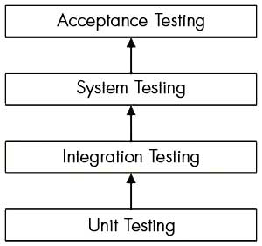

Figure - Integration Testing

* **Integration testing:**Testing performed to expose defects in the interfaces and in the  
  interactions between integrated components or systems. See also c*omponent integration  
  testing, system integration testing*.
* **Component integration testing:**Testing performed to expose defects in the interfaces and  
  interaction between integrated components.
* **System integration testing:**Testing the integration of systems and packages; testing  
  interfaces to external organizations (e.g. Electronic Data Interchange, Internet).

# 6. RESULTS AND DISCUSSION

## 6.1. Test Reports

Test Report is a document which contains

* A summary of test activities and final test results
* An assessment of how well the Testing is performed

Based on the test report, the stakeholders can Evaluate the quality of the tested product make a decision on the software release. For example, if the test report informs that there’re many defects remaining in the product, the stakeholder can delay the release until all the defects are fixed.

|  |  |  |  |  |  |  |
| --- | --- | --- | --- | --- | --- | --- |
| **Functions** | **Description** | **Executed**  **( % )** | **Passed**  **( % )** | **Pending** | **Priority** | **Remarks** |
| New Customer | Check new customer is created | 100% | 100% | 0 | High |  |
| Edit Details of customer | Check customer details can be updated | 100% | 100% | 0 | High |  |
| Edit password of customer | Check customer password can be updated | 100% | 100% | 0 | High |  |
| Add device | Check customer to add device | 100% | 100% | 0 | High |  |
| Request Fault Repair | Check customer be able to request fault repair services | 100% | 100% | 0 | High |  |
| Maintenance service request | Check customer can add maintenance service | 100% | 100% | 0 | Hight |  |

## 

## 6.2. User Documentation

**Installation related Help:**

1. Make a Copy the folder service-center to your desire location.
2. We want to tell our system, the location inside of webroot folder, Open .htaccess file
3. Replace RewriteBase /mca-mini-project/service-center to RewriteBase /your-folder-location-path. Suppose you are putting all code inside of webroot folder, then you will replace “/mca-mini-project/service-center” with “/”.
4. Save and close .htaccess file
5. Open index.php file
6. Replace '/mca-mini-project/service-center/' to '/your-folder-location-path'. Suppose you are uploading all files directly to webroot folder then you will replace location “/mca-mini-project/service-center/” to “/”.
7. Save and close index.php file
8. ***Database:*** *We also provide, sql file that can be used to import database schema and example records for your database, you just have to create a database by using phpmyadmin, then find the option to import/export ( phpmyadmin feature are based on server to server, but in generally it will be their, may be in different orientation ) now import file from folder /app/sql/db/service_center.sql.zip file, this will create your database tables automatically.*
9. Now we want to tell our system about database credentials, app/init.php file.
10. Search for match “// database details”, set DB_SERVER, DB_USER, DB_PASS, and DB_DATA (database name).
11. Close and save your file. You are all set, now you can access your website by going to web browser, type <http://yourdomain.com/your-folder-location-path>, it will open your website. Suppose you had uploaded all files inside of webroot folder then you had to type in your web browser just your domain name, for example <http://yourdomain.com> .

**Help for Customers:**

1. First step is to register, go to website.

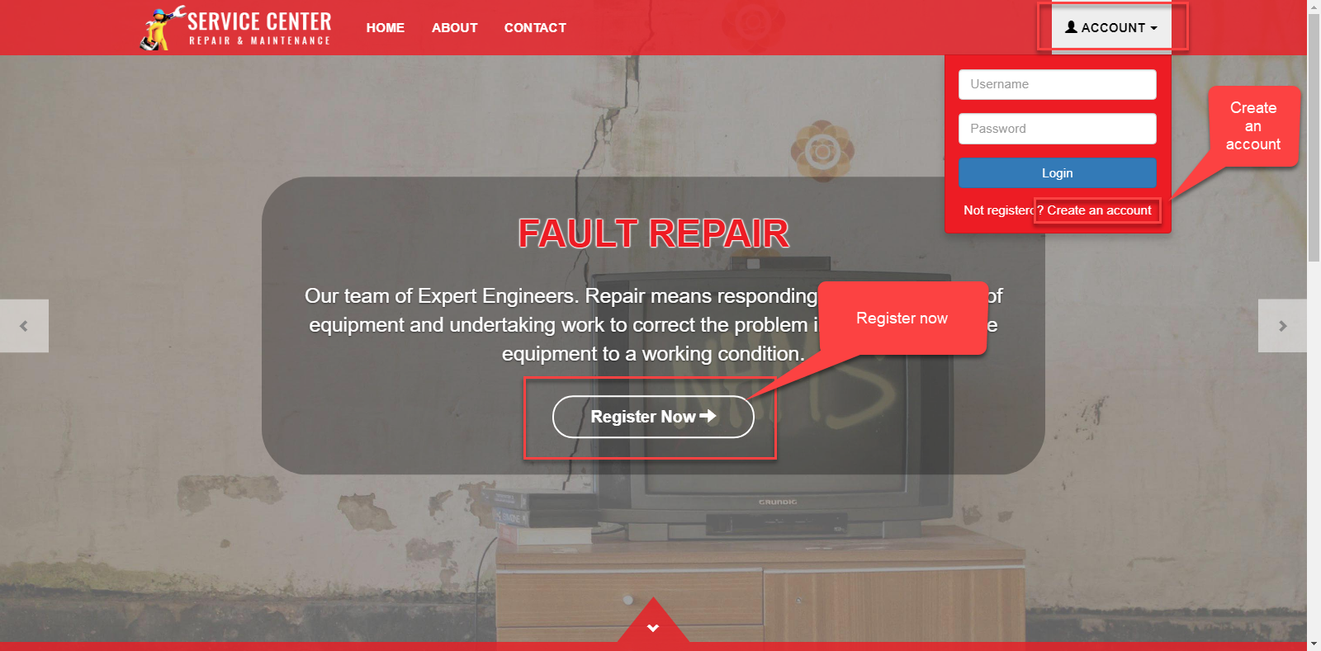

1. Click on Register Now button or Account > Create an account.

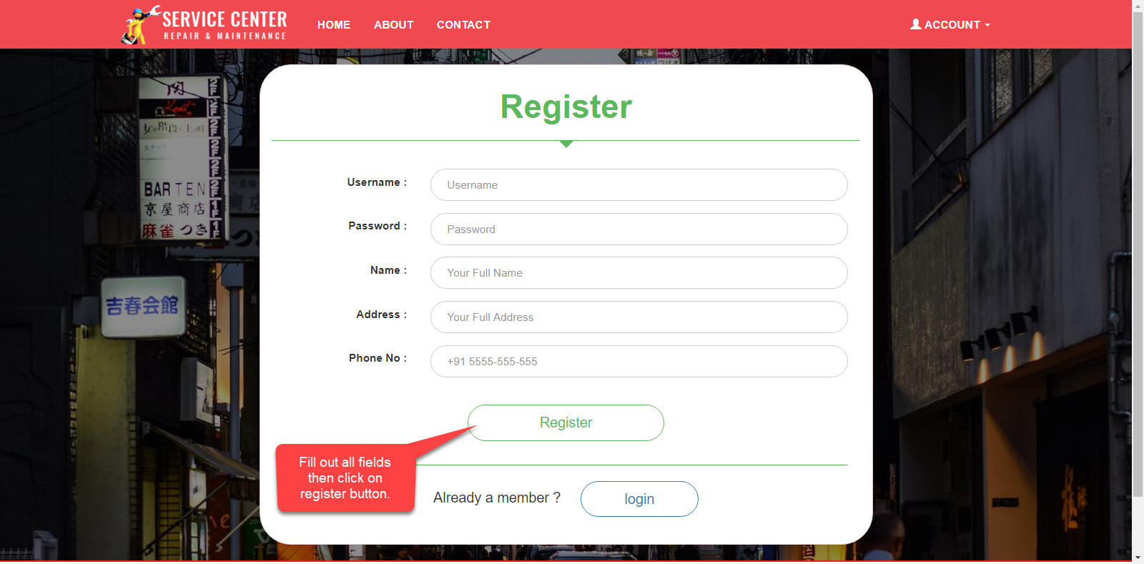

1. You are at Registeration Page now, fill up all fields and click on register button. If your account is created then you will be going to login page.

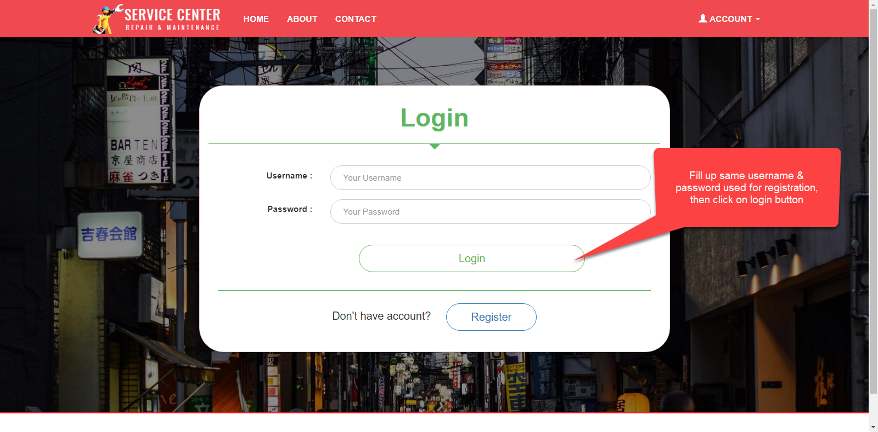

1. If your Username & Password is correct then you will be redirected to Dashboard page, as shown below.

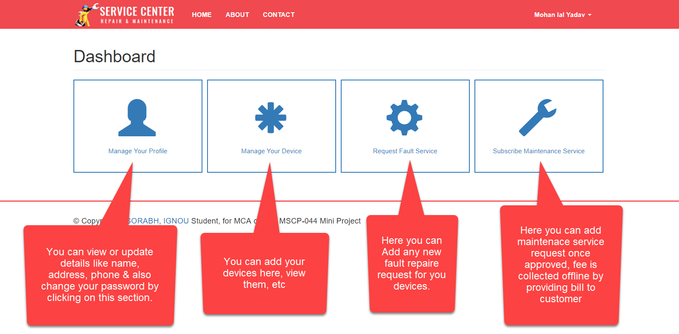

1. When you drive in live site you will have better understanding to their workings.

**Help for Admin Area:**

1. Suppose you had uploaded your files in webroot directory. The web address for website is <http://yourdomain.com> then admin area will be available at <http://yourdomain.com/admin> .
2. First we will tell you about, how you can change admin username & password.
3. Open file at path /app/models/AdminModel.php in any text editor
4. Here you will see public $username = ‘admin’, change ‘admin’ to ‘youradmin’ , that is username.
5. Also you will see public $password = ‘admin’ change ‘admin’ to ‘yourpassword’, that is admin password.
6. After making changes, just save and close the file.
7. Next step is to go and access admin area, go to http://yourdomain.com/admin

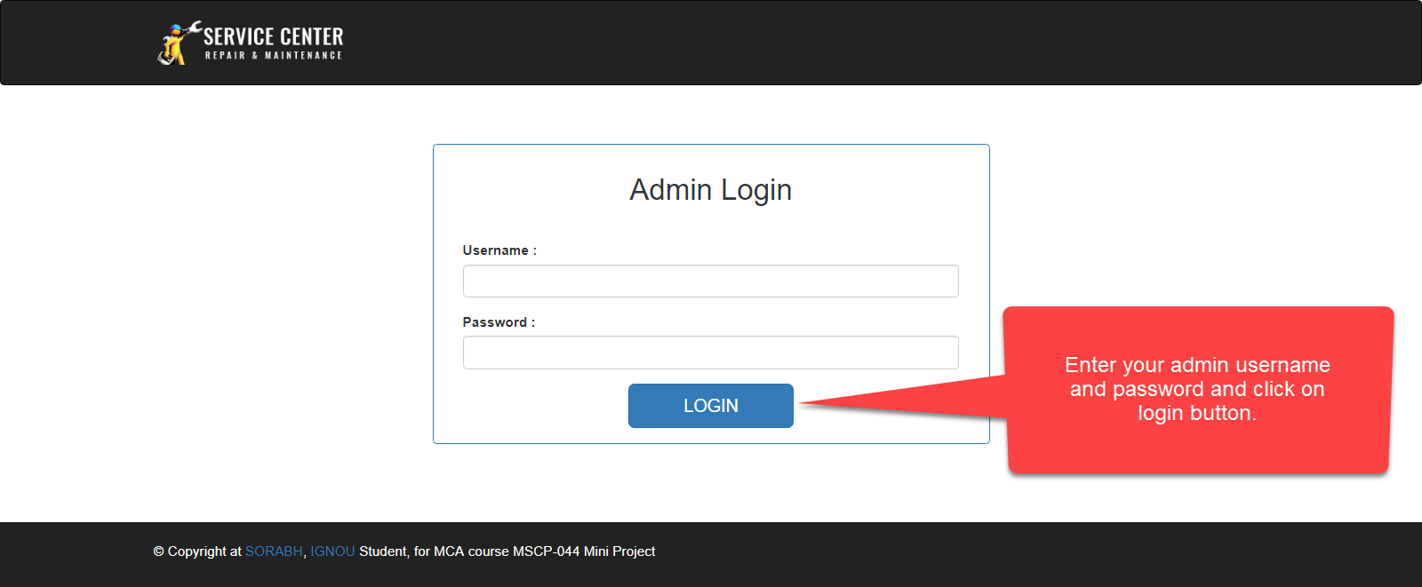

1. If your details authenticate successfully, then you will see admin management interface, here everything is organised as navigation links on left side and their settings on right side, You will find following admin modules to organized set of useful data as bellow.
   1. Categories : This section provide functionality for adding different device category to system, are used for providing different services at their domains, like TV, Air Conditioner, etc.
   2. Devices : This section will going to list all devices added to the system.
   3. Customers : This section will help to list all customers of organization, and their informations.
   4. Engineers : This section help to manage engineers, those repair or provide maintenance services to customers.
   5. Fault Request : This section list all repair requests in one place and provide different set of functionality like print bill, give approval, change status if payment had been collected, add parts, assign engineer, etc.
   6. Services : This section list all maintenance reqeusts from customers, also various useful functions to create, edit, approved, reject, generate bill, add parts, etc.

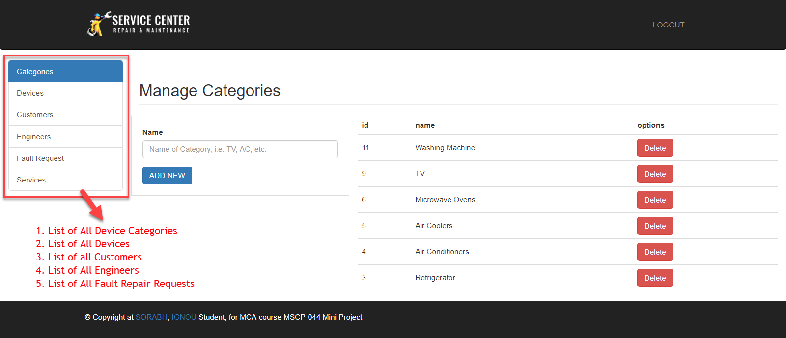

1. For more understanding to system, we recommend you to do some practical things by going into our system.

# 7. CONSLUSIONS

## 7.1. Conclusion

We build a robust Online Maintenance Management System for our Service Centre, which contains all basic functionality, which will help their customers to purchase maintenance services or submit a fault repair request. Administrator can view those requests and appoint specialized Engineer to that task, he can be in touch with their customer by contacting via phone number that provided by customer, and give feedbacks to them after consulting with engineer. Here Customers are getting a workspace for storing their device information to one place as well quickly submit request based on saved information, or he can add more, customer is also able to purchase maintenance services provided by service center, so their selected devices are maintained quaterly.

## 7.2. Limitations of the System

Online Maintenance Management System is designed for booking online service records, manage engineers, manage customers & their products/devices, etc. This system have following limitations.

1. There is no access control for administrator, means you could not add more admins based on there roles in administrator module.
2. We do not have engineer login module where every engineer can manage or update progress of their work, he had to keep contacting to administrator for providing progress details.
3. Our system need internet connection to access different features. i.e. Purchase of services, request a fault repair, customer or admin login, etc.
4. All fee and payments are collected offline, there are no online payment gateway for transaction or payment of recipts.
5. Customer must register and login by themself to access to any services, he need to add their device informations, by themselves and most of customer don’t like paperwork, so device information will be added by administrator after pickup of device, for simplifies this process, pickup team will collect basic information about customer by paper form, and those will be provided to administrator where he create a account for that customer, and inform provide his account details.

## 7.3. Future Scope of the Project

We can say, there are following scope further:

1. We can add some online payment gateway for collecting fee online.
2. We can manage customer addresses in different tables to organized more records sets.
3. We can organized replacement parts in different set of tables to improve more flexibilities.
4. We can add some chatting system, to chat online, or a AI bot for automate customer negotiation for handle, those are bargaining clients.
5. We can add Employee/Engineer Work Management Module, like login, give status reports, etc, that will surely reduce administrator work load. Adding user roles to our website on based on their type, for example customer, engineer, administrator, we can give access to required modules.
6. Database export/import feature for csv files, those can be quickly edit by any excel sheet editor, like openoffice or MS Excel.
7. We can add pagination to page, as well as search box for searching customers, devices, etc by name or date, etc.
8. We can add statistical graphs, reports generation, so admin would be able to collect data for analysis better decision making for the business.

# REFERENCES

Here are some sites, that would help me going to the all development process, Many existing websites, those used while gathering and inspiration.

1. <http://www.serviceman.in/>
2. <https://dir.indiamart.com/indianservices/>
3. <https://www.housejoy.in/electrical-services>
4. [*https://github.com/sorabh86*](https://github.com/sorabh86)
5. <https://getbootstrap.com/>
6. <https://jquery.com/>
7. <http://php.net>
8. <http://w3schools.com>